*Other books by* **EDWARD O. THORP**

*Elementary Probability Beat the Dealer*

*Other books by* **SHEEN T. KASSOUF**

*Evaluation of Convertible Securities A Theory and an Econometric Model*

*for Common Stock Purchase Warrants*

**BEAT THE MARKET**

*A scientific Stock Market System*

*Random House New York*

BEAT

THE MARKET

## A Scientific Stock Market System

*Edward O. Thorp, Ph.D.*

*Professor of Mathematics University of California at Irvine*

## Sheen T. Kassouf, Ph.D.

*Assistant Professor of Economics University of California at Irvine*

9 8 7

*© Copyright, 1967, by E. O. Thorp and S. T. Kassouf All rights reserved under International*

*and Pan-American Copyright Conventions. Published in New York by Random House, Inc., and simultaneously in Toronto, Canada,*

*by Random House of Canada Limited.*

*Library of Congress Catalog Card Number: 67:22624 Manufactured in the United States of America Designed by Betty Anderson*

*Contents*

INTRODUCTION *3*

*Chapter*

1. **A SYSTEM IS BORN** *7*

*First venture into the market. The market calls: boardrooms and chartists. The “circus”. Fundamentals: the “better” they are, the faster they fall. Textron and Molybdenum. The moment of discov- ery. Steady profits in bust and boom.*

1. **WARRANTS: OPTIONS ON THE FUTURE** *15*

*Rediscovery of the system: Ed Thorp under a tree. What is a warrant? Get rich quick? The warrant-stock diagram. The two*

*basic rules relating warrant prices to stock prices. Adjusted warrants and adjusted exercise price. Reading the financial pages. Checking the two rules. The warrant-stock law: predictability in the stock market.*

1. **SHORT SELLING: PROFITS IN BAD TIMES** *33*

*Short selling. Selling warrants short. Molybdenum warrants and the avalanche effect.*

1. **THE BASIC SYSTEM** *43*

*Hedging: high profit with low risk. Changing the mix. Deeper insight into the basic system. The basic system: preview. An in- credible meeting.*

*vi Contents*

1. **THE SYSTEM IN ACTION: $100,000 DOUBLES** *51*

*The Molybdenum story. Moly coda. Bunker-Ramo (Teleregister). Catskill conference: Sperry Rand.*

1. **HOW TO USE THE BASIC SYSTEM** *71*

*Identifying the listed warrants. Picking short-sale candidates. Using the warrant-stock diagram. Which are best? Choosing the mix. How much protection: Dividing your capital among the candidates. Final points. Summary of the basic system.*

1. **FURTHER PROOF: THE HISTORICAL RECORD** *91*

*A simplified mechanical strategy. The potential future for the basic system. Performance through the 1929 crash.*

1. **MORE ON WARRANTS AND HEDGING** *103*

*Over-the-counter, regional, and Canadian warrants. What determines warrant prices? What is a warrant worth? Reverse hedging. Spotting candidates for reverse hedging.*

1. **CAN ANYTHING GO WRONG?** *127*

*Short squeezes. 1929 again? Volatile price movements. Extension of warrant privileges. Banning of short sales. Extensive use of the basic system.*

1. **THE GENERAL SYSTEM: THE EVALUATION OF**

**CONVERTIBLE SECURITIES** *141*

*Scope of convertibles. Convertible bonds. Anatomy of a convertible bond. Reverse hedging with Collins Radio “warrants.” Picking con- vertible bond situations. Best candidates for reverse hedging. Basic system with latent warrants. The basic system with Dresser In- dustries “warrants.” Finding the best basic-system hedges with convertible bonds. Convertible preferred stocks. Call options. Puts, calls, and the basic system.*

1. **DECIPHERING YOUR MONTHLY STATEMENT** *169*

*Your brokerage account. The cash account. The margin account. The short account. Calculations in a mixed account. Applicability to the basic system.*

1. **PORTFOLIO MANAGEMENT** *181*

*Exploiting a rise in the price of the common. Exploiting a decline in the price of the common. Diversification? Having several ac- counts. Long-term gains.*

*Contents vii*

1. **WHY WE ARE SHARING THE SECRET** *189*

*They wouldn’t believe us. I want to do it myself. The threat of rediscovery.*

1. **WHAT THE FUTURE HOLDS** *195*

*How much can be invested in the basic system? How much can be invested by the entire system? A general solution for the stock market.*

APPENDIX

**A** Mathematics of the avalanche effect. 199

**B** Over-the-counter and Canadian warrants. 200

**C** Scientific proof that hedging can offer high expected return. 200

**D** The prediction of warrant prices. 201

**E** Basic-system hedge performance, 1946-1966. 204

REFERENCES 209

INDEX 213

**BEAT THE MARKET**

*A scientific Stock Market System*

Introduction

We present here a method by which investors can consistently make large profits. We have used this method in the market for the past five years to earn 25% a year. We have made prof- its during two of the sharpest stock market drops of this century; we have made profits when the stock market soared; and we have also made profits in stationary and churning markets. We have used mathematics, * economics, and electronic computers to prove and per-

fect our theory. After reading dozens of books, investigating advisory services and mutual funds, and trying and rejecting scores of systems, we believe that ours is the first scientifi- cally proven method for consistent stock market profits.

This book analyzes convertible securities and their associated common stock. These securities are now held in the portfolios of several million investors. More than 300 of the 3,500 securities traded on the New York and American stock exchanges are convertibles. Our methods apply to these convertibles jointly with their more than 200 associated common stocks. (We emphasize

* Some of the research which made this book possible is based in part upon mathematical research supported in part by Air Force grant AF-AFOSR 1113-66.

that our profits generally come from both the common stock and the convertibles.) The total of over 500 securities is about 15% of all the securities listed and has a market value of per- haps $50 billion.

We predict and analyze the price relationships which exist between convertible securi- ties (warrants, convertible bonds, convertible preferreds, puts, and calls) and their common stock. This allows us to forecast future price relationships and profits. We do not need to pre- dict prices of individual securities in order to win.

The minimum amount required to operate the system is determined by the amount required to open a margin account. This amount is subject to change. As we write, it is

$2,000. Our method does not require you to invest all your funds in it, though we expect most readers will wish to do so. It is natural, for instance, to begin with a trial investment, increas- ing it as you gain skill, confidence, and success. If the total equity in your brokerage account is at least $2,000, then you are free to invest any portion of it by our system, ranging from a few dollars to the total amount.

We begin the book by telling how we discovered the system. Then, as needed back- ground, we discuss warrants, short selling, and hedging. In the fifth chapter we illustrate the system with investments made by one of the authors over a five-year period. The sixth chap- ter shows the reader how to select his own investments with that part of our method we call the basic system. Next we present the historical performance of the basic system, which aver- aged more than 25% a year over a seventeen-year period.

When the reader finishes the first nine chapters, he can successfully operate his own stock market investments. Chapter 10 shows how to extend our analysis to the entire area of convertible securities.

We conclude by discussing accounting and monthly statements, portfolio management, and the future for our method.

The scientific proof of the basic system, indicated in the exposition, consists of four

parts:

1. We show (Chapter 7) that the basic system gained more that 25% per year for seventeen years (after commissions but before taxes). We also show that when stocks fell from September 1929 to 1930, the basic system could have doubled an investment.
2. A statistical analysis, with the aid l basic-system opportunities from 1946 to 1966 (Appendix E).
3. Our five-year cash record of no losses and an average return of 25% per year with the method. One of the authors more than doubled $100,000 in just four years (Chapter 5).
4. A theoretical argument that convinced colleagues in whom we confided (Appendix C).

The tables and charts in the book make our strategy easier to use. For the interested

reader, appendixes indicate the technical foundations for our method. this supplementary material need not be read to successfully employ our winning method.

We do not claim that you can breeze through this book and then shake the money from trees. This book needs to be studied. However, we intend *Beat the Market* to be useful and profitable to the entire investment public, from professionals to beginners.

*Chapter 1*

# A SYSTEM IS BORN

On October 5, 1961, Sheen Kassouf began a series of investments which averaged 25% a year over the next five years. Kassouf tells of his trial and rejection of the usual stock mar- ket approaches and how he then discovered the basis of our system.

### First Venture into the Market

In 1957 I sought investment opportunities. The advertisements of brokerage houses and advi- sory services implied that stock market profits were just a matter of following their proce- dures. I subscribed to a respected advisory service and received hundreds of pages of finan- cial data, charts, and advice. Emerson Radio was rated “promising” so I purchased 100 shares.

The stock market had been declining and now this general decline quickened. Analysts and financial writers could not agree on an explanation. They blamed Sputnik, the economy, credit and banking conditions, foreign interests selling stock, deteriorating “technical” posi- tion, and “wedge formations” in the stock averages.

I continued to buy Emerson. My broker * asked, “What shall I

* Most investors place orders with a registered representative, also known as a customer’s man or an account executive. We replace these cumbersome terms with the widely used but slightly inaccurate “broker.”

do tomorrow for your account if it drops again?” The question jolted me. My loss was now

$1,500. How much further could it fall?

Early in 1958 Emerson rose, and I sold out at a profit of $500. A year later Emerson tripled in price. The enormous profit that escaped and the sharp price fluctuations tantalized me. By 1961, after similar experiences, I sold my business and plunged into the financial maelstrom.

The Market Calls: Boardrooms and Chartists

I subscribed to services and publications, emptied entire library shelves for evening and weekend reading, and spent the hours between 10:00 A.M. and 3:30 P.M. in boardrooms around the city. I was a “boardroom bum.”

High above the city was a carpeted, elegantly furnished Park Avenue boardroom. But for the muffled clatter of the Western Union ticker and the muted but persistent ringing of telephones, it might have been the drawing room in a Sutton Place town house. A thin, dark man wearing a large jade ring was seated at a small French provincial desk. He nervously turned the pages of a chart book, pausing frequently to draw neat geometric patterns in red and blue with the aid of a draftsman’s triangle. His head jerked up periodically to watch the prices dance by. He was a chartist, convinced that there are repetitive patterns in price move- ments.

Chartists, or technicians, believe that patterns of past price performance predict future performance. They rely solely on price and volume statistics from the ticker tape, claiming that insiders have already acted by the time statistics such as sales, earnings, orders, and div- idends are published. Technicians claim that var-

ious configurations on their charts, such as heads and shoulders, triangles, wedges, and fans, repeat themselves over and over again, signaling the start and the reversal of price trends. Thus by studying price charts, they believe they can detect trends soon enough to profit from them.

Chart reading seems scientific but it isn’t. For instance, the most celebrated of all tech- nical theories is the Dow Theory. Richard Durant’s *What Is the Dow Theory?* asserts that

$100 invested in the Dow-Jones industrial average in 1897 would have grown to $11,237 by 1956 if these stocks were sold and repurchased whenever the Dow Theory gave the appro- priate signal. This is equivalent to 8.3% compounded annually. By comparison, the University of Chicago’s Center for Research in Security Prices found that random buying and selling of stock from 1926 to 1960 would have averaged a 9% gain per annum, about what the Dow Theory claims to have earned by design.

My doubts about chart reading were strengthened by a test I gave to people who claimed to be able to “read” charts. I selected pages at random from a chart book, covered the name of the corporation and the last half of the chart, and asked what price change the “pattern” indicated. Their “predictions” were no better than those of someone making ran- dom guesses!

### The “Circus”

In contrast to the plush Park Avenue boardroom, I sometimes sat in a ground-floor office in the garment district–a “circus.” Posted in the windows to attract passers-by are the latest Dow-Jones averages and free literature. Noisy emotional crowds fill the straight-backed chairs. During lunch hour workers pack in from

the surrounding buildings. “There goes KST!” someone shouts jubilantly. “They’re picking it up now!” A broker with his hand over the mouthpiece of his telephone asks loudly, “Did anybody see any Pan Am?” Later, over a hurried lunch at his desk he tells me, “Okay, this market discounted already the slowdown coming in the economy. What I want to know is, are they going to discount this twice?”

I seriously considered the question and nodded in agreement that the elusive “they” of the stock market would be foolish if they didn't. I still hadn’t learned to disentangle the jar- gon and nonsense from reality. Many investors use a ritual language to help them cope with uncertainty.

The year 1961 was a frenzied one–the year of new issues. Companies with exotic or scientific names were coming to market daily with securities for sale. Investors bid so aggres- sively for these stocks that they were rationed. Even favored clients were allotted just a few shares in these companies. One morning my broker informed me that I could buy 10 shares of Adler Electronics at the offering price of $11 per share. With the wisdom acquired in the last few years, I politely refused. My brother reluctantly accepted. In weeks the stock hit $20 per share.

It was also the year of the hot tip. One afternoon the manager in a small midtown office hurriedly emerged from his glass-enclosed cubicle. He walked swiftly between the desks of his brokers and said to each, “X * likes Hydrocarbon–over-the-counter and now 9fi to 10.” The brokers dialed quickly and without question. At each desk the story was the same–at times it sounded like an echo chamber. “He’s never been wrong–he gave us Puritan Sportswear a few weeks ago and you what *that*

* X was the advisor for a mutual fund. He continues to enjoy a reputation for shrewdness and is presently the manager of a new and well-promoted fund.

did. How many shares do you want?” And in those magic days of 1961, those who followed X had a profit before the day was out–Hydrocarbon rose more than 1fi points.

### Fundamentals: The “Better” They Are, the Faster They Fall

I didn’t follow X. My line of attack was to seek “value.” This is called the fundamental approach to the stock market. Members of this school believe that every stock has an “inher- ent” value (also called intrinsic value), very often distinct from its market price. The future stream of earnings and dividends determines inherent value. For example, suppose it were known that General Motors would pay $5, and only $5, in dividends each year on each share of its stock forever. Assume for simplicity that the interest yield on “risk-free” assets, per- haps United States bonds, will remain at 5% in the future. Then it is easy to see that a share of General Motors has an inherent value of $100. If the stock could be purchased for less than

$100, it would yield more than 5%; if it cost more than $100, it would yield less than 5%.

Of course nobody knows the amount of all future General Motors dividends, but if a good estimate could be made, inherent value could be calculated. (Estimates of future inter- est rates must also be made.)

A fundamentalist studies financial statements, industry and firm prospects, managerial ability, government policy, and whatever else he believes will affect future earnings. This leads him to an estimate of the future income stream of a share of stock which he then con- verts into inherent value. If the market price of the stock is less than his computed inherent value, then it is attractive; if the market price is more, the stock is to be avoided.

I returned to the advisory service that prematurely but cor-

rectly called Emerson Radio a winner. Again their fundamental analysis impressed me. they surveyed the entire economic scene, weighed the prospects of one industry against another, and finally recommended the most promising firms. This advisory service operated with “facts.”

I studied the advisory service’s entire current report of a thousand pages. I also read daily every inch of the financial sections of *The New York Times* and the New York *Herald Tribune*. Then I made my initial move: I bought 100 shares of Columbia Broadcasting at 40⁄ and 100 shares of General Dynamics at 38fl.

Although most of my friends were making profits in the stocks of lesser companies, the so-called “cats and dogs,” and although the market averages were near their all-time highs, my two stocks slowly but steadily declined in price. The more I used fundamentals the less money I made, while some friends who were very successful gave little thought to their investments.

My attraction to fundamental analysis weakened further as practical difficulties appeared. It is almost impossible to estimate earnings for more than a year or two in the future. And this was not the least difficulty. After purchasing an undervalued stock it is essen- tial that others make similar calculations so that they will either purchase or wish to purchase it, driving its price higher. Many “undervalued” stocks remain bargains for years, frustrating an owner who may have made a correct and ingenious calculation of the future prospects.

### Textron and Molybdenum

Later that summer the fundamentals tempted me to buy Textron, Inc. My studies indicated the existence of things called Textron

warrants, listed on the American Stock Exchange. I learned that a warrant is an option to buy a share of common stock at a fixed price; that the higher the common, the more the warrant tends to sell for; and that these warrants are themselves bought and sold just like common stock. I was torn between buying the common or the warrant. Consequently, I studied the past behavior of both the Textron warrants and the common stock, attempting to find the relation- ship between them.

I also noticed other warrants and charted their activity. I sought “cheap” warrants that might advance dramatically in price. None seemed attractive at the time. Molybdenum seemed to be the most overpriced warrant of all. I wanted to sell the Molybdenum warrants short, which is a method for profiting from a fall in price. (Short selling is explained in Chapter 3.) The Wall Street mythology characterizes short selling as both dangerous and sub- versive, so I hesitated. Besides, I would lose if the common rose substantially and the war- rant consequently advanced.

### The Moment of Discovery

One evening as I studied my charts of the possible price relationships between the Molybdenum warrant and common stock, I realized that an investment could be made that seemed to insure tremendous profit whether the common rose dramatically or became worth- less. I would win whether the stock went up or down! It looked too good to be true.

I called my brother late that night and unfolded the plan. He agreed that it looked prom- ising but warned me that we might be overlooking something. Nevertheless, to get more cap- ital for the pilot investment I sold 100 shares of Columbia Broadcasting the

next morning. The previous week I had sold 100 shares of General Dynamics and the com- bined loss on my first two carefully chosen investments exceeded $1,500.

### Steady Profits in Bust and Boom

Then I entered the Molybdenum “situation.” For the first time my investments were virtual- ly assured of success. I was no longer at the mercy of strange chart formations that smacked of astrology. And it was no longer necessary for the market to eventually agree with me on the value of a security. As I perfected my operations, investment after investment proved profitable.

Through the stock market earthquake of 1962, I sat content and confident with my steady flow of profits amidst dejected boardroom crowds. My success was not dependent on a falling market; when prices rose feverishly after the Cuban crisis in October, my profits continued, as they have to this day.

In the fall of 1962 I enrolled as a full-time graduate student in the Economics Department at Columbia University. I eagerly tested the logic of my theory on that renowned faculty. In particular, I presented my views and theories in the seminars of Professor Arthur

F. Burns, President Eisenhower’s chief economic advisor. His interest and wise criticisms gratified me, and when he agreed to sponsor my doctoral research in this area I was delight- ed.

The remainder of this book describes simply but in detail the consequences of that research: ideal investments perfected in collaboration with Professor Thorp–investments that in practice from 1961 to 1966 have yielded 25% a year with virtually no risk.

*Chapter 2*

# WARRANTS

*Options on the Future*

### Rediscovery of the System: Ed Thorp Under a Tree

The dry sun blazed down from a clear desert sky. The quiet New Mexico summer afternoon was perfect for reading. I settled into the lawn chair under the shade of a poplar tree with a thin book on warrants [6] * that had just come in the mail. My tranquil surroundings gave no hint that one of the fateful hours of my life was now begun.

### What Is a Warrant?

As I read, I quickly learned that a warrant is an option to buy common stock. That is, under certain conditions it may be converted into common stock. If the warrant owner wishes to get ABC common stock by converting his ABC warrants, he pays a specified price per share of common.

For instance, each Sperry Rand warrant entitled the holder to purchase one share of common stock at $25 per share, from March 17, 1958, up to and including September 16, 1963.

* Numbers in brackets denote references, a list of which is found on pages 209-211.

From September 17, 1963, to September 15, 1967, inclusive, the purchase price of a share of common increased to $28.

The **expiration date** † of a warrant is the last date it may be converted. For the Sperry Rand warrant this was September 15, 1967, after which the warrants had no value. The price of $25 (and later of $28) that the holder of these warrants had to pay if he wished to buy one share of common is known as the **exercise price** of the warrant.

There are some warrants which have no expiration date. These warrants, the most famous of which are Alleghany Corporation, Atlas Corporation, and Tri-Continental Corporation, are good for the life of the corporation itself and are known as **perpetual war- rants.**

How and why do companies issue warrants? The Sperry Rand warrants illustrate a common procedure. In 1957 the company wished to raise more than $100 million. They offered $110 million worth of 5fi% bonds due in 1982. To make the bonds more attractive they included with each $1,000 bond 20 of the warrants described above. Since there were 100,000 such bonds, this created 2,200,000 warrants. The warrants were detachable, which meant that they could be separated from the bond and sold independently of it. If the corpo- ration had issued these bonds without warrants, it would have had to pay more than 5fi% interest.

### Get Rich Quick?

The book I was reading pointed out that a lucky buyer of warrants could turn a modest sum into a fortune beyond his dreams. For

† We print in boldface the more important terms when we define them for the first time. Definitions can be relocated by first finding the term in the index, then referring to the page given under the term’s subentry “definition.”

example, the Tri-Continental perpetual warrants cost only three cents apiece in 1942. Four years later they could be sold for $55/8.* An investment in these warrants would have increased by 55/8 divided by .03, or 187.5 times. (This figure is somewhat inflated because we omitted commission costs to simplify our discussions.)

A $1,000 investment would have become $187,500 in four years. By 1965 these same warrants reached 473/8. The lucky 1942 investor of $1,000 who sold would get over $1.5 mil- lion!

Tri-Continental common stock also was a good investment in this period. From a low of 3/8 in 1942 it rose to 27fi in 1965. The lucky investor of $1,000 would see it grow to about

$73,333. However, as we have seen, the even luckier warrant holder had more than $1.5 mil- lion for his original $1,000. He made more than 20 times as much as the stockholders because the warrant moved up more than 20 times as fast as the stock. This behavior of the warrant, increasing in value more rapidly than the associated common, is one example of financial leverage.

If investment A tends to rise or fall proportionally more than investment B, then A is said to have leverage † relative to B. Leverage can arise in many ways. For instance, if equal dollar amounts are used to buy stock for cash or on 50% margin, the margined investment will rise and fall twice as much as the cash investment. Warrants have leverage relative to their common stocks because they rise and fall faster. It is precisely this quality that attracts investors.

* The enlightened reader should note that U.S. stock exchanges still retain the backward habit of quoting prices in fractions rather than in the more modern and efficient decimal notation. Thus we will be plagued with fractions throughout.

† This well-known and widely used meaning seems to be inadequately covered in the principal unabridged dictionaries.

Unfortunately, leverage can multiply both losses and profits. The unlucky purchaser of warrants may see his money melt away with blinding speed. For instance, in 1945 Universal Pictures warrants were each worth $39. In two years they dropped to $1.50, reducing a

$1,000 investment to a mere $38.

Here were undreamed of profits mixed with the cruelest losses. As I read, I wondered if there was a way to realize some of the enormous profit potential of warrants and yet be safe from the losses. The next step was automatic for a trained scientist: analyze the relation between the price of the warrant and the price of its associated common stock. Find the rules, or “laws,” connecting the two prices.

The book I was reading did not analyze warrants scientifically. To read further would keep me from thinking beyond the author. I put down the book, and reasoned out for myself the price relation between a warrant and its common stock. I jotted down my flood of ideas. As I hoped, they were often quite different from those in the book. They make up the rest of this chapter.

The Warrant-Stock Diagram

Let’s use Sperry Rand warrants to begin our study of how warrant and stock prices are relat- ed. Table 2.1 lists the 1960 monthly high prices, the monthly low prices, the month-end (close) prices, and the net change from month to month in these closing prices, for both the warrant and the common. The high and low for the month are customarily included in pub- lished stock market information to give us an idea of how much the prices “moved around” or fluctuated that month. The closing prices of warrant and common give us the two prices at approximately the same time, so we

can use these prices to investigate how the two prices move together. The net-change column shows us quickly whether the stock or warrant moved up or down from one month to the next.

If we compare the net-change columns for the stock and for

*Table 2.1. 1960 prices for Sperry Rand warrants and common.*

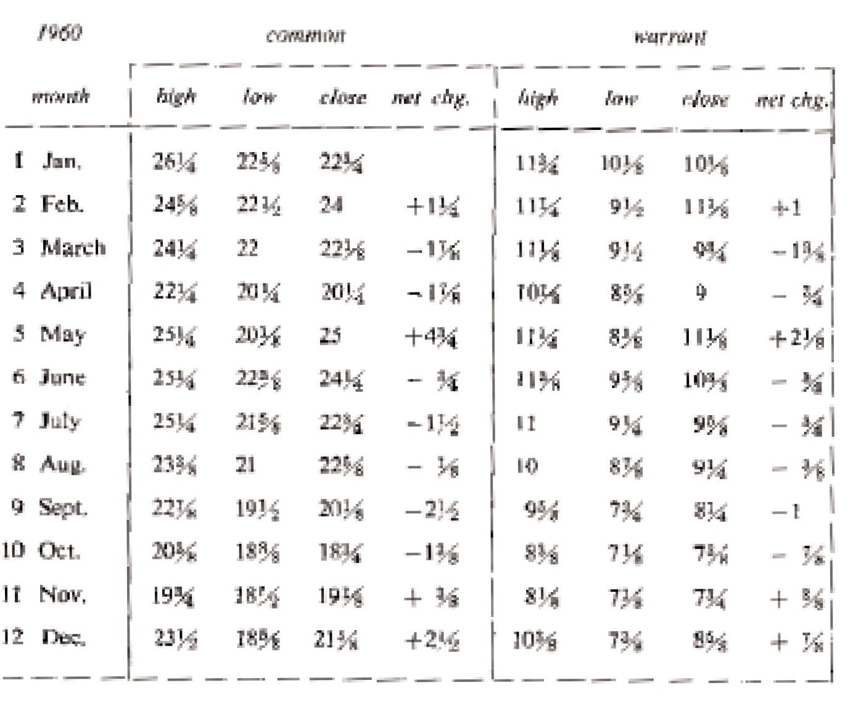

the warrant (fourth and eighth columns in Table 2.1), we see that the warrant generally moved up and down with the stock. For example, when the stock closed higher in February than in January by 1⁄, the warrant closed higher by 1. The stock and warrant also moved up together at the ends of May, November, and December. The net change was down for both stock and warrant at the ends of the other months.

The rule is that stock and warrant prices from day to day

usually move up and down together. This is plausible because the warrant is an option to buy common, and when the common becomes more valuable, one would expect the warrant to follow suit.

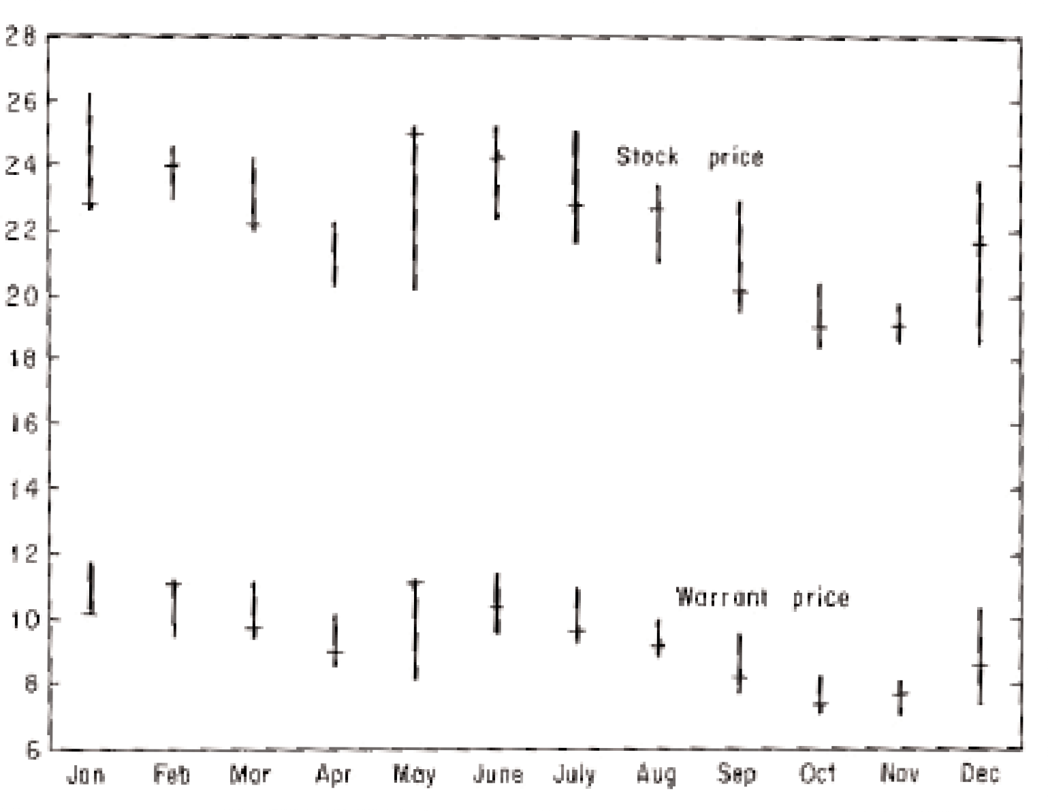

*Figure 2.1. A bar graph of the 1960 monthly prices of Sperry Rand warrants and common.*

To better understand how the warrant price is affected by a change in the common, stock market students generally picture the information in Table 2.1 much as in Figure 2.1. This figure does little more than support our observation that the warrant and the common tend to move up and down together.

There is another approach, generally unknown to stock market practitioners, which we call the warrant-stock diagram. It leads to a penetrating understanding of warrants and is fun- damen-

tal for all that follows. Here is how it works. Take a piece of ordinary graph paper and draw upon it a pair of lines, as in Figure 2.2. We call these lines the axes. The S, or stock axis, is the horizontal line and the vertical line is the W, or warrant axis.

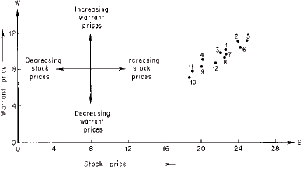

*Figure 2.2. The warrant-stock diagram for the year 1960 for Sperry Rand warrants and common.*

Now we draw twelve dots in Figure 2.2, one for each month of the year, as follows. For January, locate the January month-end stock price of 22fl on the S axis. Then go up by the amount of the January month-end warrant price, 101/8, and make a dot. The result is labeled “1.” Repeat the process for February and get the dot labeled “2.” Draw the other dots in the same way.

Notice that we have a “movie” of how the month-end prices change throughout 1960. Higher stock prices correspond to dots farther to the right. For instance, from the picture we see that the highest month-end stock price occurred in May. Of course, we could also see this easily from Table 2.1 or Figure 2.1.

If the stock price increases, as happened for instance from April to May (dots 4 and 5), the dots move to the right. This is indicated by the horizontal arrow labeled “increasing stock prices” in the “cross” of arrows in the left part of Figure 2.2. If the stock price decreases, the dots move left as indicated by the horizontal arrow labeled “decreasing stock prices.” Similarly, if the warrant price increases, the dot moves in the direction of the vertical arrow labeled “increasing warrant prices,” and if the warrant price decreases, the dot moves in the direction of the vertical arrow labeled “decreasing warrant prices.”

### The Two Basic Rules Relating Warrant Prices to Stock Prices

We have seen that the price of the warrant and the price of the common tend to move up and down together. Now we learn about other important relationships between the two prices.

We begin with the Sperry warrant. To convert it into a share of common in 1959, the holder had to add the exercise price of $25. This made the warrants less valuable than the stock itself. Did the warrant have compensating advantages that tended to raise its value over that of the common? No, it had none. In fact the opposite was true. The common had the advantage that it might pay cash dividends whereas the warrant never could. This tended to make the common worth still more than the warrant.

This commonsense argument, applied to all warrants, leads to the first rule: the price of the warrant should be less than the price of the associated common stock.

The next rule also is logical. If we added $25 to a Sperry warrant we could get one share of common. Therefore the price of a warrant plus $25 was worth at least the price of a share of

common. This argument, applied to all warrants, gives the second rule: the price of a warrant plus the exercise price should be at least as great as the price of the stock.

Suppose the second rule were violated for Sperry, with the common price being above the warrant price by more than the exercise price of $25. For instance, imagine the common at 40 and the warrant at 10. Instead of paying $40 per share in the market for common, prospective purchasers would get it for $35 by purchasing a warrant for 10 and adding $25 to get a share of common. This operation repeated would increase the demand for warrants, driving up the price, and it would reduce the demand for common, driving down the price. Soon the second law would be reestablished.

In the 1930s there were warrants which frequently violated the second rule; it was cheaper to buy common by first buying and converting warrants than it was to buy the com- mon outright. Perceptive operators who noticed this bought up the warrants at a price W, added the exercise price of E to each, and got common for a total cost of W + E per share. They then sold this share for the higher price S and pocketed an immediate profit of S – (W

+ E) per share.* Their purchases increased the demand for warrants and therefore raised the price above W. Their sale of stock obtained by converting the warrants increased the supply of stock and drove down the price below S. This tended to reduce the profit more and more, until it disappeared altogether.

*This operation is called **arbitrage**, in conformity with the customary definition of arbitrage as “the simultaneous purchase and sale of the same or equivalent securities, commodities, or foreign exchange in different markets to profit form unequal prices.” In the financial world two securities are called equivalent if at least one of them can be converted into the other. Thus, although the common cannot be converted into the warrant, the warrant (plus money) can be converted into the common.

In the chaotic 1930s when capital was scarce and warrants were less well understood, such chances for profit were frequent ([21], pp. 186-187). Now such opportunities rarely arise and are almost immediately “killed” before they amount to anything. For practical pur- poses the second rule always holds.*

### Adjusted Warrants and Adjusted Exercise Price

We discussed the Sperry warrant, which in 1958 entitled the holder to buy precisely 1.00 shares of common per warrant for $25. Many warrants entitle the holder to buy more or less than one share of common. For instance, by July of 1966 the terms of the Sperry Rand war- rant had been changed to allow the holder to purchase 1.08 shares of common up to and including the original expiration date of September 15, 1967. How did this come about?

On March 30, 1961, holders of Sperry common received a 2% stock dividend. This means that for each 100 shares owned, 2 more were given so that 102 shares then represent- ed what 100 shares did previously. Each share after declaration of the dividend was worth 100/102 of the “old” shares.

The warrant originally entitled the holder to buy one share at $25. The shares are now worth less. To protect the warrant holder’s original rights, for each 100 warrants he holds he is allowed to buy, after the stock dividend, 102 shares of common; one warrant buys 1.02 new shares, still for $25. An anti-dilution provision to thus adjust the warrant’s terms after stock splits and dividends was made for the protection of the Sperry warrant holders when the warrants were issued.

* Commissions are not a factor because some traders have virtually no transaction costs and are ready to exploit such opportunities.

There was another 2% stock dividend on September 28, 1961. The warrant was adjust- ed so that after the dividend one warrant plus $25 bought 1.02 times as many shares as before this second dividend. Since it could buy 1.02 shares before this second dividend, it became the right to buy 1.02 x 1.02 = 1.0404 shares after the dividend. In practice this was rounded off to 1.03 shares.

On June 29, 1962, there was a 4% stock dividend. Each warrant was adjusted so it would buy 1.04 times as many shares as before, or 1.04 x 1.04 = 1.0816 shares for $25. This was again rounded off to 1.08 shares. The exercise price had originally been set to increase from $25 to $28 after September 16, 1963. Thus, after this date, one warrant plus $28 bought

1.08 shares.

When you apply our system to your own investments, you will need to know only the present terms of a given warrant; your broker will get this information for you.

We now extend the discussion of the warrant-stock diagram and the two basic rules to those warrants that do not convert into exactly one share of common. If a warrant is convert- ible into some number Q of shares, then we say the warrant is equal to Q **adjusted warrants**. For instance, if one warrant converts into 2 shares, then it is equal to 2 adjusted warrants; if one warrant converts into half of a share, then it is equal to half of an adjusted warrant. The Sperry Rand warrant, after stock dividends, was convertible into 1.08 shares so it was then equal to 1.08 adjusted warrants. We emphasize that adjusted warrants are an arithmetical con- cept; they are not necessarily the same as the warrants that are bought and sold, but are gen- erally some fraction or multiple thereof. Note that an adjusted warrant is convertible into pre- cisely one common share.

*To calculate the price of an adjusted warrant divide the price*

*of the warrant by the number of shares it may be converted into*. For example, if a $10 war- rant is convertible into 2 common shares (so that it is equal to 2 adjusted warrants), then the price of one adjusted warrant is $10 divided by 2, or $5. When the Sperry warrant was sell- ing at $10, the adjusted Sperry warrant was worth $10/1.08, or $9.26.

The **adjusted exercise price** of a warrant is the amount paid per share of common received if the warrant is exercised. For instance, one Sperry warrant was convertible into

1.08 shares for $28 so that the price paid per share of common received was $28/1.08, or

$25.93. *The two rules apply as stated to all warrants, provided we use the adjusted warrant price and the adjusted exercise price in place of the warrant price and the exercise price.*

**Reading the Financial Pages**

We illustrate the two basic rules of warrants with the aid of this morning’s *Wall Street Journal*

(Friday, July 22, 1966).

The star of the show this morning on the New York Stock Exchange is Sperry Rand. At the top of the page there is a box listing the most active stocks for the previous day’s market action. Sperry Rand traded 346,300 shares, making it by far the most active stock of the day. The closing price (close) was 29. That means that the last transaction of the day in Sperry, of 100 shares or more, was at $29 per share. The net change in the price of Sperry is listed as

+2fi. This means that the stock closed up 2fi from the previous day must have been 26fi.

Syntex was most active on the American Exchange yesterday. The second most active “stock” was none other than the Sperry

Rand warrant! Sales were 127,400, the close was 103/8, and the net change was +7/8.

We noted that one Sperry warrant plus $28 buys 1.08 shares of common. Thus each traded warrant is 1.08 adjusted warrants; we found the adjusted exercise price was therefore

$28/1.08, or $25.93. Similarly, if the warrant closed at 103/8, the adjusted warrant is worth 103/8 divided by 1.08, or $9.61.

More detailed information about all the stocks that were traded is listed in the body of the financial pages. Stocks are listed alphabetically in fine print. Generally the opening (open), high, low and closing (close) prices are given, along with the volume (sales in 100s). For Sperry common and Sperry warrants, today’s complete listings in my paper read:

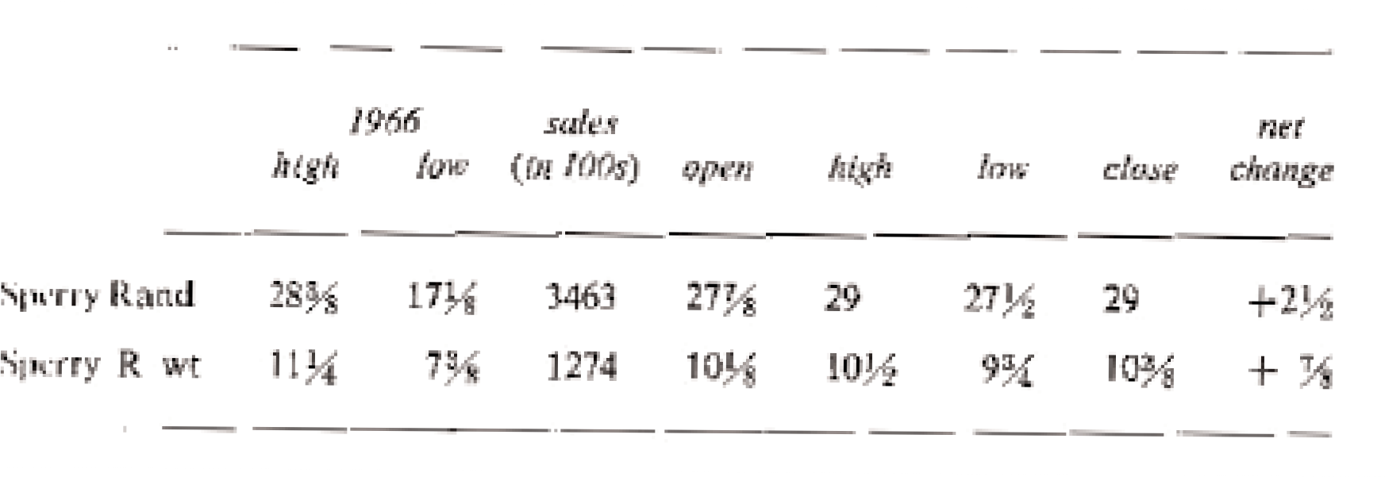

Of course the Sperry common listing was under the New York Stock Exchange and Sperry warrants were listed under the American Stock Exchange. We have placed them together for convenience. Sperry warrants will no longer be listed after they expire on September 15, 1967.

The 1966 high and low in the listing above indicates how much the price of Sperry fluc- tuated during the year and makes a useful comparison for today’s price. The high is the high- est trade

recorded for 1966 to date, excluding the current day’s trading. The low is computed similar- ly.

Let’s use Sperry to check the first rule connecting stock and warrant prices. The rule says that the adjusted warrant price should be less than the stock price. We found the closing price of an adjusted warrant on July 21, 1966, as $9.61 and the stock price is given as $29. The first rule easily holds for Sperry.

The second rule says that $9.61, the price of the adjusted Sperry warrant, plus the exer- cise price of $25.93, a total of $35.54, should be at least as great as $29, the price of the com- mon. It is, so the second rule holds for Sperry. The difference of $6.54 between $35.54 and

$29 is the extra amount a person would pay (ignoring commissions) if he purchased a share of common by first purchasing an adjusted warrant and then converting it, rather than buy- ing the common directly. This extra amount is known as the **premium** at which the warrant is selling.

### Checking the Two Rules

Now let’s check our two rules for other warrants listed in my paper this morning. All the war- rants are listed on the American Exchange. Some of the corresponding stocks are listed on the New York Exchange and some are listed on the American Exchange. The results of our check are listed in Table 2.2. Sperry is first, to show how the results already obtained are organized into the table.

Strictly speaking, the two rules apply only to stock and warrant prices for transactions which occurred at approximately the same time. Our table lists closing prices of each. These are prices for the last transactions of the day and the last transaction in the stock and the last transaction in the warrant may occur at different

*Table 2.2. Checking the two rules*

*, rirg*

*11-,UTi.mf*

*pri'CT*

Pf1t11?rb<-r rd *ud),rRl,iul*

*(W}0tf:..1t'U 'fl."t.trft(,#.'f, Ut"rc•i.fi"! flnt'.e*

pr; 11-tlrtu,,1r, E OJf *7ill/ti6*

*J,ni'flg ailfested war­ rnM prir.t!* **W**

t,,1-,/.iil(

*sm·k*

*/ll'lf:e* S

W+E ***s;q)inl***

|  |  |  |  |  |  |  |  |  |
| --- | --- | --- | --- | --- | --- | --- | --- | --- |
| :SpMt:r R1.1nd | ]O¾j | I.OS | :iS.93 | 9.til | *29* | Jj, 5'!1, |  | !}/1-j/'Ol |
| AJi. Cp | *1* | I | *rs* | 7 | 10 | I0.7.5 |  | * 11fll |
| Atlas Cp | *'>U*  ***)J*** |  | 61( | :2:½ | )% | $ | Jl Lla1 | |
| *Fst* N Rt |  | 1,15 | 5.22 | U4-3 |  | .HiS | 12/Jl/71 | |
| Gc:n Acc-cp­ | j_ |  | b) | $ | :21 |  | 10,-':]1/6' | |
| Hiltun Hott | *1¼* |  | 4!i | *13_* | l 1r!lfi | 53,_ | 10/1.Vll | |
| Indian Hd | lcY _ |  | *]A)* | 10¾ | :n | lOI.¾ | S/ljj90 | |
| Ji:1.11. re; |  | I | H 1 | JO | *"1.1.*. | *19* | /l/il | |
| .Mack. Tr | lOU | 1.4' | 4.DI | 7.40 | ]8¾ | 41.41 | l;;i/1/-tifi | |
| Mru:t111Mi"· | .28¾ | :2.'B | 16..48 | JO,J |  | 26-Jl7 | U/l/68 | |
| '.i.tCC'mQ• | Jttj | l | 20 | 3 |  | :ns | .J/L'i/75 | |
| J..fCC'l'()lj' IILU..V |  |  | 20 | *3¾* |  | *.3¾* | 3/1.5/ijl | |
| NIU Gi:ml | 4 | **1** | 1Ji | ..t |  | 0 | 5/U/74 | |
| Pac Prtro! | *5* | I.L | ]7,l, | 4,:5:5 | 10¾ | .U8.2 | 3/)1/ | |
| R1::aJty E | l>• | L2 :5 | .fJ.7' | ,US | :s | I0.9 | *,1tr·* | |
| R[o AIBom | *¾* | .n. | ·n. | 4.63 | 25 1 | :Z6.SIJ | 12/j 1 **/6t'i** | |

iv-

|  |  |  |  |  |  |  |  |  |
| --- | --- | --- | --- | --- | --- | --- | --- | --- |
| TC!:);1.m Im: | 13 | *2* |  | 15 | 36½ | **:!il** | .51½ | 5/})ll,!I, |
| Tmr'l::i,W Ai£ |  | l |  | 22 | 68, | 9½ | 'il i | l:2/1/11 |
| Tri Cont | "t.£1 , .,  l ,ri | 2 | . 4 | &.EB | H.4' | *!3¼* | 23:J7 | pi;:rp:1.1.ml |
| Uni, lnc;l | 6 |  | *.5* | 17 | 12 | *::U¾* | *1* | 11/li/M |
| Unil' Amer | :5¾ |  | | u. | *5* | *15½* | l9. _ | "1,/31/n-7 |





IJrls Bd

*6:!,.i* '"'

11'.IISOJ

11.18

J.?l

l'-1

lr.49

5/ I *(JS*



" J!' oa. ecu:r.tty lfid nrrt bTidi!, wa !l"''t 1nu =iHII'' of chEi *t,J;J pri "* (llllil l'11p!!r.z f1-T1.ru gt 'K-111.cll saml!aae affl!ci!!d la bu.,. LIN; l«a.rri.l:]") ;Uid. 111&: *rwrt..t prt<.* (I. Lownt

ps1t"t1■t whu:h ;!,OTttCr:IIX' •OIR::tti:I rn sc:ll ilK:'1cjcy),

I 'Fi11!!h Hill,,:,■ H,"llci W,\l:,ft'l.lllt pl11 !!i;U; b11!Ji'l-01:!lt sh cl! nf Hilt,nr, lRrl-!!lil CM;p,, .OOlnlMli'I Ml.di o,niit-t,illf IIIIIJ"!!j D1 BlH011 b1Ltrn.1llOllfil C'O, IllC:IC::Jo1'; COT S. we u2 **1bii**

d111.J11s p1k1! l B rrP HUt,ua H-ncelil pl121h.tilf lht.! !.!klhilig riet :Mt¼ 1:1r HJholl [J1tl:ll!Jll1tlc:i■r , a ct¥L41 o-f :J2t.::;. ,,.

llir_, AlfU"' *...-i* "'n!I :pl"illl a RiQ /LN'f'■ wL.

times. However, closing prices are generally good enough for our purposes.

The first rule is verified in each and every case by comparing the prices in the W col- umn with those in the S column and noting that the adjusted warrant prices are always less than the stock prices. The second rule is verified in all but one case by noting that the prices in the S column are less than or equal to the W + E values in the last column. There is one violation of the second rule. The closing price of Textron is 517/8, which is slightly larger than the W + E figure for Textron of 51fi. There is no profit opportunity here for us though. Suppose we buy Textron warrants for 36fi, add $15 for a total cost of 51fi for conversion to a share of common, and then sell the share of common we got for 517/8. We make a profit of 3/8. But the commissions costs of the transaction are about 3/4, so we would have a net loss of about 3/8.

### The Warrant-Stock Law: Predictability in the Stock Market

The beginning of this chapter found me relaxed under a shade tree, learning about warrants. There I realized the central ideas that we have discussed: (1) Warrants have incredible poten- tial for profit or disaster. (2) The warrant-stock diagram is the revealing way to picture the join price action of warrant and stock. (3) The price of adjusted warrants and their associat- ed adjusted exercise price should be used in the pictures and calculations, instead of the prices for actual warrants. (4) The two rules for relating warrant prices and stock prices should hold. (5) The price of a stock and its warrant generally move up and down together, but at different rates.

For each warrant at each point in its history I now guessed that there should be a “curve” in the warrant-stock diagram. This

means that, even though one might have no idea of the price of the common on some future date, he will know that when the point is plotted for the stock and warrant prices on that date, that point

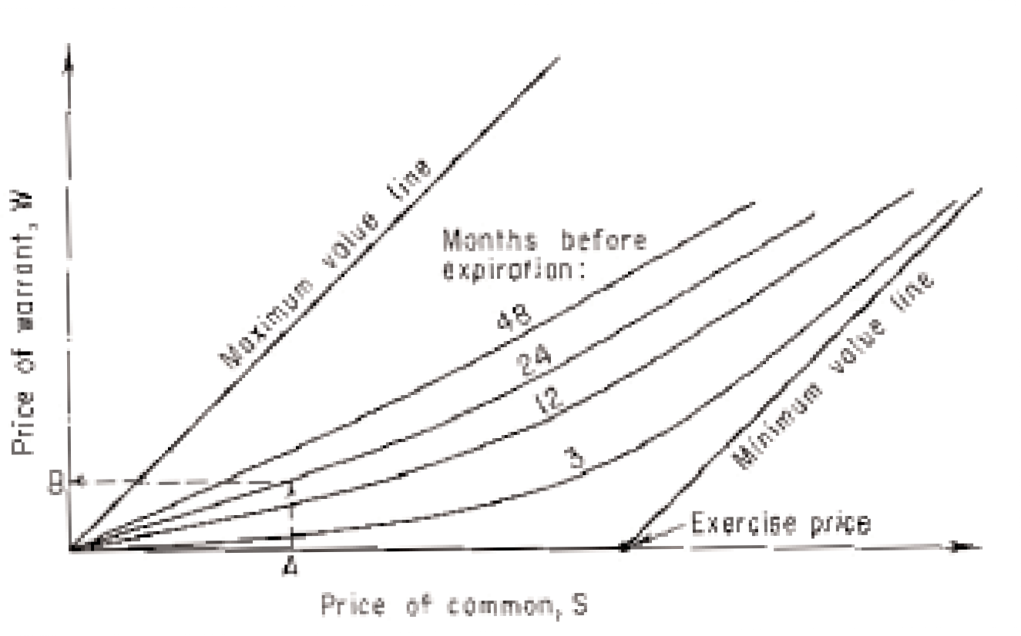

*Figure 2.3. Typical normal price curves for a hypothetical warrant X. As expiration approaches, the curves drop toward the minimum value line. If X common is A 24 months before expiration, then X war- rant will be near B.*

will be near the curve for that date. This guess turns out to be right; we call these normal price curves. Figure 2.3 shows the general situation for any warrant.

Warrants that are closer to expiring are worth less, all other factors being equal, so their curves should be lower than they were when the warrant had more time to run. Thus the curves in Figure 2.3 drop toward the heavy lower lines. We call this heavy lower boundary in the warrant-stock diagram the **minimum value line**. According to the second rule (page 23), the warrant price will generally be above this line.

Corresponding to the first rule (page 22), there is a line in Figure 2.3, which the war- rant price stays below, labeled the **maximum value line**. Since in practice warrant prices sel- dom come any-

where near this line, it is of much less practical importance than the minimum value line.

I did not yet know how to find the precise location of these curves for a particular war- rant. But I “knew” (based at that time on a mixture of reasoning and guesswork) that the sit- uation was generally as indicated in Figure 2.3, which shows normal price curves for a hypo- thetical warrant X. Using the curves in the figure, the predicted price for warrant X at a given time T is found, when the stock price S is given, by locating the price S on the S axis, then proceeding up to the curve labeled with the T value given, and reading off the theoretical value of the warrant. This is illustrated in Figure 2.3 for a hypothetical price 24 months before expiration. The predicted price and market price are generally close.

Using these curves I could predict portfolio behavior. A scientific stock market system was now just a matter of time. It had been an inspiring hour of reading and ideas.

Later I was to meet Professor Kassouf (see the end of Chapter 4: **An Incredible Meeting**) and learn that he had thought along these same lines before me. He also had cal- culated the prediction curves, using statistics and computers. The system he then built helped him to more than double $100,000 in just four years.

We have organized this book so that you learn and use the system without the mathe- matics of the normal price curves. Those readers with a mathematical background who are interested in learning more about such curves may refer to Appendix D.

*Chapter 3*

# SHORT SELLING

*Profits in Bad Times*

The usual way to make stock market profits is to buy a stock, hold it for a period of time, and then sell it at a higher price. Stocks, as measured by the Standard & Poor’s 500, have risen an average of 11.2% per year in the period from April 28, 1961, to October 15, 1965 ([13]),

pp. 111-112). They have gone up about 9% a year * during the 1926-1960 period [5].

Even when most stocks are going up (a bull market) some stocks are instead dropping in price and their owners are losing. Still worse are the times when the great majority of stocks are falling rapidly (a bear market); then it is the rare investor indeed who holds a stock that is rising in price. Unfortunately, it is at these times, when most stock prices are falling, that the average investor most needs to sell his holdings.

Stocks fell on an average over the three years 1929 to 1932 to a mere 13% of their orig- inal prices. † A solid “blue chip” like U.S. Steel descended from 262 on September 3, 1929, to 22 on July 8, 1932. In 1962 stocks dropped an average of 26% in just 3fi months. A solid blue chip like American Tobacco fell from

* Equivalent rate compounded annually, with reinvestment of dividends and neglecting taxes.

† Using the *Times* industrials, at 452 on September 3, 1929, and at 58 on July 8, 1932 ([7]), pp. 140,

146).

47 to 30. (A **blue chip** is a relatively high-priced common stock of a leading company that has a relatively long, uninterrupted history of dividend payments.) There was a stock market drop in 1966 similar to the one in 1962. Contrary to certain industry propaganda, the stock market by no means provides a comfortable 9 to 11% a year profit–even to the most “pru- dent” investors. The stock market is filled with risks and pitfalls that the investor ignores at his peril.

There is a technique for making a profit when stocks are falling. It is something every serious investor in the market should understand but that few do. It is called short selling, and it is one of the crucial tools that allows our system to make money whether stocks go up or down.

### Short Selling

The average investor first buys a stock and then sells it. For instance, suppose that in March of 1962 we buy 100 shares of American Tobacco at 47, for a cost of $4,700. We own the stock from March to June and are then said to be long 100 shares of American Tobacco. We sell our 100 shares in June at 30, receiving $3,000. Neglecting commissions we have lost $1,700. In 3 months we lost 1700/4700, or 36% of our investment, in a so-called blue-chip stock. This sad result was repeated for millions of investors, for this was the year of the 1962 crash. The famous Dow-Jones average of 30 industrials, a rough indicator of average overall stock market behavior, plummeted from a close of 723.54 on March 15, 1962, to a close of

534.76 on June 26, 1962. This was a drop of 26% in 3fi months. The more representative Standard & Poor’s index of 500 stocks also fell 26% between these two dates.

Few stocks went up. What could be done? If only we could have sold American Tobacco first, in March of 1962 when it was up at 47, and then bought it later, in June of 1962, at 30. Then we would have had a profit of $1,700, not a loss. Many investors are sur- prised to learn that they can in fact do precisely this: they may sell a stock first and buy it later.

If we told our broker in March of 1962, “Sell short 100 shares of American Tobacco at 47,” he would have borrowed 100 shares from a lender and sold it in the marketplace at 47. The $4,700 would be credited to our account. However, we are now short 100 shares of American Tobacco, which means that we must later buy and return the 100 shares to the lender. Meanwhile, the $4,700 is deposited as collateral with the lender of the stock. (Therefore, the $4,700 credited to our account is not actually there, and cannot be used by us. It is, for the moment, just a bookkeeping entry.) If the price of the borrowed stock rises, the lender demands more collateral. If the price drops, he returns the excess collateral. These adjustments are termed **marking to the market**.

In June we say to our broker, “Cover the 100 shares of American Tobacco that I am short, at the current price of 30.” He buys 100 shares at 30 in the market, returns the certifi- cates to the lender, and pays for the purchase with $3,000 from the returned collateral. The remaining $1,700 is profit. Short sellers profited in 1962 while stocks crashed and most investors were losing.

Briefly, a short sale involves four steps:

1. Sell at the current price a security not owned.
2. Borrow the security, leaving the proceeds of the sale with the lender as collateral.
3. Buy the security in the market at a later time.
4. Return the newly purchased certificate to the lender, who returns the original proceeds, or collateral.

Short sales, unlike long purchases, are subject to the “up-tick” rule. A security transac- tion is an up-tick if the last preceding transaction which occurred at a different price was at a lower price. The up-tick rule says a short sale, except for certain special exempt short sales, can be executed only on an up-tick. Thus, a short sale cannot always be made when desired. This should be kept in mind in all our following discussions of short sales.

### Selling Warrants Short

Experience shows that holders of short-term warrants usually lose money. For instance, Table

3.1shows the losses and gains when 11 listed warrants were purchased 18 months before expiration and held until 2 months before expiration. Large losses, some nearly total, were experienced in eight of the eleven cases.

The three large gains were smaller than most of the eight losses. The overall average performance was –46.0%, in 16 months, an average loss of 34.5% per year. This equals the average annual profit for those selling these warrants short. Commissions are neglected.

This 34.5% per year gain from short sales resulted without using margin. With 70% margin the annual profit increases to 34.5/0.7, or about 50%, and with 50% margin it increas- es to 69%. The avalanche effect, discussed later, can increase it much more. (The price for those average gains in rate of profit is increased risk on the separate investments.) This sug- gests that short-term listed warrants are generally overpriced and should not be purchased. Instead, they should be sold short.

To sell expiring warrants short, we must open a margin ac-

*Table 3.1. Results of buying 11 listed warrants 18 months before expiration and*

|  |  |
| --- | --- |
| *selling 2 months before expiration, neglecting commissions.* |  |
| name | gain or loss as per cent of initial price |
| International Minerals and Chemicals | 66.3% |
| Richfield Oil Corp. | -60.0% |
| Manati Sugar | -94.8% |
| Pan American Airways | -98.4% |
| Pennsylvania Dixie Cement | -57.1% |
| Radio-Keith-Orpheum | -99.2% |
| Colorado Fuel and Iron | -92.4% |
| ACF Brill | -75.1% |
| Molybdenum | -81.4% |
| Armour | 36.0% |
| General Acceptance | 50.0% |
| Average 16-month loss from buying: | -46.0% |
| Average 16-month gain from selling short: | 46.0% |
| Average short-sale gain * per annum: | 34.5% |
| with 70% margin: | 49.3% |
| with 50% margin: | 69.0% |

* Reinvestment of profits to exploit the avalanche effect further increases the average gain, with an increase in risk.

count. Whereas an ordinary account generally requires only credit and banking references, a margin account * requires greater proof

* In Wall Street a brokerage “account” usually means a “general account” which is composed of many bookkeeping entries. For most purposes, a distinction is made only between “cash” and “margin” accounts. The latter term refers to transactions in which the investor borrows (either money *or* securities) from his broker. Thus if any investor opens a margin account, i.e., his broker permits him to borrow, then he automatically opens a short account.

of solvency. A minimum deposit of cash or securities must be made. As of this writing, the amount is $2,000. Although this minimum is changed from time to time, we will take it to be

$2,000 to simplify discussions.

Suppose we sell short 200 Molybdenum (“moe-LIB-duh-num”) warrants at 13. Our account is credited with $2,600 from the sale. This money is given to the lender as collater- al, to make sure we buy back the stock we owe. But if Molybdenum warrants suddenly jump to 16, it will cost $3,200 to repurchase the warrants so the lender demands another $600 col- lateral from your broker. Federal Reserve regulations require the deposit with your broker of security, called **initial margin**. As we write, this initial margin is 70% for most listed stocks. It is changed from time to time. Using 70%, the short sale above requires an initial margin of 70% of $2,600, or $1,820.

If the security we sold short were to rise in price, some of our initial margin money would be transferred as collateral to the lender. We might eventually either have to cover or post more margin to maintain the position. As this is written, at least 30% of the current price of the security is required to maintain the short position. This 30% is called the **maintenance margin**.

For example, if the 200 Molybdenum warrants we sold short rise from 13 to 20, the lender demands $200 times the point rise, or $1,400 additional collateral. This reduces our margin to $420 from an initial $1,820. However, to meet the 30% maintenance margin requirement, our broker wants on deposit 30% of the current market value of the 200 war- rants. They are at 20, the market value is $4,000, and 30% of this is $1,200. We will get a margin call from our broker requesting us to increase the margin from $420 to $1,200. We deposit the additional $780 if we wish

to remain short; otherwise the broker will cover our short position.

Most margin accounts are not opened by investors who intend to sell short but buy cus- tomers who wish to buy without putting up the full price. To illustrate, suppose we bought 1,000 Molybdenum warrants at 13. The margin requirement was 50% for long purchases in October of 1962. We could put up as little as 50%, or $6,500, of the full purchase price of

$13,000 if we had a margin account. Our broker would put up the remaining $6,500 and charge us interest on his loan to us. The interest is computed daily. This is called **buying on margin**.

It is important to realize that when we put up margin for a short sale, we are not bor- rowing from our broker and we are not paying interest. In fact, the deposit we make in con- nection with a short sale can be used to offset interest charges on funds borrowed to buy other securities on margin. This is described in Chapter 11.

### Molybdenum Warrants and the Avalanche Effect

The interplay between the margin requirements and the profit potential from short selling warrants becomes clearer if we follow a hypothetical operation with Molybdenum warrants from October 1962 to October 1963. During this time the warrants declined fairly steadily in price from 13 to 1/2.

In October of 1962 we sell short 1,000 Molybdenum warrants at 13. With 50% margin we put up $6,500, and another $13,000 was deposited to our accounts as the proceeds of the short sale, for a total credit balance of $19,500. If we cover a year later, in October 1963, when the warrants have fallen to 1/2, we buy 1,000 warrants using $500 from our balance. Our account

now contains $19,000, including our original investment of $6,500, so our net profit was

$12,500, nearly tripling our investment in a year. However, we could have done much better. As the price drops from 13, cash can be withdrawn from our account. For instance, when the warrants reach 12, the initial margin required is only 50% of $12,000, or $6,000, thus releasing $500 for the $6,500 we originally posted. The collateral required by the lender is now $12,000, so $1,000 is returned to use from the original $13,000 collateral; recall that this $13,000 came from the proceeds of the short sale. Thus we could withdraw $1,500 from our account–$500 in “released margin” and $1,000 in profit from the one point drop in price

of each of our 1,000 shares.

Instead of withdrawing the $1,500, suppose we sell on margin $3,000 in additional war- rants at 12, or 250 warrants. (This $3,000 worth that we can buy is termed buying power; because of margin it is usually greater than the amount of free cash we have, in this case

$1,500.) We continue reinvesting as the price drops. When the price falls to 11, we can invest an additional $1,250 in profit, at one point per share, plus $625 in released margin. With 50% margin, this $1,875 gives us $3,750 in buying power. We sell short 3,750/11, or about 341 warrants, bringing our total position to 1,591 warrants short. For each point of price decline we continue to pyramid.

Table 3.2 summarizes the calculations. At the end of the year our $6,500 makes $86,839 in profits. Our money multiplies more than 14 times–an avalanche of money.

The column labeled “initial margin requirements” needs explanation. For stocks worth

$2.50 or less per share, the initial margin requirement on short sales is a full $2.50. For exam- ple, to

Table 3.2. The avalanche effect. An initial investment of $6,500 becomes $84,292.

Commissions have been neglected. The actual gain is somewhat smaller.

|  |  |  |  |  |  |  |
| --- | --- | --- | --- | --- | --- | --- |
| *price* | *total warrants*  *short* | *increase in profit*  *$* | *released initial*  *margin* | *surplus*  *$* | *initial margin*  *required* | *additional warrants*  *sold short* |
| 13 | 1,000 | 0 |  |  | 50% | 0 |
| 12 | 1,250 | 1,000 | 500 | 1,500 | 50% | 250 |
| 11 | 1,591 | 1,250 | 625 | 1,875 | 50% | 341 |
| 10 | 2,068 | 1,591 | 795 | 2,386 | 50% | 477 |
| 9 | 2,482 | 2,068 | 0 | 2,068 | $5/wt. | 414 |
| 8 | 2,978 | 2,482 | 0 | 2,482 | $5/wt. | 496 |
| 7 | 3,574 | 2,978 | 0 | 2,978 | $5/wt. | 596 |
| 6 | 4,289 | 3,574 | 0 | 3,574 | $5/wt. | 715 |
| 5 | 5,147 | 4,289 | 0 | 4,289 | $5/wt. | 858 |
| 4 | 7,721 | 5,147 | 5,147 | 10,294 | wt. value | 2,574 |
| 3 | 12,868 | 7,721 | 7,721 | 15,442 | wt. value | 5,147 |
| 2fi | 18,015 | 6,434 | 6,434 | 12,868 | $2.50/wt. | 5,147 |
| 2 | 21,618 | 9,008 | 0 | 9,008 | $2.50/wt. | 3,603 |
| 1 | 30,265 | 21,618 | 0 | 21,618 | $2.50/wt. | 8,647 |
| fi | 30,265 | 15,133 | 0 | 15,133 | $2.50/wt. | End |

Total profit: $84,292

NOTE: From July 10, 1962, to November 6, 1963, margin was 50%.

sell short a stock at 1, an additional $2.50 per share must be posted over and above the $1 per share proceeds of the short sale.

When selling short stocks between 2fi and 5, the full price of the stock is required as ini- tial margin. For stocks over $5, the greater of $5 or 50% (or other current per cent require- ment–70% as of this writing) is required. This works out to be $5 for stocks between 5 and 10 and 50% for stocks above 10.

For stocks bought on margin, the initial requirement remains 50% for lower-priced stocks. Margin is probably higher for lower-priced stocks because, as a group, they tend to fluctu- ate more than higher-priced stocks (see [3], “square root law”). The tendency for a stock to fluctuate is called volatility. In Chapter 8, we will estimate volatility and use it to increase our profits.

As another illustration of the avalanche effect, suppose that a high-priced stock like IBM drops steadily from 500 to 5. with continual reinvestment and 50% margin, a $250 invest- ment in the short sale of one share becomes (ignoring commissions) nearly $1.7 million! With 100% margin, the result is only $25,000, but with 25% margin it rises to $2 billion! These calculations and the mathematics of the avalanche effect are discussed in Appendix A, which the general reader may omit. By pyramiding as the price of a security falls, it is theoretically possible to make very large gains. Of course this entails increasing risks, because a reversal in price can result in losses.

In conclusion, we remark that the avalanche effect is greatest when a security drops “almost to zero.” Stocks seldom do this, but expiring warrants do so often.

*Chapter 4*

# THE BASIC SYSTEM

The vast potential profit from trading warrants and selling securities short are attended by ter- rible risks. Now we show you how to keep substantial profits by combining two or more oth- erwise risky investments so that the risk nearly “cancels out,” yet much of the profit is retained. Combining investments to reduce risk is **hedging**.

### Hedging: High Profit with Low Risk

We now explain the method we call the basic system.* As a first illustration, suppose the war- rant of company XYZ allows the purchase of one share of XYZ common at any time in the next 18 months. Suppose too that the common is currently at 6 while the warrant is at 3. Now sell short 100 company XYZ warrants

* The basic system has been known since the 1930s as the warrant hedge [21]. Incorrectly or incom- pletely analyzed until now, its full potentialities have gone unrecognized. In particular, previous writers did not have a method for accurately identifying *overpriced* warrants, and they failed to fully realize that the warrant hedge should in general be used *only* with overpriced warrants.

Our contribution has been to scientifically analyze warrants, particularly the warrant hedge, and to extend our methods to the vast area of all convertibles and their associated common stock, with a market value of perhaps $50 billion.

and simultaneously buy 100 XYZ common, with the plan of liquidating both positions just before the warrant expires.

Given the price of the common on expiration date, we know very closely the price of the warrant. If the common is at or below the exercise price of $10, the warrant will proba- bly sell for a few cents. If the common is above $10, the warrant will sell for about $10 less than the common.

Let’s compute the total profit or loss on our investment for possible prices of the com- mon on expiration date. Suppose the common is above the exercise price of 10 when we liq- uidate our position. If, for instance, the common is at 20 so that the warrant is at 10, we make

$20 – $6 = $14 per share of common we are long, and we lose $10 – $3 = $7 on each war- rant we are short. Our gain is $700 on the combined investments. It turns out that we gain this same amount whenever the common is above the exercise price.

If the common is at or below the exercise price of $10 on expiration date, we expect to cover warrants for a few cents a share, making about $3 per share on the short sale. If the common is between 6 and 10, we will also make a profit of from $0 to $4 per share on the common. If the common falls below 6, we will lose the amount that is below 6. Unless the common falls below 3, these losses will be more than offset by our short-sale profits, and we will still have a net profit.

No matter how much the common rises in the next 18 months, our combination of investments guarantees us a profit of from $300 to $700. We are also guaranteed a profit unless the common falls to half of its present value within 18 months. This can happen but it is rather unlikely. Even if the common stock falls to zero (in which case our greatest possi- ble loss occurs), we lose only $300, less than half the largest gain we can expect. Therefore a

gain would seem both more likely to occur than a loss and more likely to be larger. The sit- uation is illustrated by Figure 4.1.

Suppose we estimate the expected profit from our investment

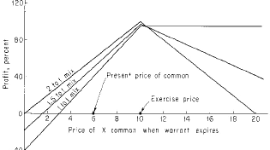

*Figure 4.1. Basic-system profit as per cent of original investment for mixes of 1 to 1, 1.5 to 1, and 2 to*

*1. Eighteen months before expiration, warrants of hypothetical company X are at 3 and the common is at*

*6. Exercise price is 10. Warrants are sold short and common is purchased at these prices, with the plan of liquidating the entire position just before expiration. Initial margin of 3 for the warrant and 5 for the com- mon are assumed. Gains from intermediate decisions or from reinvesting profits are ignored, as are trans- actions costs.*

as *roughly* equal to the short-sale proceeds of about $300. (This happens, for instance, if the common at expiration is unchanged in price.) We have put up $300 initial margin for the 100 warrants short at 3. For 100 common long at 6, we ned $420 if initial margin is 70%, for a total original investment of $720. We realize a 42% profit on the $720 in 18 months. This is 28% per annum. Chapter 7 shows that this annual rate of return has been typical of the basic system.

The surprising results of simultaneously buying common and shorting overpriced war- rants may be easier to grasp from another

point of view. Table 3.1 showed that it was on average a good investment to sell warrants short. However, there was the risk of severe losses. We also remarked (page 33) that com- mon stock has tended historically to rise at a rate of about 9 to 11%, and that buying com- mon long therefore tends to be a good but risky investment. We have mixed these two good but risky investments together. The result is a good investment which is now comparatively safe. The risks cancel out.

A stock and its warrant tend to go up and down in price together. If the stock and war- rant both go up, the loss in the short position in the warrant is largely covered by the gain in the common. If the stock and warrant both go down, the loss in the common is approximate- ly covered by the gain in the short position. thus day-to-day or week-to-week violent fluctu- ations in stock price generally have comparatively little effect on the hedged investment.

A properly hedged portfolio seldom shows much loss; the equity may be recovered, with little loss and generally a profit, at any time. What other stock market investment com- bines such safety with an average yield of 25% per annum?

### Changing the Mix

In the previous example, we shorted one warrant for each share of common that we were long. The number of adjusted warrants short, per share of common, is called the **mix**. The mix above was 1.0, or one to one. Other mixes are of course possible and lead to different types of protection.

As an illustration, suppose we instead short 300 warrants at 3 and go long 200 shares of common at 6, a mix of 1.5, or three to

two. Figure 4.1 shows the profit situation. Neglecting commissions, the 1.5 mix insures a profit if the common is anywhere between 1fi and 27 just before expiration. The common must fall to less than one-fourth its price, or increase more than 4.5 times, before we have a loss. Stocks seldom have changed so violently in price in 18 months. However, it does hap- pen, and later chapters will tell us how to protect against such losses.

Our initial investment is $840 (long margin) plus $900 (short margin), or $1,740. Experience shows the average return is likely to be about $900, for a profit of about 52% in 18 months, or about 34% per annum.

Figure 4.1 also indicates the profit with 200 warrants short and 100 common long. We have a profit if the common is anywhere between 0 and 20 at expiration. The investment of

$1,020 returns on average about $600. This is 59% in 18 months, or about 40% per annum.

### Deeper Insight into the Basic System

Effects of the various possible mixes are illustrated in the warrant-stock diagram of Figure

4.2. The heavy dot represents the stock and warrant prices 18 months before expiration. The normal price curves for 12 months, 6 months and 3 months are shown. These curves are heaviest where the future warrant-common price point is most likely to fall. The dashed **zero profit lines** are included for mixes of 2.0 to 1, 1.5 to 1, and 1.0 to 1. When the point repre- senting the current stock and warrant prices is below a zero profit line, a portfolio with that mix shows a profit. For instance, when the mix is 1.0, the portfolio with that mix shows a profit. For instance, when the mix is 1.0, the portfolio shows a profit at expiration if the price of the common is more than 3; for a mix of 1.5, the portfolio shows

a profit at expiration if the common is between 1fi and 27; and for a mix of 2.0, the portfo- lio shows a profit at expiration if the common is above 0 and below 20.

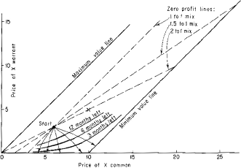

*Figure 4.2. Constant profit lines for various mixes, and portfolio behavior in time. Arrows from “start” to minimum value line indicate a few of the possible future price actions of the stock and warrant.*

To draw the zero profit line in Figure 4.2 for a two-to-one mix, locate one guide point as follows. go right 2 steps from the warrant-stock point, then up 1 step. A step can be any size. The crosses mark two such guide points, one obtained by going over 4 and up 2 (so a step was 2), and the other obtained by going over 10 and up 5 (so a step was 5). Now place a ruler so the edge is over both the warrant-stock point and a guide point. The ruler edge indi- cates the zero profit line.

To get the zero profit line for any mix M, simply go over M

steps and up 1 step to locate a guide point. Then use the ruler as before.

### The Basic System: Preview

The basic system sells overpriced expiring warrants short while hedging by buying common. In Chapter 5 we trace through Sheen Kassouf’s highly profitable basic-system operations. In Chapter 6 you pick out situations and begin your own portfolio. You learn which expiring warrants should be sold short and how to pick the best mix for hedging. In Chapter 7 we show that $10,000 invested in the basic system in those fifteen years when it was useable between 1945 and 1965 would have made more than $500,000. This is equivalent to a rate of 25% per year, compounded annually.

### An Incredible Meeting

In Chapters 1 and 2 we saw how the authors were each led to large, consistent profits through warrants. By coincidence they came from their separate universities to the new Irvine cam- pus of the University of California in the summer of 1965. There they met, perfected the basic system, and extended their methods to the whole area of convertible securities. (**Convertibles** are securities which can be changed into other securities; the addition of cash may be required. They include warrants, convertible bonds, puts and calls, convertible pre- ferreds, and rights.) This book is based on that research.

*Chapter 5*

# THE SYSTEM IN ACTION

## $100,000 Doubles

From 1920 to 1940 it was easy to make a lot of money in the stock market with the Gridiron Method:

1. If the loser of the Harvard-Yale game failed to score, buy stocks.
2. Disregard rule 1 if in the same year California and Army had the same score in their games with Stanford and Navy.
3. If California beat Stanford, sell stocks the following year.

Without going into the rest of the absurd details [writes Robert A. Levy ([13], pp.

13-14) in his doctoral dissertation] it is interesting to note that . . . this “system” [was] very profitable . . . from 1920 to 1940.

With hindsight, thousands of such “profitable” systems can be devised. But if the rules seem arbitrary, with no logical connection, then only a naïve or superstitious investor would invoke the system.

In contrast, we now detail *actual* transactions employing the commonsense rules of the basic system. We show how the investments made by Kassouf and his brothers returned about 25% a year.

### The Molybdenum Story

I first purchased Molybdenum common shares and sold short the warrants in October 1961. Though I had much to learn about the detailed tactics in placing orders and analyzing situa- tions, it was my first worry-free investment. I looked forward to each day’s price movements with extreme curiosity and interest, but without fear that prices might move against me. Within wide limits, I expected to profit no matter how stock prices changed!

By the end of December 1961, I had purchased 150 shares of “Moly” common at an average price of 33 and sold short 400 warrants at an average price of 18. The warrants were to expire in less than 22 months and were exercisable at $28.83. (The warrants then trading entitled the holder to purchase 1.0406 common shares for a total price of $30.) My total investment to this point was about $8,500.

Looking ahead to October 18, 1963, when the warrants were to expire, I reasoned that I could not lose unless the common rose beyond 52. In fact, even if the common stock became worthless, this investment would return 26%!

Figure 5.1 summarizes the potential of this initial investment. The maximum profit would result if the common was at $28.83 on the date of expiration:

|  |  |
| --- | --- |
| Profit on short sale of 400 warrants at 18 | $7,200.00 |
| Loss on 150 common long at 33 | 625.50 |
| Total Profit on Investment | $6,574.50 |
|  | (77%) |

By similar calculations, if the common became worthless, this investment would yield

$2,250, or 26%.

Pessimistic about the fortunes of Moly, we weighted our investment to pay off hand- somely in the event the stock dropped. This pessimism seemed justified early in 1962 when most stocks,

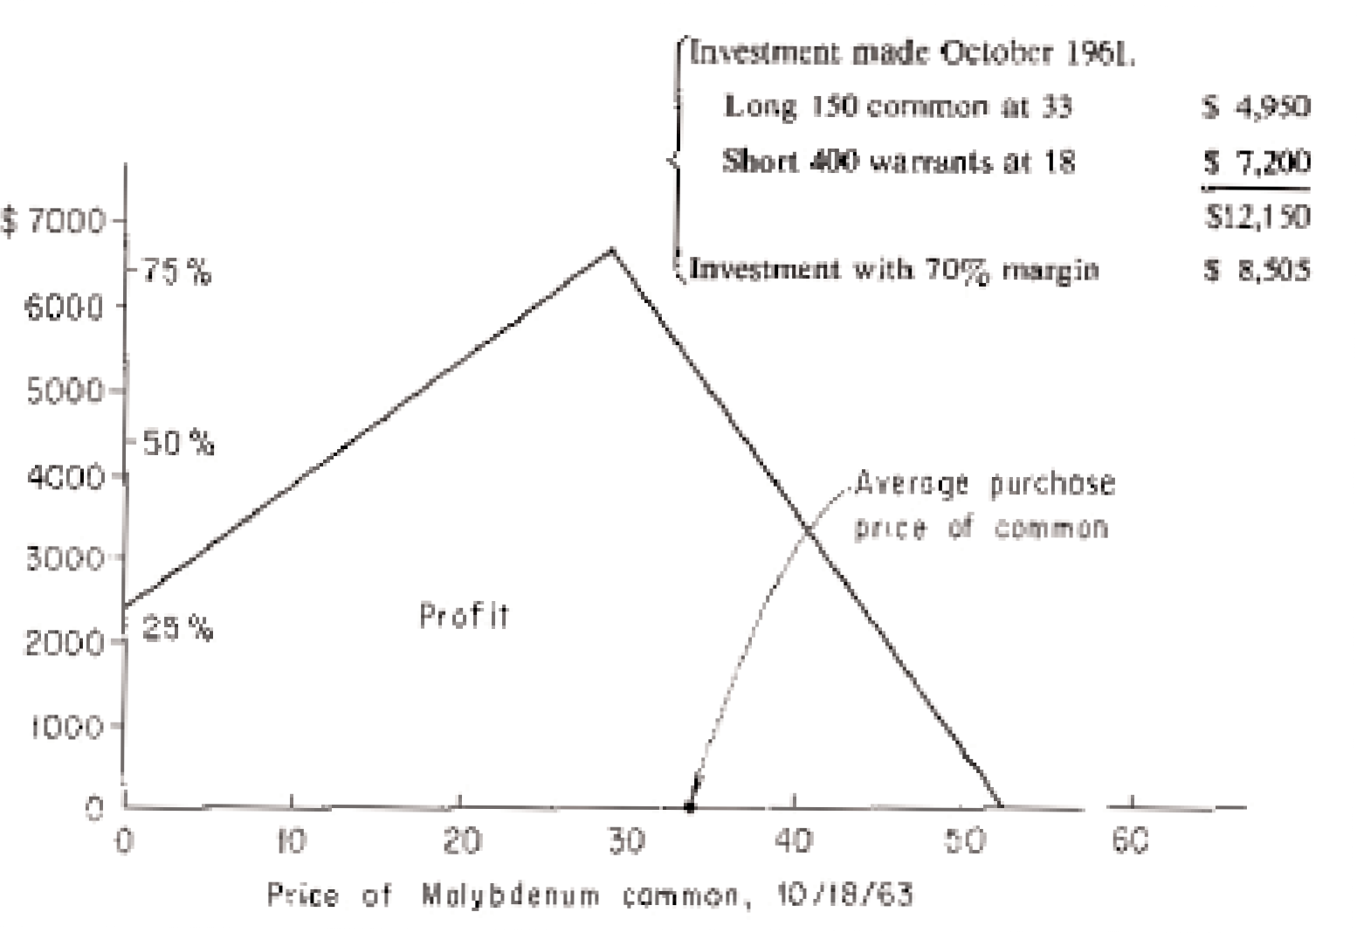

*Figure 5.1. Profit potential of investment in Molybdenum.*

including Moly, began to drift lower. We continued to short warrants until we were long 150 common and short 1,300 warrants.

Late on the afternoon of Friday, March 23, the common stock traded heavily and closed at 335/8 up 5fl; the warrant closed at 16fl up 3fl. One broker explained, “Somebody knows something.” Wall Street observers often advance mankind’s knowledge with such insights.

There were rumors Monday of a “new process” involving Moly’s “rare earths.” In Tuesday’s *Wall Street Journal*, A. L. Nickerson, Chairman of Socony-Mobil, denied that Moly was supplying Socony with ingredients for a newly announced catalyst used in oil refining. Despite this denial and despite the silence from

Moly’s officers, the stock and warrant held ground while most stocks weakened. On April 5, the common rose 2⁄, to 39. An article in the *Oil and Gas Journal* glowingly discussed the company’s new catalyst for gasoline refining and its implications for future earnings. The warrants also rose 2⁄, to 20fi.

On Friday, April 7, the averages were lower again but brokers were talking about a “consolidation.” In *The New York Times* Burton Crane quoted an analyst of “long experi- ence”: “One thing that must impress us all is that this market does not want to go down . . . I am convinced that we are not going to break through our January lows.” Within months the market would suffer its second worst drop of the century. On this day Moly touched 40 and the warrants 22⁄.

In early 1962 we took some profits in the Molybdenum situation by selling common but our position was risky. We now wished we had more common relative to the warrants short. We decided to wait until after the company’s stockholders meeting on Tuesday, April 10, before adjusting the mix of warrants short to common long.

The meeting was set for 10:00 A.M. in the fashionable Sheraton East Hotel in New York. I arrived early and sat in the front row of a large banquet room filled with folding chairs. On a raised platform was a long table with a white tablecloth, nameplates of the direc- tors, ashtrays, pitchers of water, podium, and microphone. The room filled. Members of the press stood on the side. The directors filed in and sat down, including Admiral A. W. Radford who sat directly in front of me. Throughout the meeting he was silent, staring mostly at the table in front of him.

Chairman Marx Hirsch rose, greeted everyone, and brought the meeting to order. His mild mannerisms and soft, croaky voice

evoked surprise and sympathy. This was not a suave, articulate tycoon. He was a dedicated man who had faith in the future of his company and the potential uses of exotic metals. In answer to a question about the “new catalyst” and the “secret process” he smiled broadly. He looked first left, then right, at his directors (some returned his knowing smile), and said he could not comment because of confidential negotiations.

The stockholders persisted; could give them some indication of what this may mean for the company’s earnings? “Be patient,” he said, holding his hands up in front of him as if to physically push back encroaching hordes, “it won’t be long before every one of you will be riding in a Rolls-Royce.” Unable to restrain themselves, stockholders began elbowing each other and mumbling about their good fortune. One shouted from the rear of the room, “Does that apply to a one-hundred share owner?” Bursts of nervous laughter, while Mr. Hirsch raised his glass to sip some water. Admiral Radford raised his head to glance out over the audience. He seemed slightly amused but his incipient smile never quite broke into a grin.

Little information was presented and I sensed some disappointment when the meeting was over. I expected the common stock to drop on the lack of news, but the hopes and opti- mism of investors can apparently be fed for long periods on an occasional mysterious wink from someone who “knows.” The stock remained steady amidst weakness in most other stocks.

But forces were not at work that would soon panic the financial community. In the morning, Marx Hirsch promised his stockholders Roll-Royces; in the evening Roger Blough promised the nation a rise in steel prices. Many now claim that President Kennedy’s violent reaction–he accused “a tiny handful of steel execu-

tives” of showing “utter contempt for the interest of 185,000,000 Americans”—spread pes- simism and doubt among businessmen.

Whatever the cause, fear turned to panic. Prices fell with sickening speed. On “Blue” Monday, May 28, 1962, even Molybdenum, which one broker a few weeks earlier said was “in a bull market of its own,” was carried by the tidal wave. Molybdenum fell 45/8, to 277/8, and the warrant fell 43/8, to 151/8, at the close of trading. The New York Stock Exchange tick- er did not flash its last price until 5:59 P.M., two and a half hours after the market closed.

The following day 14,750,000 shares traded on the New York Stock Exchange, the sec- ond most active day on record—1,032 issues made lows for the year and just 2 stocks made highs. The ticker printed its last price at 8:07 P.M.

A few days before “Blue” Monday, we sold short 200 Moly warrants in an account at a medium-sized brokerage house that catered primarily to substantial accounts. This firm had no ground-floor offices and little interest in small investors. Three weeks later I received an anxious call from the broker informing me that we were about to be bought-in to cover the 200 Moly warrants we shorted. He claimed he had to return the warrants to the lender. Ordinarily he would borrow them from someone else. He said he couldn’t do this because they were scarce. when we were bought-in at 15 he tried to make this sound like a coup—we had sold them short at 20 and in three weeks made $1,000. But our expectations were much higher. In fact, a week after we were bought-in at 15, the warrants fell to 10⁄. However, the house that handled the bulk of our transactions assured me that there would be no buy-in. They still had several thousand warrants available for selling short. The incident led me to learn in detail how short sales are executed.

Recall from Chapter 3 that when a security is sold short, the seller must borrow the cer- tificate from an owner. When an order is placed to sell short, your broker will first search his inventory of securities (mainly those held for his clients). These securities are generally kept in a secure room with walls of steel wire mesh (cage room) and the custodian of these secu- rities is the cage man. Most securities held here are in a street name—that is, in the name of the broker—although all beneficial rights accrue to the client. All securities purchased on margin are kept in the cage and many securities purchased in cash accounts are kept there for safekeeping.

A client who opens a margin account allows his broker to lend securities he purchases. Many cash-account clients also allow their broker to do this. The client is safe because the broker lends these securities only if the borrower puts up in return full cash value as collat- eral. If the security should rise in price, the account is market to the market, as described ear- lier.

After you place an order to sell short, and often not until after it has been executed on the floor of the exchange, your broker asks his cage man if the firm has physical possession of the securities. If so, these securities are delivered to the buyer in the short-sale transaction and the proceeds are credited to your short account. (The short account is explained in Chapter 11.) In accordance with Exchange regulations, your broker does not pay you inter- est on these funds. He has the free use of these funds during the entire time you are short. This reduces the amount he must borrow from banks and other institutions, saving him inter- est charges. This gives him a clear incentive to sell short for his clients’ accounts when the securities are in his cage.

If the securities are not in his cage, his loan clerk borrows them from another broker.

Then he must deposit with the lend-

ing broker the entire proceeds from the sale as collateral and your broker does not gain the use of interest-free funds. The lending broker, of course, does use this collateral at no cost to him. Therefore, your short sale is less profitable for your broker when he must go outside to borrow the certificates to execute your short sale.

In practice, the loan clerk, who is responsible for locating securities, calls loan clerks in other brokerage houses. Depending on his stamina and persistence, he may call many loan clerks in search of the certificates. Usually he develops a relationship with some loan clerks, perhaps as few as two or three, and if they cannot accommodate him, he says the securities are unavailable for loan. If the short sale has actually taken place, the buyer will demand his certificates. If they are not delivered in four business days, the buyer may then *buy-in* the cer- tificates by purchasing them and billing the short seller through his broker.

Often an issue is “scarce” because the loan clerk lacks energy or contacts. In June 1962 the broker who bought-in the 200 Molybdenum warrants he had sold short did not have the certificates in his cage, and his loan clerk did not contact any house that would lend them. When we understood what had happened, we concentrated our activities at a firm with a large inventory of the warrants. It taught us an important rule: *determine the broker’s inventory before selling short any security*. In some future operations this required opening accounts at different houses, for often, though a firm had a large inventory of one security, it had little or none of another. We were doing the work of the loan clerks in locating supplies of certifi- cates.

A week after we were forced to cover 200 warrants at 15, the warrants fell to 10⁄. We covered more warrants voluntarily, at

prices below 11. We decided that if the warrants fell below 10, we would close out the entire investment for a very substantial profit in none months’ time.

Late in June the “veteran analysts” who a few months earlier could see no impending disaster now said that the recent slide was only the start. Pessimism spread world-wide as foreign exchanges mirrored Wall Street. Perversely, the stock market rose in the face of the gloom and doom emanating from political and business analysts. Moly common and warrant joined this rise and by mid July the common was at 26 and the warrant at 15. On Thursday, July 19, the warrants reached 171/8; on Friday they climbed above 19, with the common at

28. The warrants were to expire in 15 months and the common stock was trading near the exercise price. If the common did not advance from 28, holders of the warrant would see their

$19 vanish. Furthermore, without a 65% rise in the common, to 46, the warrant holders would lose. Only if the common advanced beyond 84, a rise of almost 200%, would the hold- er of the warrant fare better than the holder of the common. (If the common were 84 on the date of expiration, the warrant would be worth 573/8, about 200% more than 19.)

Perhaps the investors who were buying the warrant were unaware of the terms of con- version and were unable to make simple arithmetic calculations. This proved false. Lewis Harder, President of International Mining, was aggressively purchasing the common stock and the warrant. By early August, International Mining held 36,300 warrants. (Kennecott Copper Corporation held 14,285 warrants; these two holdings accounted for 27% of the 186,000 outstanding warrants.)

When the source of the buying was discovered, rumors spread that a short squeeze was being attempted. A **short squeeze** occurs

when one person or group gains possession of virtually all the certificates of a security which many have sold short. (This is called cornering the market.) Then, by demanding return of the borrowed securities, this person or group forces the short sellers to buy them back at once. Since the group has cornered the market, the short sellers must buy from them and pay whatever they demand. A few years earlier, Eddie Gilbert, the colorful financier who later took refuge in Brazil because of ventures that backfired, had cornered the market in the stock of E. L. Bruce, driving its price from 17 to 195.

Gilbert’s short squeeze was well remembered. In a *New York Times* interview of July 28, Mr. Harder claimed he had no intention of getting anyone “in trouble”; he was only inter- ested in eventually converting the warrants. Since simple calculations show that an astute, knowledgeable person wanting the common would not buy and convert the warrants, this strengthened the rumor that a short squeeze was in progress. Many chose to help corner the market in Moly warrants. On Monday, July 30, the warrants reached 24 and the common 32. On Tuesday, during a brief and intensely active opening hour, the warrants touched 25 and the common 33. But from there, it was all downhill for the warrant. In the next few weeks the common advanced to about 34 while the warrants fell to 19.

The American Stock Exchange, fearful of another Bruce incident, asked its members in late August to begin reporting short positions in Moly warrants weekly, rather than monthly. This scrutiny may have caused Harder to sharpen his pencils and make a new evaluation of the warrant. The Securities and Exchange Commission reported that International Mining *sold* 22,600 Moly warrants in August and *purchased* 26,253 shares of common. In

September, International Mining sold another 13,700 Moly warrants and purchased an addi- tional 14,399 common shares. The common fell to 25 and the warrants to 11.

In early February, I called an officer of a company with large Moly warrant holdings. Did they plan to hold them until expiration, hoping then that the common would be selling close to 50? Only if the common advanced to that figure in the remaining 8 months could possession of the warrants rather than the common be justified.

The officer seemed unaware of his company’s Moly warrant holdings. But he recov- ered quickly, assuring me that it was in his shareholders’ best interest to retain the Moly war- rants.

Perhaps the company reconsidered, because two days later the warrant dropped almost 50%, to 5, on heavy volume while the common was steady at about 25. At this time I had developed estimates of the price at which a warrant tends to sell. At 5, the Moly warrant fell below its normal price for the first time in over a year. We had a handsome profit in 16 months so we closed out our holdings. Our average monthly cash investment had been

$11,500 and our total profit was $6,435, a return of 56%, or about 42% per annum. Several others who were now imitating my investments had similar profits.

### Moly Coda

When the Moly warrant again rose above its normal price, in May, we sold short 100 war- rants at 7fi. Then the American Stock Exchange banned further short sales in the Molybdenum warrant. They have since done this a few months before expiration for most warrants.

We remained short until a few days before the warrant expired and covered at $1—a gain of $650 in 6 months on an investment of $500. This illustrates what we later learned to be fact: *the rate of gain in using the basic system is greatest when the warrant is close to expiration*. (See Appendix E.) Chapter 6 shows how to choose the proper time to go short for maximum profit yet well before the American Stock Exchange might ban short sales.

### Bunker-Ramo (Teleregister)

In March and April 1963, Teleregister beckoned. (Many of my clients took positions here but I detail only my own and my brothers’ actual transactions.) Teleregister manufactured elec- tronic data processing equipment. It also owned and leased the large stock-quotation boards in brokerage offices throughout the country. In glorious 1961, when the word “electronic” was the philosopher’s stone, the stock reached a high of 34. The 1962 crash pummeled the stock to 33/8. It had a warrant traded on the American Stock Exchange due to expire on May 1, 1965. The warrant was exercisable at $15 through May 1, 1963, and at $17 thereafter to expiration.

Generally you will be “neutral” about the common stock; that is, you will consider the likelihood of its rising about equal to the likelihood of its falling. However, when applying the basic system, you may wish to use a prediction for the common stock. When you use the basic system, your prediction for the common can prove totally wrong while your investment nevertheless experiences a huge gain.

In estimating the future price of this stock, I noted that the officers and directors, the “insiders,” bought the stock in the open market consistently after the summer of 1962. By early March

they had purchased about 20,000 shares at an average price of about $5—an investment of about $100,000. Insider transactions, of course, do not always foretell the movements of a stock.

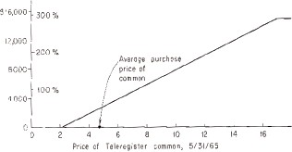

*Figure 5.2. Potential profit on Teleregister investment, April 1963. 1,000 shares common long at 4fl and 1,000 warrants short at 23/8. Total investment was $5,041.*

Insiders have been known to make gigantic miscalculations. Nevertheless, because of this insider activity and because of the feeling that electronics might become glamorous again, my estimate was that the common was more likely to advance than decline in the next two years. We therefore chose a mix that gave more protection on the up-side than on the down- side.

By April we were long 1,000 shares of common at an average price of 4fl and short 1,000 warrants at an average price of 25/8, for a total investment of $5,041. Figure 5.2 is a profile of our profit potential for a two-year period. There could be no loss if the stock advanced, even beyond $1,000 a share, and a loss would occur only if the common fell below 21/8. If the stock was still at 4fl on the date of expiration, the investment would return about

$2,600, or more than 50%. If the stock advanced to 17 or more, the investment would yield about $15,000, or about 300%. In the following two years we shifted this position from time to time primarily by selling common stock and shorting additional warrants as they rose.

As an example of the avalanche effect, described in Chapter 4, the following transac- tions were recorded in a separate account. On June 2, 1964, we shorted 400 Teleregister war- rants at 51/8. The warrants steadily declined from this point and on July 29 an additional 200 warrants were sold short in the same account at 3fi without depositing any additional margin. When the warrants fell from 51/8 to 3fi, enough purchasing power was generated to sell short the additional 200 warrants. Of course, if one had been sure that the decline would be con- tinuous, more warrants should have been shorted at every possible opportunity.

Soon after the additional 200 warrants were shorted, we received a margin call. When we protested, the margin clerk recalculated and still claimed margin was required. Finally, however, when the head margin clerk tallied the account, he was satisfied that no margin was needed. This once again indicated that we must constantly check our own accounts and not blindly accept the statements of brokerage houses. (In fairness we point out that calculations in a **mixed account**, namely one short and long simultaneously, may not be simple. Such an account is often complicated by the margin requirements on low-priced issues. Our experi- ence indicates that margin-clerk errors are unbiased; their errors seem to be in our favor as often as not. Chapter 11 shows you how to keep track of your account at all times.)

These 600 warrants in the separate account were covered in the succeeding months at an average price of $1, so that a $2,000

investment more than doubled, even though the warrants were covered before they expired. In the summer of 1964, Teleregister was reorganized and became known as Bunker- Ramo. At a party in December 1964, an in-law chided my brother for not opening an account with him. My brother said he would be happy to—would he inform him the next day of their inventory of Bunker-Ramo warrants? We received a call the following day that 1,000 war- rants could easily be shorted. In a week we shorted the 1,000 warrants at 2fi. Less than 5

months later we bought these warrants back at a price of 1/32, about three cents each.

For the 26 months we were involved with Bunker-Ramo (Teleregister), our average monthly investment was $3,500. Our total profit was $8,964, an increase of more than 250%, or about 120% per annum.

### Catskill Conference: Sperry Rand

Late in the summer of 1962, with the Molybdenum warrant expiring in a year, we had to plan for the future. I turned to the Sperry Rand warrant.

During the hot, steamy Labor Day weekend my wife and I sought relief in the Catskills.

One night we met my brother in a resort dining room, where I tested my ideas on him.

Sperry Rand Corporation, with sales of more than $1 billion yearly, resulted from the merger of Remington Rand and Sperry Gyroscope. This giant company produced business machines, the Univac electronic computers, instrumentation and controls, farm equipment, and consumer goods. The common stock, at 24 earlier in the year, fell to a new low of 14 in late September. The losses of

the Univac Division depressed earnings; the cash dividend was eliminated. The stock was far from its all-time high of 34, made in the halcyon days of 1961.

The Sperry Rand warrant plus $25 could be converted into 1.08 shares of common until September 15, 1963, after which time conversion would require $28. The warrant expired in five years, on September 15, 1967. Earlier in 1962 the warrant traded at 14 and in late September it had fallen to 8. I planned to exploit an apparently large premium. Again I decid- ed it would be profitable to purchase common and sell short warrants. And again, some judg- ments were made about the probable future course of the common stock.

I told my brother the crash of May–June 1962 might develop into a disaster similar to 1929. It was necessary to estimate the worst calamity that might overtake Sperry in the ensu- ing five years. This company, vital to our national defense, had book value of about $10 a share. (Book value is a rough indication of the value of the assets of a company, less its debts.) I estimated that in the event of a true disaster, the common would not decline below 6, less than half its current price.

It was difficult to put a ceiling on how high the common might move in five years. If Univac became a true competitor to IBM, and if defense-oriented stocks became fashionable again, Sperry might rise beyond 100 before the warrant expired.

With these considerations, we planned to sell short one warrant for every share of com- mon purchased. Suppose such an investment were made and not altered until the day of expi- ration. Margin requirements were then 50%, so buying 100 common at 14 required $700 and shorting 100 warrants at 8 required a deposit of $500, a total of $1,200. Although the entire investment

would be margined 50%, the actual amount borrowed from our broker would be only $200. Our interest charges at 5% would be $10 a year.

If the “worst” happened in five years and the common fell to 6, this investment would lose $800 on the short sale of the warrant, for no net loss. We ignore interest charges because as the warrant falls, marking the account to the market would eliminate our debt. If the com- mon stock fell 65%, the investment was still safe from loss.

If the common stock ended at 14, then the purchase of the common would show nei- ther profit or loss. There would be a profit of $800 on the short sale of the warrants, for a net profit of $800, or 67%. That is, if the common neither rose nor fell, this investment would return 67%. Suppose the common were to double, and rise to 28 on expiration date. The war- rant would then sell for about 2⁄; the profit on the common would be $1,400, and the profit on the warrants would be $575, for a total profit of $1,975, or 165%. (This again ignores interest charges.) In fact, this investment would yield a profit unless the common advanced beyond $200 a share. (See Figure 5.3.)

In this analysis we neglected the possibility of changing the mix during the five-year period until expiration. In practice, decisions made at intermediate times with changing cir- cumstances can further increase profits. For instance, if it seemed that the stock would fall below 6, some common could be sold *before* it happened, thus cutting the possible loss. And if the common were nearly stationary while the warrant drifted lower, the excess purchasing power could be used to short more warrants or to buy more common, or both.

During the next 47 months, we had an average monthly invest-

ment of $40,000 committed to Sperry Rand. In this period, Sperry ranged between 11 and 28. Our accumulation of about 5,000 shares of the common was mostly at prices below 15, and our

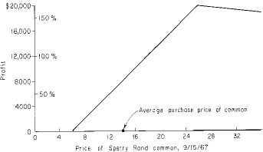

*Figure 5.3. Potential profit on Sperry Rand investment, September 1962. 1,000 shares common long at 14 and 1,000 warrants short at 8. Total investment was $12,000.*

short sale of about 7,500 warrants was mostly at prices above 8. As the common rose in late 1964 and 1965, we sold some common and shorted additional warrants without additional funds. In December of 1965, for instance, the common moved to 22 and the warrants to about

11. For every share of common we sold we were able to sell short 2 warrants without addi- tional funds.

In July 1966, after Univac reported a profitable quarter and many mutual funds became attracted to Sperry, the common moved to 28. But the warrants lagged at 10, now below nor- mal price. It was possible that the common might remain at 28 and the

warrants explode to 14 or 15 in the near future, or for the common to decline substantially, with the warrants remaining at 10. either situation would erase some of our profits. If instead the common continued to rise, then ultimately our investment would not yield any more prof- it than already realized. We therefore closed out Sperry. If the warrant again became over- priced, we would take a much larger position with a still larger profit potential. By July 1966 our Sperry profits were $50,150 after costs and commissions, equivalent to 23% per year compounded.

Our total net profits in these three situations—Sperry Rand, Teleregister, and Molybdenum—were $66,200. In addition there were profits from extensions of the basic sys- tem in National Tea, Universal American, Pacific Petroleums, and Realty Equities.

Our total profits in all of these stock market situations were about $85,000 by October 1966—five years after the initial investment in Molybdenum. We earned more than 25% per year on our investments. The profits of a few friends who had made similar investments car- ried this total beyond $100,000. Furthermore, during this period over a hundred investors sought investment advice from me. It is almost impossible to calculate their profits during these five years, but it is conceivable that many hundreds of thousands of dollars were dou- bled.

*Chapter 6*

# HOW TO USE THE BASIC SYSTEM

### Identifying the Listed Warrants

The basic system shorts expiring overpriced warrants, reducing risk by purchasing common at the same time. Warrants are not traded on the New York Stock Exchange but 15 or 20 war- rants are generally listed on the American Stock Exchange. More than 100 warrants are trad- ed over-the-counter or on regional and foreign exchanges.

We first consider warrants listed on the American Stock Exchange (AMEX). We dis- cuss later the advantages of trading these rather than over-the-counter or on the other exchanges. Table 2.2 gives listed warrants and their terms as of July 21, 1966. The latest issue of the American Stock Exchange handbook of commission tables includes a complete list of AMEX warrants with updated terms. Your broker should have a copy, or you may inquire from the publisher, Francis Emory Fitch, Inc., 138 Pearl Street, New York, New York 10005. You can also make a list directly from the financial pages, provided that they are complete; we suggest that you subscribe to and use the Wall Street Journal. If you have it or

an equally good paper available, scan the AMEX listings for securities followed by

“wt.” Check both the securities which traded on the day covered and the separate tabulation of securities which are listed but did not trade. The warrants given in Table 2.2 were obtained from the newspaper and checked against the AMEX handbook.

If the AMEX handbook is not available or if you want to cross-check the informa- tion, you can find expiration dates, exercise price, and other important facts about listed war- rants in the recent Standard & Poor’s fact sheets for the company which issued the warrant. These are available from your broker.

The terms of the warrants and their history are given annually in *Moody’s Manuals*. These manuals are usually available at brokerage houses or larger public or university libraries. We have found errors in these sources; if much is at stake, get the information directly from the bank which acts as transfer agent for the company, as given in Moody’s.

### Picking Short-Sale Candidates

When you know the expiration date for each warrant, *limit yourself to those warrants which expire in less than four years*. These warrants are the most likely to yield substantial short- sale profits. For instance, on July 21, 1966, the listed warrants (as given in Table 2.2) which expired in less than four years were Mack Trucks (September 1, 1966), Rio Algom (December 31, 1966), Universal American (March 31, 1967), Sperry Rand (September 15,

1967), Pacific Petroleums (March 31, 1968), Martin Marietta (November 1, 1968), General

Acceptance (November 1, 1969), and United Industrial (November 15, 1969).

Some months earlier the Exchange banned short sales in Mack

Trucks warrants, eliminating them as a basic-system candidate. The Exchange often bans short sales of warrants which are a few months from expiration and which have a large short interest, perhaps to protect short sellers against a squeeze, or corner.

When we checked all listed warrants from 1946 to 1966, we found that *if the stock is selling at more than 1.2 times the adjusted exercise price (in other words, at more than 20% above the adjusted exercise price), shorting the warrant is usually unprofitable*. According to Table 2.2, the adjusted exercise price of the Martin Marietta warrant was 16.48 shows that the stock is at 1.43 times adjusted exercise price, which eliminates the Martin Marietta warrant. Similar calculations show that United Industrial stock was selling at 1.42 times exercise price, so it too is eliminated.

### Using the Warrant-Stock Diagram

The remaining warrants under consideration (General Acceptance, Pacific Petroleums, Rio Algom, Sperry Rand, Universal American) cannot be directly compared because they have different unadjusted exercise prices. The next step in selecting a warrant for the basic system is to standardize all warrant and stock prices. This allows us to pictorially compare warrants in the warrant-stock diagram.

Consider the General Acceptance warrant, which with $20 is convertible into one share. Every dollar of the exercise price goes toward the purchase of 1/20 of a share; thus we can consider $1 the exercise price of 1/20 of a share. In this way we can reduce *any* exercise price to $1 by calculating the fraction (or multiple) of a share that may be obtained with $1. With this standardized exer-

cise price of $1, we are not now interested in the current price of *one* share of the common stock, but the current price of 1/20 of a share. This is obtained, of course, by dividing the cur- rent price of the common by 20. For example, if the current price of the

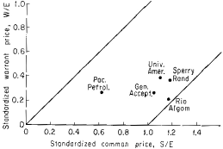

*Figure 6.1. Position of basic-system candidates in warrant-stock diagram. (See calculations and data in Table 6.1.)*

common is 21, then the standardized common stock price is 21/20, or 1.05. We designate the standardized common stock price by S/E and *calculate it by dividing the price of the com- mon by the adjusted exercise price*.

To purchase 1/20 of a common share of General Acceptance we don’t need one war- rant; we only need 1/20 of a warrant. Therefore the price of that fraction (or multiple) of a warrant which with $1 can be converted into 1/20 of a common share is called the standard- ized warrant price. *It is designated by W/E and is calculated by dividing the adjusted war- rant price by the adjusted exercise price*. (Note that the warrant price must first be adjusted before dividing by the adjusted exercise price.)

In Table 6.1 the standardized prices, S/E and W/E, are

calculated for the five basic system candidates still under consideration. Columns 6 and 7 of this table are used to plot the position of the warrants in the warrant-stock diagram, Figure 6.1.

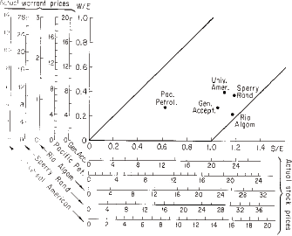

*Figure 6.2. Basic-system candidates with their actual price scales. (See Table 6.1.)*

Rather than compute standardized prices from newspaper prices whenever the war- rant and common change in price, a scale for the newspaper price of any warrant and its com- mon can be drawn on the warrant-stock diagram. Figure 6.2, in addition to the standardized prices W/E and S/E, has the actual newspaper prices for the five candidates of Table 6.1.

To construct actual (newspaper) price scales draw lines parallel to the S/E and W/E scales, as in Figure 6.2. For the scale of actual common prices mark off the price of 0 direct- ly below the 0

*Table 6.1. Calculation of standardized prices, S/E and W/E, for warrants which were candidates for the basic system on July 21, 1966.*

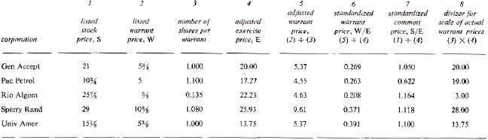

on the S/E scale. Mark off 1 on the actual price scale directly below 1/E on the S/E scale; mark off 2 directly below 2/E, etc. The scale for Rio Algom common in Figure 6.2 was con- structed in just this way. There E is 22.23 so 2 is marked off below 2/22.23, or .09, 4 is marked off below 4/22.23, or .18, etc.

To construct the scale of actual warrant prices we proceed as we did in the case of actual common prices, with one important change. Instead of dividing actual prices by E we first multiply E by the number of shares obtainable with the warrant. With Rio Algom we multiply 22.23 by .135 (see Table 6.1, Col. 8), which gives us 3.0. Now we mark off 1 on the scale of actual warrant prices directly to the left of 1/3, or .33 on the W/E scale; 2 is direct- ly to the left of 2/3, or .67, etc.

### Which are Best?

Our study of all warrants listed on the AMEX after 1946 indicated that on average the war- rant-common price relationship could be described by a curve in the warrant-common dia- gram. The position of this curve depends on many factors (see Appendix D). For instance, the less time to expiration, the lower this curve is in the diagram.

Figure 6.3 shows the average position of these curves when a warrant expired in 24 months, 18 months, 12 months, 6 months, and 1.5 months. As an example, consider the curve labeled “24 months normal price.” In the post-World War II period, two-year warrants were typically on or near this curve; if the common stock sold at the adjusted exercise price (S/E

= 1.0), then this curve indicates (see hollow circles on two-year curve in Figure 6.3) that on average the warrant sold at 43% of adjusted exercise price

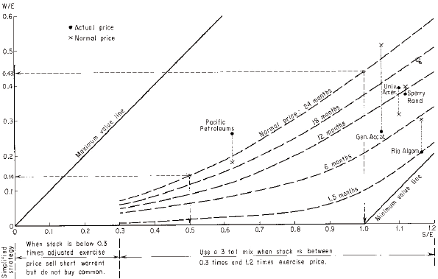

*Figure 6.3. Picking the most profitable warrants to sell short, July 21, 1966.*

(W/E = 0.43); if the common stock sold at 50% of the adjusted exercise price (S/E = 0.5), then on average the warrant sold at 14% of the adjusted exercise price (W/E = 0.14).

With Figure 6.3 we can compare the five candidates with the average price relation- ship that prevailed for twenty years. Although normal price curves are shown only for 24, 18, 12, 6, and 1.5 months, intermediate curves can be approximated by intermediate positions. For example, Pacific Petroleums warrant on July 21, 1966, expired in 20.8 months. This is almost midway between 18 and 24 months, so the 20.8-month normal price curve is about midway between the 18- and 24-month curves.

The dots in Figure 6.3 are the actual warrant positions as computed in Table 6.1 and plotted in Figure 6.2. The crosses connected to these dots by a dotted line represent the aver- age normal price of listed warrants for the years 1964–1966. The actual prices of Pacific Petroleums and Universal American warrants considerably exceeded these average normal prices; Sperry Rand was very close to the average normal price; General Acceptance and Rio Algom actual prices were substantially less than average normal prices.

This comparison of actual with normal price suggests that we eliminate General Acceptance and Rio Algon as candidates. The reason: shorting normally priced warrants in the past yielded better than average profits, so if we restrict our attention to warrants that are on or above the normal price curve, we expect the greatest profits.

Thus Universal American, Pacific Petroleums, and to a lesser extent Sperry, are quite attractive. We discuss next the choice of mix for each of these. Once this is done you will be able to divide your funds between them.

Choosing the Mix

After we choose a warrant for the basic system we must determine the mix of warrants short to common long. The bottom of Figure 6.3 indicates a working rule that has been successful: if S/E is less than 0.3, sell short the warrant but do not buy common; if S/E is at least 0.3 and at most 1.2, buy 100 shares of common for every 300 adjusted warrants sold short; if S/E is greater than 1.2, do not use the basic system at all. Chapter 7 shows that a mix of three to one on listed warrants in the 1946-1967 period could have earned a profit equivalent to 25% per year, compounded annually.

Let’s examine the basis for the rule above. We will see that a mix other than three to one may be still more desirable.

Consider the Pacific Petroleums warrant on July 21, 1966, as shown in Figure 6.4. As the prices of the common and warrant change, the Pacific Petroleums point will move around in Figure 6.4. To determine which points in this figure represent a profit from our original position, we draw a zero profit line. Then all points above the line represent loss positions and all points below represent profit positions. To draw the zero profit line for Pacific Petroleums and a three-to-one mix, refer to Figure 6.4. The zero profit line passes through the point representing our original position and it has a slope of 1/3. This means that for every 3 units we move to the right, we move up one unit.

It is usually convenient to use units of the S/E and W/E scales. The original position represents 0.622 on the S/E scale and 0.263 on the W/E scale. Three units to the right would be 0.622 plus 0.3, or 0.922, and one unit above would be 0.263 plus 0.1, or 0.363. Therefore we plot the “guide point,” which represents

0.922 for S/E and 0.363 for W/E. This is indicated by a cross in Figure 6.4. The line drawn through this guide point and the

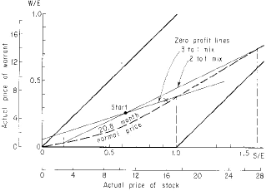

*Figure 6.4. Choosing a mix for Pacific Petroleums, July 21, 1966*

original position is labeled “zero profit line, 3 to 1 mix.” If, when the common changed price, the warrant moved along this line, then a 1 point increase in common would result in a 1/3 point increase in the warrant. If we are short 3 warrants to one common long, then the gain on the common is completely offset by the loss on the warrant.

If the warrant moved below this line, our original investment would show a profit; if above, a loss. The zero profit line slope is determined by the mix; if the mix were two to one, the slope would be 1/2.

After taking a basic-system position we would like our investment to build profits continuously, until expiration of the warrant.

Therefore, we do not want short-term changes in the price of the common to cause a loss. That is, we do not want immediate changes in the price of the common to put us above our zero profit line. To minimize this possibility, our zero profit line should have a slope about equal to the slope of the normal price curve at our starting position. Figure 6.4 shows the nor- mal price curve for a warrant with 20.8 months to expiration. It is important to note that each individual warrant has its own normal price curve (see Appendix D) and that the curve drawn in Figure 6.4 is simply the average of such individual normal price curves. Nevertheless, the slope of the Pacific Petroleums 20.8-month normal price curve will be almost the same as the slope of the average curve shown in Figure 6.4.

Notice that the three-to-one zero profit line intersects the normal price curve at about

1.0 on the S/E scale. The three-to-one line is above the normal price curve when S/E is less than 1.0, indicating that if Pacific Petroleums moved along the normal price curve in the immediate future, a basic-system position of three to one would show a profit if the common did not advance beyond 1.0 times the adjusted exercise price, or about 17⁄. On the other hand, even if the common fell to 0 in the near term, a three-to-one mix would probably always show a profit. Thus if an investor had no reason to believe that the common was more like- ly to fall than rise in the immediate future, a three-to-one mix gives him more down-side than up-side protection.

Now look at the zero profit line for a two-to-one mix. It intersects the normal price curve at two points, representing prices of 0.16 and 1.6 for S/E, or about 2fl and 27fl for the common. With a present price of 10fl for the common, a two-to-one mix seems to afford more insurance for short-term moves in either direction than does a three-to-one mix.

As S/E decreases, the slopes of the normal price curves also decrease, indicating that more warrants should be shorted for each share of common. When S/E is less than 0.3, the slopes are almost horizontal, indicating a very high mix of warrants short to common long. This leads to the simplified rule of only shorting warrants when the common is less than 0.3 times the adjusted exercise price. When S/E is between 0.3 and 1.2, the slopes of the normal price curves average about 1/3, indicating that in this range a mix of three-to-one is usually appropriate. This resulted in the simplified system detailed at the bottom of Figure 6.3.

### How Much Protection?

Zero profit lines let us quickly calculate what happens to a basic-system position if it is held until the warrant expires. Suppose that on July 21, 1966, we took a basic-system position in Pacific Petroleums by selling short 200 warrants and buying 100 shares of common. Since each warrant is 1.1 adjusted warrants, this would be a mix of 2.2 to 1. The zero profit line is shown in Figure 6.5. It intersects the minimum value line at 0.04 and 1.8 for S/E. Recall that points below the zero profit line represent a profit from the starting position. If at expiration, S/E is greater than 0.04 and less than 1.8, the position will be profitable. (We have neglect- ed commissions in this example.) This represents prices of about 3/4 and 31 for the common stock. These points are the down-side and up-side break-even points.

Whenever the mix is greater than one to one, the greatest profit results if the com- mon stock is at the adjusted exercise price when the warrant expires. In this case the great- est profit results if the common is 17.27 on March 31, 1968. The original investment is:

|  |  |
| --- | --- |
| Long 100 Pac Pete common at 10fl (70% margin) | $ 752.50 |
| Short 200 Pac Pete warrants at 5 | 1000.00 |
| Total Investment | $1752.50 |

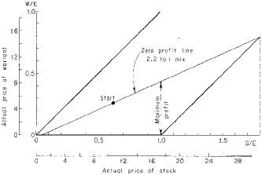

*Figure 6.5. Pacific Petroleums zero profit line, 2.2 to 1 mix.*

If on expiration the common is at 3/4 or 31, the investment will yield no profit. If the common is at 17.27, there is a profit of $652 on the common and $1,000 on the warrants for a total profit of $1,652, or 94.5% on the original investment.

These three points allow us to construct Figure 6.6 rapidly. Along the horizontal axis is measured the price of the common. The vertical axis is the percentage return on the hedge position. Above 17.27 on the horizontal axis, locate 94.5%. Connect this point with the 0% profit points on the horizontal axis—that is, the up-side and down-side break-even points. This completes the profit profile for the basic-system position of 2.2 to 1. Note that if

the common finishes anywhere between 7fi and 25, this investment will return *at least* 40% in 20.8 months, or about 23% per annum.

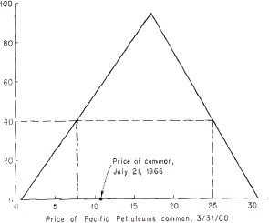

*Figure 6.6. Profit profile for 2.2 to 1 mix in Pacific Petroleums.*

A mix of more than 2.2 to 1 results in higher peak profit, and lower break-even points on both up-side and down-side. A mix of less than 2.2 to 1 results in lower peak prof- it, and higher break-even points on both up-side and down-side.

We have evaluated different mixes from two viewpoints: the effect of short-term price movements on the profit position and the range of safety implied by up-side and down- side break-even points. There is no complete prescription for an optimal mix because it varies with individual investors’ expectations for the common stock and their attitude toward risk. Venturesome inve-

tors should choose high-ratio mixes; so will investors who expect the common to decline. Cautious investors should choose low mixes; so should optimistic investors. But for nearly all combina-

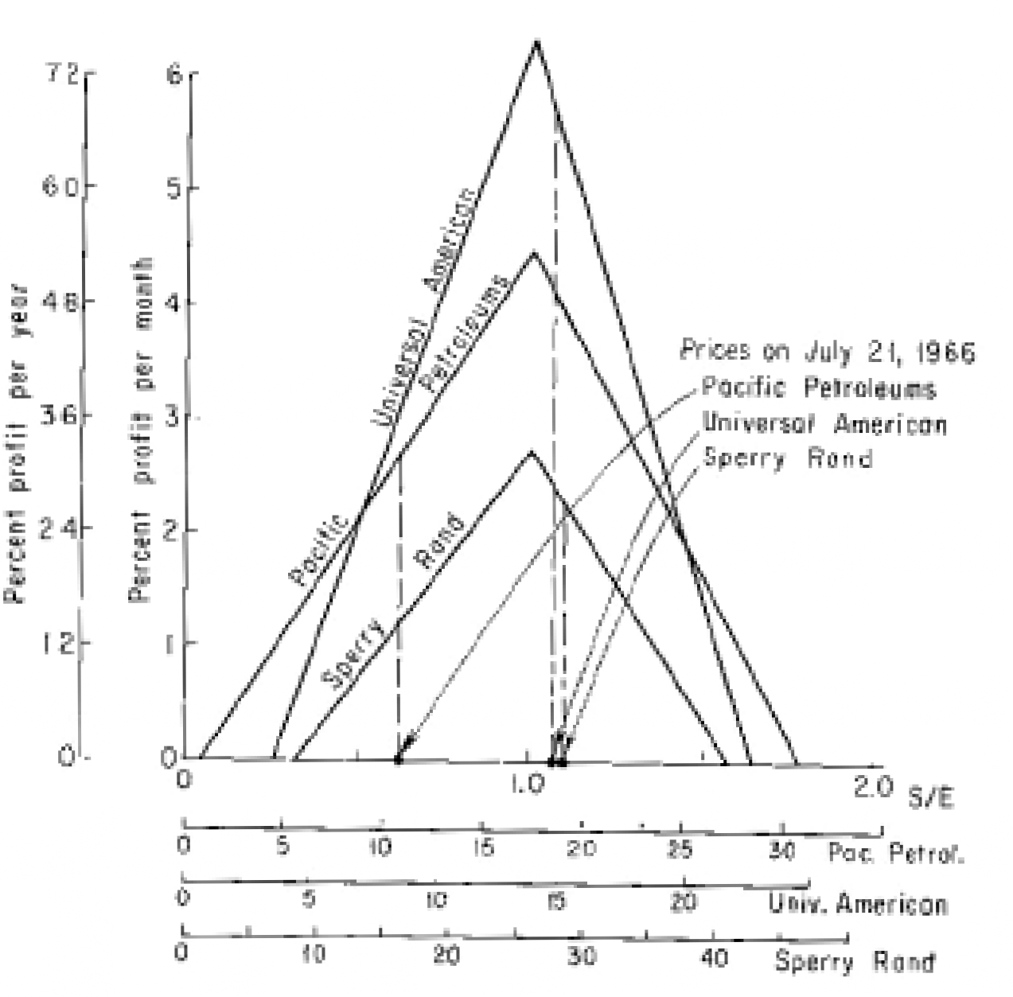

*Figure 6.7. Profit profiles of monthly percentage return with 2.2 to 1 mix for Pacific Petroleums, Universal American, and Sperry Rand on July 21, 1966.*

tions of investor risk-attitudes and expectations a hedge position is superior to a straight investment. By plotting and examining profit profiles like Figure 6.6, you can choose that mix which best suits you.

Figure 6.7 compares the three alternatives on July 21, 1966. The profit profiles show the percentage profit *per month* for each. For example, the peak profit for Pacific Petroleums (Figure 6.6)

is 94.5% and this warrant expired in 20.3 months, for an average monthly profit of 94.5/20.3, or 4.6%. In Figure 6.7 we plot profit per month on the vertical axis and standardized stock prices on the horizontal axis. The profit per year is also indicated. This allows us to compare the potential return of each investment on one diagram.

It seems clear that both Universal American and Pacific Petroleums are superior to Sperry Rand. The Sperry profit profile is lower at every point that the other two. Furthermore, the up-side and down-side break-even points are closer together than for Universal American. Since Universal American expired sooner than Sperry Rand, this indi- cates that Universal American afforded more protection than Sperry.

Comparing the protection provided by Pacific Petroleums with that by Sperry is more difficult since they are at very different positions on the horizontal axis. Nevertheless, Pacific Petroleums was probably safer: the common had to fall more than 96% or rise more than 190% in 20.8 months before a loss would occur; for Sperry, if the common fell more than 73% or rose more than 40% in 13.8 months, a loss would result.

### Dividing Your Capital Among the Candidates

If you have $10,000 or less to invest, it is usually best to put it all in one situation. Of the three best AMEX situations on July 21, 1966, this would probably have been the Universal American warrant because it expired soonest. In general, invest more in the situations that expire soonest.

There is no explicit formula for the amount you should put in each promising situa- tion. Again, this depends upon the individual investor. When two investments seem equally appealing, part of your capital should be invested in each. This tends to reduce risk.

On July 21, 1966, an investor might have divided his funds in this way: 40% in Universal American, 40% in Pacific Petroleums, and 20% in Sperry Rand. He might have invested lease in Sperry because it was slightly below normal price *and* because it was near the upper bound of 1.2 for S/E.

### Final Points

Now that you are ready to make a basic-system investment, you should open a margin account. Any convenient brokerage house with seats on the American and New York exchanges will do. However, you might check before opening the account to be sure that the house of your choice definitely can borrow the warrants you wish to short, and that they have no policy against the short sale of that particular security. Also, if you envision operations on the Toronto Exchange (Chapter 8), it is more convenient to choose a house with a seat on that exchange.

Generally, avoid selling short warrants that are trading for less than $1 because the

$2.50 maintenance margin requirement reduces the percentage return. If there is a sizable short interest in the warrant you may be forced to cover before expiration date, because the lenders of the warrant may demand their return so they can be sold before becoming worth- less. If your loan clerk is not efficient, you may have to buy the warrant at perhaps 1/4 or 3/8, rather than 1/32 or 1/64. This further reduces your return.

### Summary of the Basic System

Here is a final review of the basic system.

1. Identify the listed warrants.
2. Limit yourself to warrants expiring in four years.
3. Further limit yourself to warrants whose stock is below 1.2 times exercise price.
4. Consider only those warrants selling near or above normal price, as shown in Figure 6.3.
5. Determine the mix. The choice is not crucial. If you do not have definite views about the stock’s potential, consider that mix which is implied by the slope of the normal price curve. This tends to prevent any short-term losses in the investment.
6. Open your account and trade in one or a few situations, depending on what is available and the amount of money you invest.

The next chapter shows you the remarkable past performance of the basic system.

*Chapter 7*

# FURTHER PROOF

*The Historical Record*

In Chapter 5 we saw the basic system earn over $100,000 in actual investments, averaging about 25% a year. Did these warrants from 1961 to 1966 offer unusual opportunities that did not exist in the past and may never exist again? We now show that if investors had used the basic system from 1946 to 1966 they could have made equally spectacular profits.

### A Simplified Mechanical Strategy

We express the essence of the basic system in a simple set of rules, which we then apply to the 1946-1966 period.

Rule 1. *Restrict attention to warrants listed on the American Stock Exchange which expire in less than four years*. This rule exploits the fact that short-term warrants decline faster than long-term warrants. (See Appendix E.) We consider only listed warrants for this historical playback because it is easier to sell short listed securities than over-the-counter securities and because past price data for unlisted warrants are often unreliable or unavail- able.

Rule 2. *Eliminate those warrants selected by Rule 1 which are*

*selling for less than 6% of the adjusted exercise price. Also eliminate warrants when the stock is selling for more than 1.2 times the adjusted exercise price*. This is a simplified inter- pretation of Figure 6.1. If the common stock is above 1.2 times the exercise price, it is very seldom profitable to hedge. If the warrant is less than 6% of the exercise price, there is too “little” to be squeezed out by a short sale.

Rule 3. *Eliminate unadjusted warrants trading for less than $1*. Because $2.50 margin is required for securities selling for $2.50 or less, margin on a $1 security is actually 250%. This sharply reduces the expected percentage return from short sales of these warrants.

Rule 4. *From the remaining warrants select the one with the closest expiration date and sell short 3 warrants for every common share purchased. Use the entire purchasing power in the account under the prevailing margin rates*. We assume the short sale occurred on the first available up-tick and then the common was purchased. In actual practice an investor would not choose a mix arbitrarily. Depending upon his expectation for the common and on the position of the warrant-common point in Figure 6.1, he might sell more or fewer warrants short for every share of common purchased. But since our hypothetical investor wishes to sail away in January 1946 and not be bothered with intervening decisions, he arbitrarily chooses a mix of three to one.

Rule 5. *Cover short sales and sell the common on the last day warrants trade on the exchange. On the next trading day, start again with Rule 1. If no opportunities are available, invest in short-term treasury bills.*

Table 7.1 follows the step-by-step investments resulting from this simplified strategy. We deduct commissions but omit dividends from the common stocks. For four years, between 1956

*Table 7.1. Performance of simplified basic system, 1946-1966.*

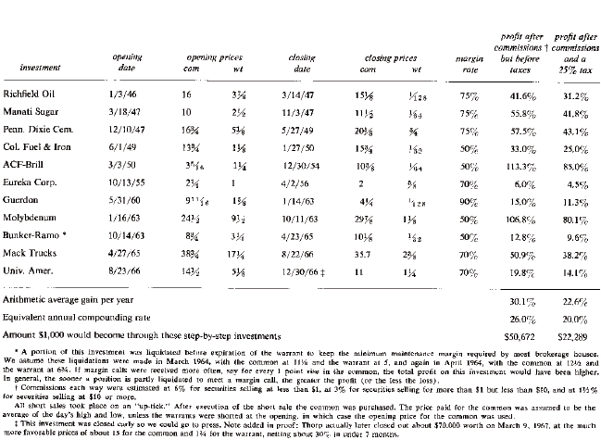

and 1960, no listed warrants met the criteria of the five rules. The system was actually employed then for seventeen years, during which it averaged 30% a year, before taxes.* If we assume a flat rate of 25% on profits when they are taken, the profit after taxes still aver- ages 22% per year.† Before taxes, the original investment multiplied 50 times and after 25% tax it multiplied 22 times. Our cash experiences in Chapter 5 are supported by the historical record.

We remark that a 25% tax on basic-system profits in Table 7.1 corresponds to a tax bracket higher than 25% when part of the profit was long-term capital gains. Since tax laws have changed, we illustrate with 1966 tax law. Profits on common held more than 6 months were long-term capital gains and were taxed at half of the ordinary income tax, but in no case at more than 25%. Profits from common held less than 6 months and all profits from short sales were taxed as ordinary income.

We have ignored the avalanche effect. If it were used, the basic-system profit figures cited in this chapter would be increased, often substantially.

Figure 7.1 graphs the performance of the basic system from 1946 through 1966. This is not as revealing as Figure 7.2, which contains this information on a semi-log grid. There, equal vertical distances represent equal percentage changes and a straight line represents a constant percentage increase, compounded annually. The greater the slope of the line, the greater the compound rate of increase. Since we are interested in compound rate of return, a

*This is the arithmetic average. For investors interested mainly in long-term growth, the equivalent annual compounding rate, which is 26% before taxes, is a more important figure. Elsewhere in the book we have referred to these figures of 26% and 30% by citing “more than 25% for seventeen years.”

†It is customary in stock market literature to figure rates of return *before* taxes, since the effect of taxes will vary with the type of investment, the investor’s situation, and with the tax laws.

semi-log grid makes it easier to compare various investments. It also allows us to see how constant the rate of return is on any investment.

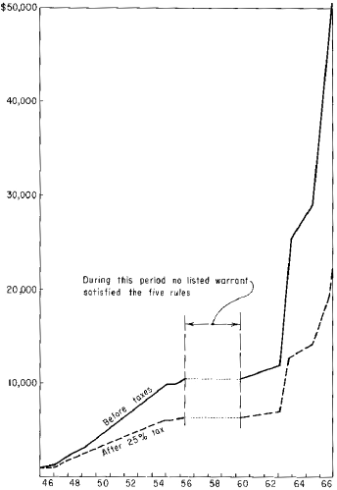

In Figure 7.2 we consider an investor who purchased the same securities as called for by the basic system but did not sell short any warrants. An initial $1,000 would have increased to about

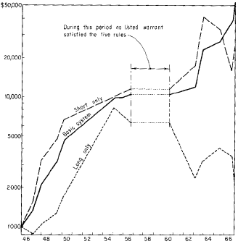

*Figure 7.2. Performance of basic system vs. straight short and long positions (after commissions and before taxes).*

$2,200 in the seventeen investment years. The basic system did more than 22 times as well. Selling short the warrants but not purchasing common gave a more erratic performance,

earning more in some years and much

less in others. An initial $1,000 would have increased to about $22,000. The basic system did

2.8 times as well.

In Figure 7.2, which graphs the performance of all three strategies, the superiority of hedging is clear. The investor who only purchased stock had a relatively poor performance. The investor who only sold short warrants had dramatic successes mixed with the spectacu- lar losses.

This last strategy would in practice have had even greater losses than indicated. For instance, after Mack Trucks warrants were sold short at 17⁄, they rose to 35fl. This seems to indicate that the investor was wiped out! But actually, depending on how quickly his broker reacted, he would have received margin calls as the warrants rose above 22fi. We assume that he then covered part of his short position rather than ante up more money. If he received a margin call for every 1 point rise in the warrant, his loss would amount to about $20,000 because the warrant then fell from 35fl to 23/8. If his broker were not alert and he was asked to cover only when the warrant rose more than 1 point, his loss would have been greater. In actual practice, with the warrant moving as much as 3 or 4 points in one day, he would prob- ably have suffered a more severe loss.

If the different tax treatment accorded to long-term and short-term capital gains were taken into account, the after-tax profits from the basic system, and from a long position only, would compare still more favorably with the profits from a short position only. Though a long position benefits the most by this, the gains do not change its position as inferior rela- tive to the others.

### The Potential Future for the Basic System

Corporations enjoy tax advantages by issuing warrants. As more managers become aware of these advantages, we expect warrants

to be issued more often, ensuring many opportunities for employment of the basic system.

The tax advantages are detailed in the Lybrand, Ross Bros. & Montgomery newsletters of June 1965 and September 1966. As an example, assume a corporation wishes to issue a bond with a “sweetener” (see the section on Convertible Bonds, Chapter 10). It may attach warrants to the bond or it may give the bondholder the right to exchange his bond for a fixed number of common shares. Such a bond is called convertible. In either case, the corporation is selling a straight bond plus an option on its common. But when it attaches warrants to the bond, it enjoys special tax considerations. Suppose that the face value of the bond is $1,000, redeemable in twenty years, that there are warrants attached, and that the warrants have a value of about $300. For tax purposes, the corporation has issued a “package” containing a bond and warrants. It has received $700 for the bond and $300 for the warrants. But when it redeems the bond in twenty years, it must pay the holder $1,000, for a loss of $300 on the bond. This loss may be amortized over twenty years, allowing substantial savings to the cor- poration. This amortization is not allowed if the corporation instead issued a convertible bond.

Successful use of the basic system requires more than a large crop of warrants—it also requires that the premium paid for warrants remain near the levels attained in the period 1946-1966. If, for instance, warrants become very “cheap,” the expected return from selling them short might decrease substantially. In this event a variation of the basic system (reverse hedging) explained in Chapter 8, might consistently yield better than average returns.

### Performance Through the 1929 Crash

Though few economists believe we will again experience a disaster like the 1929 crash, some readers may wonder how the basic system would have performed then. Let’s glance at the early warrant market.

In 1911, American Power & Light issued notes with warrants attached. This was prob- ably the first American warrant ([8] p. 656). The price history of these, and of most over-the- counter warrants, is almost impossible to reconstruct.

The first *listed* warrants were probably those of Phillips Petroleum Company and White Oil Company. Both traded in 1923 on the New York Curb Exchange (now the American Stock Exchange). By June 28, 1929, at least 22 warrants were listed on either the New York Stock Exchange or the Curb Exchange. (Warrants do not meet the present listing require- ments of the New York Stock Exchange and none have been traded there since World War

II.) Table 7.2 lists the warrants which traded on that date as reported in the *Commercial and Financial Chronicle*. Dozens of common and preferred stocks also traded with warrants attached. Figure 7.3 shows that these early warrant premiums compare with premiums after 1945.

Suppose an investor had discovered the basic system on June 28, 1929. How would he have survived the worst collapse of all time? Applying the simple rules set out at the start of this chapter, he would have purchased American Commonwealth Power common stock at 23fi and sold short 3 times as many warrants at 7fi. Margin regulations did not exist at that time and it would have been possible for him to enter this transaction on 10% margin.

But assume he was very conservative and used 50% margin. These warrants traded for the last time on June 27, 1930, and sold at 7/32 while the common sold at 24⁄. In one year, when the Standard &

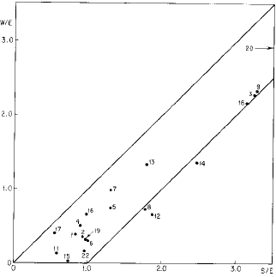

*Figure 7.3. Warrant-stock relationships June 28, 1929. (See Table 7.2 for sources and notes.)*

Poor’s index of industrial stocks fell 35%, the basic system returned almost 100%. This investor not only survived the worst stock market crash in history—he doubled his money.

The reader may reasonable object that this incredible performance was due at least in part to the fact that, despite a 35% decline in Standard & Poor’s index, the price of American Com-

*Table 7.2. Listed Warrants on the New York Stock Exchange and Curb Exchange on June 28, 1929.*

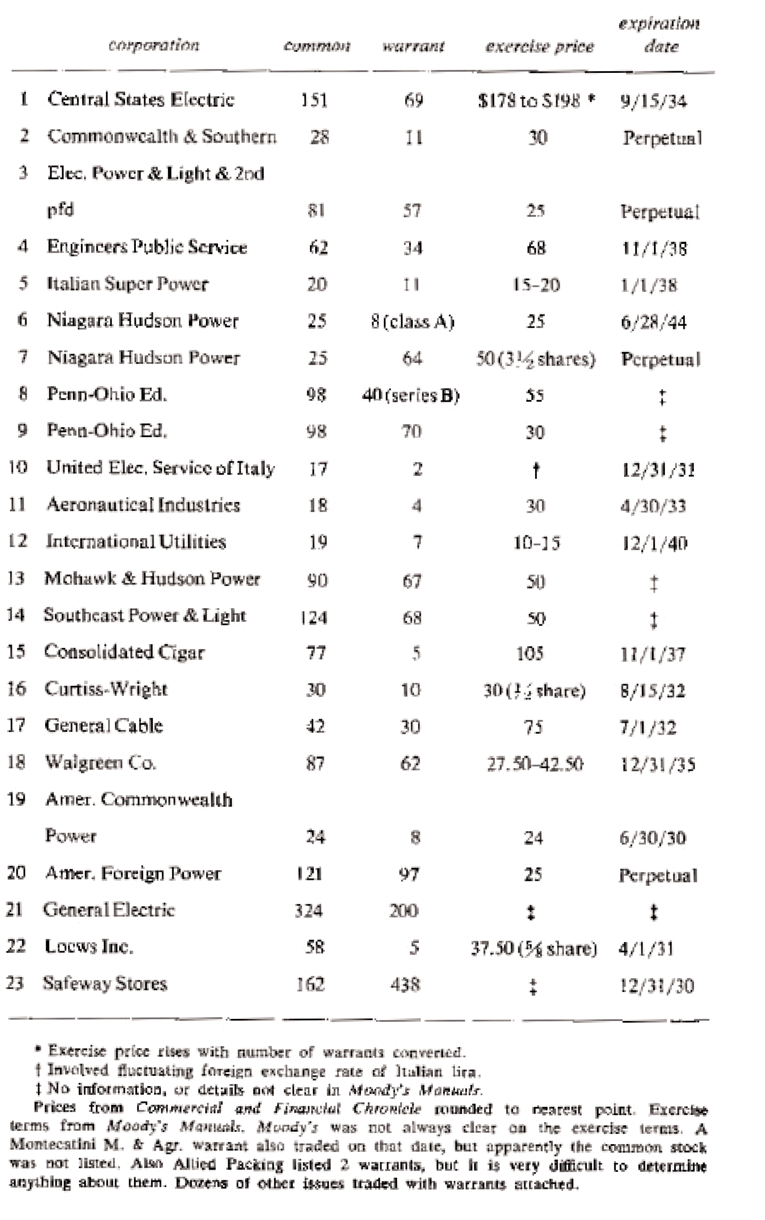

monwealth Power actually rose slightly. But we note that we would still have had a profit after costs even if the common had fallen from the initial price of 23fi to 2!

There are three other warrants in Table 7.2 which meet the criteria of Rules 1–3. They are Aeronautical Industries, Curtiss-Wright, and General Cable. Even if General Cable fell to zero, it would have produced a profit of about 90 – 42 = 48 on an investment of (90 + 42) x 50%, or 66, a profit of about 73%. If Curtiss-Wright fell to zero, the profit would have been 60 – 30 on an investment of (60 + 30) x 50%, or 30/45, which is 67%. Aeronautical Industries could have produced a loss if the common fell from 18 to less than 6. However, Aeronautical Industries had a smaller premium and a later expiration date than the other three highly suc- cessful candidates and would easily have been rejected in favor of them.

It is pointless to continue in this land of might-have-been. There can be no doubt now that this simple-minded application of the basic system would have yielded extraordinary profits during bad times and good. Note that these profits could have been made using the rigid rules 1 through 5. No consideration was given to refinements of these rules or to the pyramiding of investments.

*Chapter 8*

# MORE ON WARRANTS AND HEDGING

### Over-the-Counter, Regional, and Canadian Warrants

If none of the warrants listed on the American Stock Exchange are suitable basic-system investments, you may consider warrants traded over-the-counter, on regional exchanges, or on Canadian exchanges. To get you started, Table 8.1 and Appendix B list many of today’s warrants as they were known to us in September 1966. A current description of warrants is published weekly for subscribers by R.H.M. Associates, 220 Fifth Avenue, New York, New York 10001. In 1966 this service followed about 60 over-the-counter warrants, 25 warrants on the Toronto Exchange, and one on the Montreal Exchange, as well as those listed on the American Stock Exchange.

These warrants can be traded through your broker, or in the case of over-the-counter warrants, by contacting directly the dealer or dealers who make a market in them (as listed in the “pink sheets”).

Your broker can tell you at once the current price of a listed security. He simply queries an electronic outlet such as the Quotron. But it is difficult to get instant quotes on over-the- counter securities. The prices of most over-the-counter securities are not

given even in the *Wall Street Journal*. Prices for over-the-counter warrants are almost never given. The prices are available from the **pink sheets**, a daily service of the National Daily Quotation Service consisting of three parts—an Eastern Section (the principal one), a Pacific Coast Section, and a Western Section.

A subscription to the pink sheets is expensive, but copies are often on hand at local bro- kerage offices. You can phone your broker for a quote on over-the-counter warrants. He will usually wire New York if you are outside that city, so an hour’s delay is possible. By the time you get the quote the prices may have changed. One disadvantage in trading over-the-count- er is this inconvenience in following the price action.

The *Wall Street Journal* quotes “representative” bid and asked prices on many over-the- counter stocks. Over-the-counter dealers offer to buy securities at the bid price and to sell them at the asked price. The difference, or **spread**, gives an indication of the profit the deal- ers realize. Another disadvantage in trading over-the-counter securities is that the spread gen- erally makes the effective transaction cost to the buyer a considerably greater per cent of the investment than it would be if it were a listed security.

For instance, in late September of 1966, Lynch Corporation warrants seemed to provide an excellent basic-system investment. The warrants were 2⁄ bid, 2fl asked, and the common was at 95/8. The warrants expired in 6 months and one traded warrant plus $14 bought 1.08 shares of common. The adjusted exercise price was $14/1.08, or $12.96, the common was at

.74 of exercise price, and the warrant at 2⁄ was at 0.17 of exercise price. Figure 6.3 shows the warrant well above the 6-month average price curve. Proceeding as in Figure 6.4, we find that with a mix of about 2.2 adjusted warrants short per share of common

long (almost exactly 2 traded warrants short per share of common long), we realize a profit unless the common more than doubles or drops to less than half.

A broker had 300 Lynch warrants on hand for borrowing so we instructed him to sell short 300 Lynch warrants at 2fi. We did not offer to sell at the bid of 2⁄ because the spread of 1/2 between the bid and the asked represented a whopping 22% of the proceeds. Also, if we had to return the borrowed securities soon and were unable to borrow more, we would have to buy-in, perhaps near 2fl, and suffer an immediate loss comparable to the spread of 1/2.

Our offer to sell at 2fi was refused, and was refused again when we lowered it to 23/8. The common then fell to 9⁄ and the warrant fell to 2 bid, 2fi asked. We offered to sell at 21/8 and then at 2. We were refused and were given a new quote: 1fi bid, 2fi asked, with the spread of 1 point now being 67% of the bid price! Since the Universal American warrant was equal- ly attractive, and more convenient to trade, we took our business back to the American Stock Exchange.

Table 8.1 shows some of the unlisted warrants which in September 1966 had 27 months or less until expiration. Of these 28 warrants, proceeding as in Figure 6.3, 4 looked particu- larly profitable for the basic system. They were Lynch Corporation, with 6 months to go; Consolidated Oil and Gas, with 9 months to go; Gyrodyne, with 12 months to go; and Jade Oil and Gas, with 15 months to go. (Canadian Delhi and Lake Ontario Cement, which appear to qualify, are excluded by the more detailed analysis given later in this chapter.)

Attractive as these warrants may appear, there are practical difficulties. One house refused to short any over-the-counter secu-

*Table 8.1. Some over-the-counter and Canadian warrants, with terms and prices, for September 1966.*

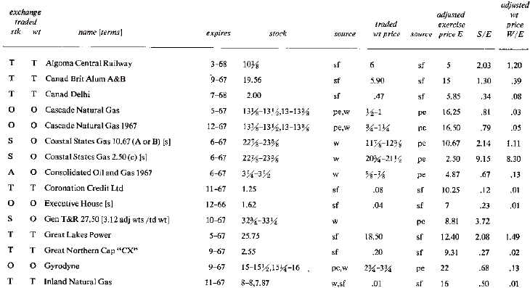

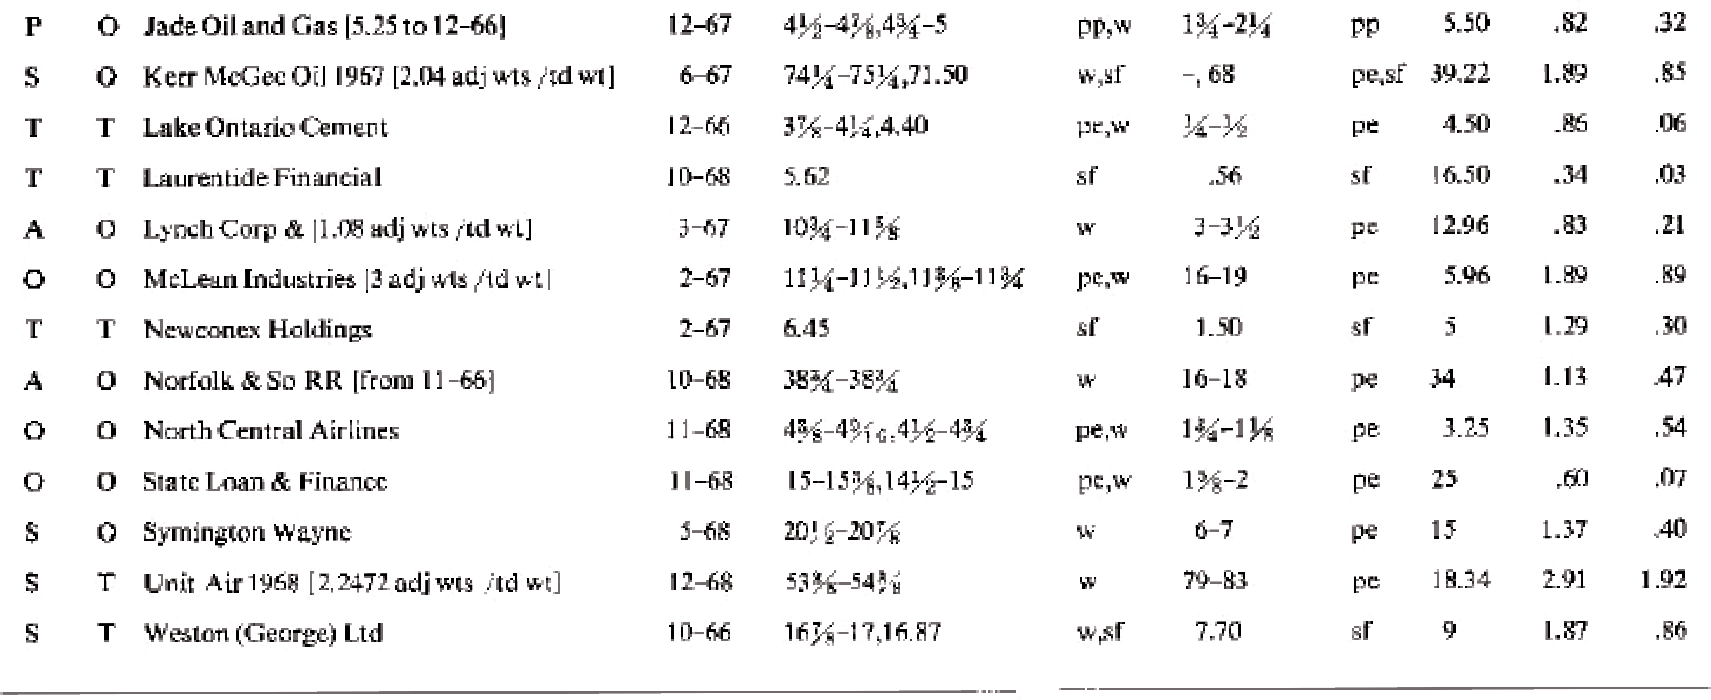

NOTES: Under "exchange traded," S means New York Stock Exchange, P means Pacific Coast Stock Exchange, O means over-the-counter, and T means Toronto Stock Exchange. Traded warrants and adjusted warrants are identical unless otherwise indicated under [terms]. The term [s] means a senior security can be used at par instead of cash when exercising the warrants. Warrant terms change; obtain current information on the warrants that interest you.

Along with stock or warrant prices the source is given. Source w means the *Wall Street Journal* for the same date as the warrant price; pe means the Eastern Section of the pink sheets dated September 15, 1966; pp means the Pacific Coast Section of the pink sheets dated September 20, 1966; sf means the Sidney Fried R. H. M. survey dated September 16, 1966. These last prices are often misleading or erroneous, so we have used them only when it was difficult to obtain others.

Over-the-counter prices from the pink sheets or the *Wall Street Journal* are bid-asked. For NYSE and AMEX listed stocks, the low-high prices are given because they are to be used with warrant prices and we do not know the time during the day that these prices were valid. In the S/E column we have used the asked price, or the high price for S, and in the W/E column we have used the bid price, or the low price for W. This is conservative, for these are the most unfavorable prices for the basic system. When prices from two sources are given, those from the first source are used to compute S/E and W/E. When the pink sheets gave bid-asked prices from more than one dealer, we chose the bid-asked with the the spread which was the small- est per cent of the bid.

rity, explaining that it wished to protect us (against our wishes) from “speculation.” Another house refused to short over-the-counter securities selling under $3, or any warrants. When pressed, they admitted it was annoying to borrow them. Over-the-counter securities tend to be concentrated in fewer hands, making it harder to locate certificates to borrow. Also, if the lender wants his certificates returned, there is greater risk that replacements will not be avail- able, causing you to be bought-in against your wishes.

When you use the basic system for over-the-counter warrants, it is advisable to invest comparatively small sums, and to follow developments closely. It in addition to the warrant, the common stock is also traded over-the-counter, your percentage profit will be reduced because over-the-counter stocks cannot be purchased on margin through your broker. Basic- system positions involving over-the-counter stocks *and* warrants therefore require a greater cash investment than comparable situations with listed securities. If the stock is listed and can be purchased on margin, then over-the-counter warrants can be as attractive as listed war- rants.

We also emphasize that the theory of Chapter 6, particularly the use of Figure 6.3, was based on experience with AMEX listed warrants. Experience with other warrants could be less favorable.

We know at present of no special difficulties in trading warrants on the Toronto Exchange. However, you cannot legally exercise certain of these warrants, and you may need to emphasize to your broker that you understand this, before he will take your order.

When Canadian warrants are exercised by U.S. residents, the additional securities issued are new shares. They must be registered with the Securities and Exchange Commission by the com-

pany. If this expense and annoyance is avoided, these shares cannot be purchased by U.S. res- idents through the exercise of their warrants. If you are short the warrants, you certainly have none to exercise; there is no difficulty beyond a possible initial discussion with your broker. The R.H.M. Service listings give the average of the bid asked, which conceals the often excessive spread. We also found errors in price. For instance, R.H.M. quotes Cooper Tire and Rubber common as 23.50 on September 16, 1966, and the *Wall Street Journal* gives the 1966 low-high through September 16, 1966, as 17–18⁄. For listed stocks such as Alleghany Corp., ARA, Inc., and Indian Head, prices given in the September 16, 1966, issue were never attained any time during the week ending September 16, 1966! Therefore we use the R.H.M.

figures as a handy first indication but we never rely on them, even as a historical record.

### What Determines Warrant Prices?

As a first step toward the more skillful exploitation of warrants, we study the factors which seem to determine the market price of warrants.

The dashed curves in Figure 6.3 indicate the average behavior of all warrants at vari- ous times before expiration. But the four examples for July 21, 1966, in the figure show us that deviations from this average behavior can be considerable, Sheen Kassouf, in his doc- toral dissertation, did a mathematical and computer analysis of listed warrants from 1945 to 1965, and found that normal price curves for an individual warrant may vary considerably from the curves if average behavior in Figure 6.3. We describe his results.

Using this theory, the normal price curves for each warrant may be computed (see Appendix D). The actual points for a warrants are much closer to these new curves than they were to the curves of average behavior. The location of these normal price curves depends mainly on time remaining until expiration, potential dilution, dividend rate, and slightly on exercise price. Also, the recent past history of the stock had a considerable effect on warrant price.

Potential dilution refers to the percentage of new shares which would appear if all options on stock were exercised. For instance, in 1965 there were 30 million shares of Sperry Rand outstanding and about 2.2 million new shares could be bought by warrant holders. The potential dilution from these warrants was 2.2/30, or 7.3%. The study shows that the larger the potential dilution, the lower the warrant price, other things being equal.

Also, the higher the dividend rate on the common stock, the lower the warrant price tends to be. Dividends make the common more attractive compared to the warrant. Some who hope for a rise in the common, and who would normally buy warrants, may instead buy and hold the common because they receive dividends while they wait.

A stock which pays high dividends is believed to have less chance for future price appreciation, or growth, than a stock paying lower dividends. This makes the warrant less valuable, and is a second possible explanation of why higher dividends increase tends to lower the normal price curve, increasing the profit in a hedged position.

The effect of potential dilution and dividends on warrant prices is of little interest to basic-system investors. We mention

these effects so you will realize that our predictions of warrant-stock behavior are much clos- er than Figure 6.3 indicates, and so you will appreciate the factors influencing the people who buy the warrants you sell.

The influence of potential dilution, dividends, and time until expiration on the price of warrants suggested by students of warrants, was verified and precisely measured by Kassouf. He also seems to have been the first to analyze the influence of recent past history on war- rant prices [10, 11].

He found that if the current stock price was higher than the average of the last 11 months, * the warrant price was depressed. This means warrant buyers behave as though a rising trend in the stock price makes the warrant worth less, as though a rising trend will not continue. When the current stock price was below the 11-month average, warrant prices tend- ed to be above the normal price curve. With falling stock prices warrant holders act as though the warrant is worth more, as though a falling trend in the stock price also will not continue. The greater the deviation of the current stock price from the 11-month average, the greater was the deviation of the warrant price from the predicted price. We call these deviations the **trend effect**.

We illustrate how to use the trend effect for extra profits by Ed Thorp’s description of his operation in Sperry Rand.

I shorted 100 Sperry warrants at 51/8 on August 24, 1965. Then I brought 100 common at 125/8. (We indicate these trades in Figure 8.1 by 100:100.) As the stock climbed I

*The 11-month average was obtained by first taking the average of the monthly high and low for each of the last 11 months, then averaging these numbers. The monthly high and low were used because they were in the widely used Standard & Poor’s *Stock Guides*, making them likely to influence investors and also convenient to gather.

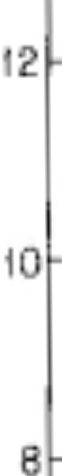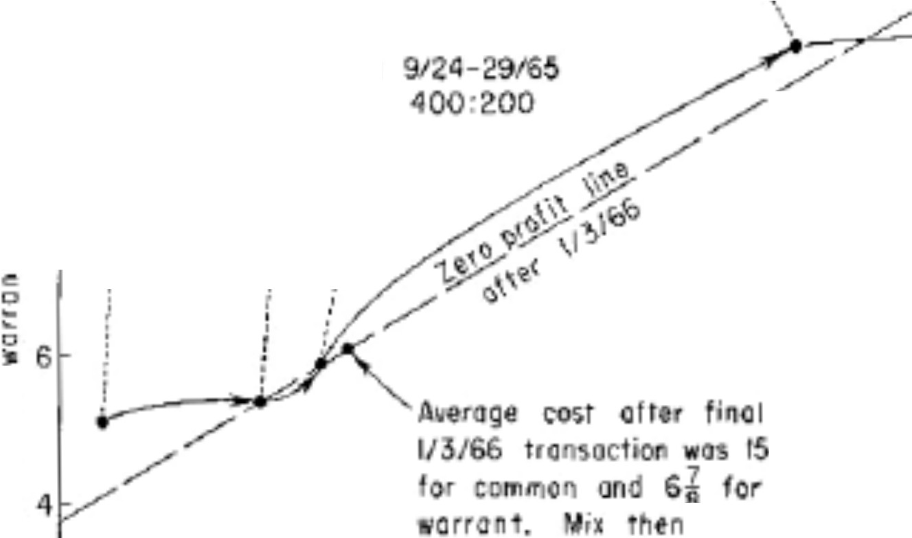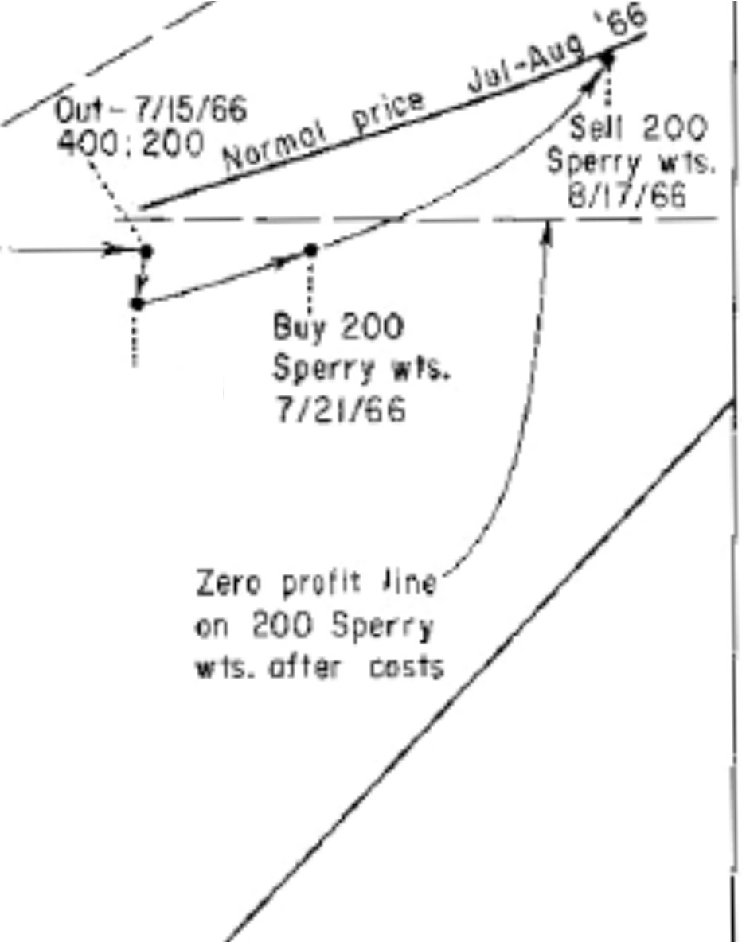

In- S/3/

10.0:

'" - 8/24•25/6

100: jO

111

,

.

,·

.

.

.

'

*f*

'

- cw:0-9/iG *:*

400:2.00

.*:*'

'

i

' ,;

...

V

i

wos 1.9 to 1.

Out - 7/16-20/66

00 40(.)



I I I I I I / I I I



J

f2 ,4 16 18 2.0 22 24 26 28 A

Pdet o1 tommo

continued to short warrants and buy common, trying to approximate a mix of about 1.8 adjusted warrants short for each share of common long. Figure 8.1 indicates the timing and magnitude of the transactions.

In July of 1966, Sperry had climbed to about 27 and the warrants were depressed at about 10. Using the same reasoning as Kassouf (Chapter 5), I closed out my Sperry position. The net profit after all costs was about $2,100 and the average investment was about $9,400, a profit of about 22%. The money was invested for an average of about 9 months, so the rate of profit was about 30% per year. When I closed out Sperry, the warrants were significantly below their predicted price. Expecting the usual prompt return the predicted price, I bought 200 of the warrants I had just been short. Because of transaction costs, these warrants would have to rise above 10fl to show a profit. This is indicated in the figure by the dotted line.

The point where the zero profit line crosses the predicted price curve corresponds to a stock price of 26fi. I would lose only if the stock price were below this when the warrants returned to norm value. This was a move of 2fi points in a short time, and Sperry had been in a strong up-trend (which tends to temporarily depress warrant prices) so the warrant pur- chase seemed likely to be profitable. The warrants were sold a month later for 125/8 and a profit of $350 after costs was realized on an investment of about $1,400, or a 25% gain in one month.

Though the expected payoff was large, this Sperry investment had much more risk than the earlier hedged basic-system investments, so only a small part of my funds were used. The total expected price move was so small that to reduce risk by also shorting 100 shares of com- mon would cancel most of the profit.

You do not need to know the predicted price of a warrant when you use the basic sys- tem. We mention it here as part of our discussion of the factors affecting warrant prices, and to show you that, successful as the basic system is, more can be done.

### What Is a Warrant Worth?

A warrant entitles the holder to purchase common at the exercise price until the expiration date of the warrant. This right is worthless if everyone “knows” that the common will trade at or below exercise price until after expiration. But if there is some chance the common will rise above the exercise price before expiration, the warrant offers a possible profit. The greater the chance that the common will move above exercise price, and the farther above exercise price it may move, the greater the profit potential of the warrant and the higher the price it should trade for.

As a simple example, consider a warrant with a year until expiration, an exercise price of $10, and suppose the common is at 10. According to Figure 6.3, when the common was at exercise price the average warrant with 12 months until expiration has traded at about 0.31 times exercise price, or about 3 in our example. But what is such a warrant really worth?

This depends on the prospects of the common before expiration. For instance, if every- one knew that the common would remain stationary at 10, the warrant would be worth noth- ing (Figure 8.2(a)). Suppose we all knew that the common would rise to 13 at expiration, making it worth 3 then. Neglecting (as we shall for this discussion) subtleties like the pres- ent value of future

income, transactions costs, and other investment alternatives, we see, as in Figure 8.2(b), that 3 would be approximately a fair price now for the warrant. (We also assume the warrant will be held until expiration, neglecting the effects of intermediate fluctuations in the price of the common.)

But nothing is certain and any description of the price of the common on expiration date must at best give various possible prices and the probabilities of those prices. Suppose we believed that the common had a 1/2 chance to rise to 15 on expiration and a 1/2 chance to fall to 5. Then there is a 1/2 chance the warrant will be worth 15 – 10, or 5, and a 1/2 chance it will be worth 0 (Figure 8.2(c)). How much is such a prospect worth?

This is a complex question, depending on what economic theorists term the investor’s utility function. Utility functions may vary from one investor to another, so that a prospect of a 1/2 chance of 5 and a 1/2 chance of 0 may be worth different amounts to different investors. This means that different investors will be willing to pay different prices for such a warrant.

The most widely used measure of the worth of an investment is known as the **mathe- matical expectation**, or **expected value**. It is obtained by multiplying each payoff by the chance it occurs, and adding. In our example it is (5 x 1/2) + (0 x 1/2), or 2fi.

The best predictions we can make about actual common stock prices are far more com- plex than these first three examples. Closer to reality is the situation indicated in Figure 8.2(d), where common prices from 4 to 16 are possible with various chances.

A detailed analysis of more realistic possibilities, like that in 8.2(d), would involve us in difficult mathematical and economic theory, which we shall present in the academic liter- ature rather than here. But some of the main conclusions of such an analysis

are easy to understand so we discuss them here to aid us in understanding what various investors might pay for a warrant.

The aspects of the future of the common stock which

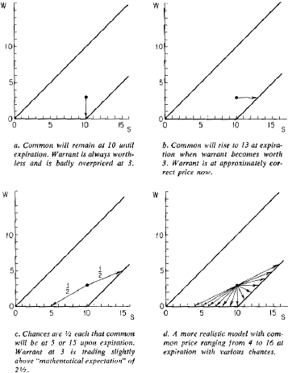

principally affect the warrant price are trend and volatility. By trend * we simply mean how the price of the common is expected to change between the present and the warrant’s expira- tion. For instance, if the common on average is likely to rise by expiration date, we call this an up-trend. If it is likely to fall, we call this a down-trend. This is illustrated in Figures 8.3(a) and (b). It should be obvious both by reasoning and from the figure that the more the up- trend, the more the value of the warrant. Unless there is very strong reason to believe other- wise, we generally take the trend of the common stock to be somewhere between 0% and 10% a year, in agreement with the long-term historical behavior of the common stocks.

By volatility † we mean the tendency of a stock to fluctuate, or for the price to move away from its present price, by the expiration date. Thus volatility refers to the spread in pos- sible prices of the common by expiration. Figures 8.3(c) and (d) illustrate lesser and greater volatility. These figures suggest, and analysis verifies, that the more volatile the common, the more the warrant is likely to be worth.

In judging warrants, volatility should be considered. Since Figure 6.3 does not do this, a warrant whose common is comparatively volatile is worth more than Figure 6.3 suggests, and is a poorer short sale. A warrant whose common is not very volatile is worth less, and is a better short sale.

We can get a quick, rough indication of the comparative volatility of different common stocks by expressing the yearly

*Mathematical readers: we mean by trend the number (E(Xf) – xo)/t, where xo is present price, t is time until expiration, and E(Xf) is the mathematical expectation of the random final price Xf.

† Mathematical readers: we really mean s(Xf – xo), where s is the standard deviation, but here we replace such mathematics by verbal constructs.

range, or high price minus low price for the year to date, as a per cent of the “middle” price of the common. The “middle” price of the common is the average (this is, half the sum) of the high and

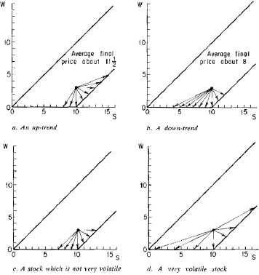

low for the year. Table 8.2 illustrates this for the 7 interesting warrants on September 16, 1966.

The larger volatility for Consolidated Oil and Gas and for Lynch Corporation makes these 2 over-the-counter warrants much less attractive for short selling and the basic system than

they seemed to be when we used only the theory of Chapter 6. In particular, we saw in Table

8.1 that Gyrodyne and Consolidated had almost identical S/E and W/E, so the same amount of potential profit would appear to be due from both situations. But Consolidated expired in 9 months and Gyrodyne in 12 months, which made Consolidated seem preferable. However, the volatility of Consolidated is so much greater that we prefer Gyrodyne.

*Table 8.2. Volatility as indicated by yearly range to date for the common stocks of the 7 warrants which were basic-system candidates*

*on September 16, 1966.*

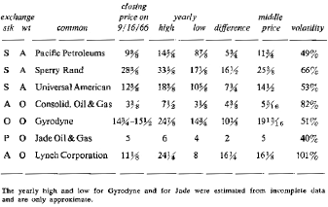

### Reverse Hedging

In the basic system we short overpriced warrants. If instead a warrant become “under- priced,” it may be an attractive but risky purchase. Hedging can again reduce risk and retain profit.

For example, on July 2, 1965, the Realty Equities Corporation warrant, listed on the American Stock Exchange, traded at

1fi with the common at 73/8, as indicated in Figure 8.4. Figure 6.3 shows that this warrant, which expired in seven years, sold for less than the average warrant with 1fi months left.

We see from Figure 8.4 that if the common advanced, the

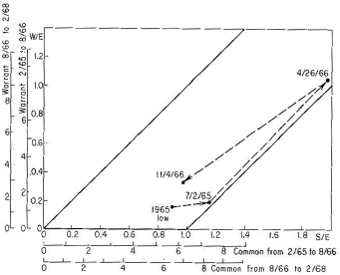

*Figure 8.4. Reverse hedging with Realty Equities Corporation warrants. From 2/1/65 to 8/1/66, each warrant plus $8 convertible into 1.255 common. From 8/2/66 to 2/1/68, each warrant plus $9 convert- ible into 1.255 common. Higher prices to expiration, 2/1/72.*

adjusted warrant price would have to advance about point for point in order to remain above the minimum value line. Since the traded warrant was 1.255 adjusted warrants, this meant that for every point the common rose, the traded warrant would rise about 1⁄ points. A 1 point advance in the common from 73/8 to 83/8 represented a 13% increase; a 1⁄ point advance in the warrant from 1fi to 2fl represented an 83% increase.

On a small upward movement, the warrant would advance over 6 times as fast as the common. An investor who thought the stock likely to rise should have bought the warrant rather than the common. However, there was rick of considerable loss. If the common and warrant fell to the lows made earlier in 1965 (5fl for the common and 1⁄ for the warrant), the warrant purchaser would lose 24% including commissions.

This 24% possible loss would ordinarily deter an investor from taking a large position in the warrant. But by selling common stock short and buying the warrant, which is the reverse of the hedge described in Chapter 6, the risk of loss is cut while the chance for large gains remains.

We illustrate with the following position:

|  |  |
| --- | --- |
| Buy 4,000 Realty Equities warrants at 1fi. | $6,240 |
| Sell short 1,000 Realty Equities common at 73/8; |  |
| no margin required. Only transactions costs |  |
| need be paid. | 170 |
| Total Investment | $6,410 |

Approximate cash investment, with 70% margin $4,500

Margin was not required for the short sale of the common stock. The $170 represents commissions and selling costs. Here we are invoking Section 220.3(d) (3) of the Federal Reserve System Regulation T, which reads in part:

. . . such amount as the Board shall prescribe from time to time . . . as the margin required for short sales, except that such amount so prescribed . . . need not be included when there are held in the account securities exchangeable or con-

vertible within 90 calendar days, without restriction other than the payment of money, into such securities sold short; . . .

The 4,000 warrants held in this transaction are convertible, in the sense of this regulation, into 4,000 shares of common stock. Therefore, up to 4,000 shares of stock can be sold short without posting margin. In the example, only 1,000 shares are short.

Since many brokers are unfamiliar with this part of Regulation T, be prepared to quote chapter and verse. Once educated to this form of hedging, many brokers wish to cooperate because the commissions generated per dollar invested are often large. The prof- its generated per dollar invested also may be large.

What were the prospects on July 2, 1965, for this investment? If the common and warrant returned to their 1965 lows of 5fl and 1⁄ and the position were liquidated, the

$4,500 investment would lose about $30, or less than 1%, after costs and commissions.

There is no need to deduce what would have happened if the common advanced. A few weeks later Realty Equities announced that it was acquiring the extensive real estate holdings of the Schine empire. The stock and the warrant moved steadily higher. They reached their peak on April 26, 1966, less than 9 months later, with the common at 125/8 and the warrant at 83/8. If the hedged investment had been liquidated at this point there would have been a profit of $26,300 on the warrants after commissions and a loss of

$6,300 on the common after commissions and dividend payments (when short a security, you must pay the lender his dividends), for a net profit of about $20,000, a gain of 445% in 9 months.

Table 8.3 compares various alternatives. Simply buying warrants on margin is best on the up-side but loses 34% on the

down-side compared with less than 1% for the hedged position. Other mixes of warrants long to common short are possible. The table shows the results of 2,000 warrants long, 1,000 short.

*Table 8.3. Performance of reverse hedge in Realty Equities vs. other alternatives.*

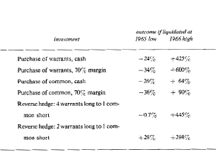

In conclusion, we note that on November 4, 1966, the common closed at 7 and the warrants at 27/8, compared to prices of 73/8 and 11/8 16 months earlier. At this later date the exercise price had risen from $8 to $9. In spite of a decrease in the price of the common, and an increase in exercise price, the warrant was selling at almost double the July 1965 price!

### Spotting Candidates for Reverse Hedging

In July 1965, the Realty Equities warrant was “bumping” into the minimum value line in Figure 8.4, so a rise in the price of the common meant a rise in the warrant, with the *per- centage* increase

in the warrant much greater than that in the common. On a down-side move, we would expect the percentage fall in an underpriced warrant to be no faster, and perhaps slower, than in the common. Therefore, the Realty Equities warrant would rise faster, and probably fall no faster that the common stock, in percentage. This is what made it perfect for reverse hedging.

Figure 8.4 shows that these conditions are met with the warrant is underpriced *and* its position is near the “corner” where the minimum value line intersects the horizontal axis.

This is behind our rules for selecting reverse-hedge candidates:

1. The common stock should be within 20% of adjusted exercise price.
2. The warrant should not expire in less than four years.
3. The warrant should be underpriced relative to “average” warrants (Figure 6.3).
4. The more volatile the common stock, the more attractive the situation.

The zero profit line helps in selecting a mix for the reverse hedge. The line is drawn just as tin the basic system, only now points *above* the line represent profit and those below it are losses. In the Realty Equities example, the four-to-one mix might be selected by an investor who expected an up-side move. The two-to-one mix would be more suitable for an investor who wanted to profit from a move either up or down in the common.

Opportunities for reverse hedging occur more frequently in over-the-counter warrants than among listed warrants. Unlisted warrants do not present the difficulties encountered in the basic system, because the warrant is purchased, not sold short. Thus, if the common stock is listed, even an over-the-counter warrant will

be easy to reverse hedge. Appendix B indicates that in September 1966, there were at least 26 over-the-counter warrants whose associated common stock was listed on either the New York or American Stock exchanges.

*Chapter 9*

# CAN ANYTHING GO WRONG?

The basic system refutes the theory that high returns must be accompanied by high risk. We believe we have demonstrated that an investor can safely earn 25% per annum. But risk can never be entirely eliminated. We now discuss risks in using the basic system.

### Short Squeezes

From the legendary bear raids of the early Wall Street buccaneers many have drawn the moral that short selling is bad. Some say short selling is dangerous because of unlimited potential losses, and that in return it offers only limited potential gains. (Appendix A shows this need not be so.) Some say selling short is unpatriotic; it means the seller has a pessimistic view of American enterprise. This is naïve and untrue. The interests of the economy are best served if stock prices reflect potential future earnings. If informed short selling guides prices to such levels, then short selling may even be called a public duty. We shall not pursue this argument. We wish to discuss the risk involved in selling warrants short.

If someone corners the market (see page 60) in a warrant, the short sellers of that war- rant can be forced to pay outrageous prices to cover. We believe such corners are unlikely. The Ameri-

can and New York stock exchanges have regulations outlawing corners. Although the exchanges in the past have always refused to declare that a corner exists, the existence of these regulations is a deterrent to some manipulators. The increasingly inquisitive Securities and Exchange Commission is another threat to them.

The nearest thing to a corner in the warrant market was the accumulation of Molybdenum warrants by International Mining in 1962 (Chapter 5). this disrupted the rela- tionship between the price of the warrant and the common to such a degree that it received attention in the press and from the American Stock Exchange. At one point, International Mining owned 20% of the outstanding warrants and another 8% were held by Kennecott Copper. This was not enough to force short sellers to cover their positions. Warrants were still available for shorting in many brokerage houses. Even when the warrants were unrealistical- ly priced, hedgers lost little and shortly thereafter gained large profits.

During a squeeze, your brokerage house may report that it is “unable” to borrow the warrants. In this event you would have to perform the duties of the loan clerk and search for the certificates. This problem may soon disappear. The *Wall Street Journal* of September 7, 1966, reported that the New York Stock Exchange is instituting a computerized “control-cer- tificate” system. Each participating member will deposit certificates of stock in one location and transfers will then be made by bookkeeping entries. The American Stock Exchange should soon institute a similar system because of the resulting economies if all certificates are housed in one location. This will make it so much easier to borrow securities that it may eliminate the loan clerks.

Another risk in selling warrants short is imaginary. It is widely

believed that a security with a high short position is more likely to rise in price than fall. Those who believe this say that short sellers must eventually buy back the stock they have sold and so represent potential demand for the security. This is true, but why should this potential demand have a bullish effect on the stock? Demand alone does not determine the price of a stock; supply, the other “blade of the scissors,” must also be considered.

When a share of stock is sold short, a “new share” of stock is created. Thus the poten- tial demand created by the short sale has been balanced by the increase in supply. For exam- ple, consider the stock of the ABC Company. There are 10 shares outstanding. Ten different individuals own one share each. If a share is borrowed from one of these owners and sold short to another individual, eleven persons would then consider themselves owners of ABC stock. That is, there are eleven potential sellers of the stock. The potential demand of the short seller has been offset by an increased potential supply.

This does not prove that short selling has no effect on the price of a stock; other con- siderations may act in conjunction with short sales to decidedly affect price movements. The increase in supply was pointed out only to show that one cannot rely on a purely logical argu- ment concerning the effects of short sales. We are forced to look at the actual data.

Whatever effect a large short interest may have on an expiring warrant is swamped by the effect of a close expiration date. This is reasonable, because the number of warrants owned (the original number issued plus the number sold short) exceeds the number that must be purchased (the number sold short). As a warrant nears expiration, only those who have sold it short have reason to buy it. Their demand is less than the potential supply.

On December 10, 1965, the short position in the Sperry Rand warrants was 346,608, the highest short interest ever recorded in a warrant. On that date the warrant ranged between 8fi and 93/8. Ten months later the short position *rose* to 373,100 and the price of the warrant *fell*, ranging between 6fl and 77/8. The warrants declined in price in spite of a rise in the price of the common (on the earlier date the common ranged between 211/8 and 217/8 and on the later date between 225/8 and 25), and in the face of a rising short interest.

Figure 9.1 traces the last 12 months of some warrants that had relatively large short positions. In each case the warrant fell steadily toward zero, even though the short interest bulged upward at some time during the last year of life. Clearly, a large short position did *not* have a bullish effect on these warrants. But the myth continues. Wall Streeters take such delight in fanciful stores that they quickly attribute movements they don’t understand to col- orful short squeezes.

On August 10, 1966, *The New York Times* reported on a “leading candidate for swinger of the year”—Mack Trucks warrants. They noted that the warrants had traded at a “stratos- pheric” high of 345/8 in February and a low of 3fl in August. They attributed the action to “speculators who were squeezed.” When the common stock reached a high of 54fl in February, the warrants at 345/8 were worth on conversion about 303/8. Therefore at their high they were selling at a very modest premium. In August, when the common fell below 40, the warrants were selling at almost exactly their conversion value. The following day the *Times* reported that it had made an error. They assumed the warrants were convertible into only one share of common stock, whereas in fact they were convertible into 1.47 shares of stock.

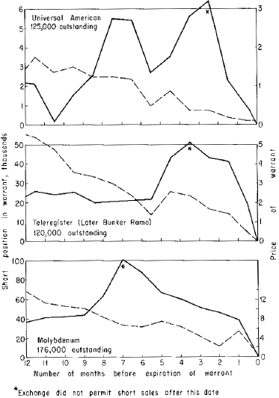

*Figure 9.1. Relationship between short position and price of warrant, for three warrants one year before they expired. The warrants are the Universal American 1955, Teleregister (later Bunker-Ramo), and Molybdenum. The dotted lines indicate the price of the warrants and the solid lines indicate the short interest.*

But nothing was said about the error of their informants, the “Wall Street point-and-figure men [who] say short selling offers the true explanation for the zip in the [warrants].” And so the myth becomes reinforced. It is easier to believe the maxims of Wall Street than to study the facts.

The short interest and volume statistics for the Bunker-Ramo and the 1955 Universal American warrants the month before they expired reveal an incredible speculative sentiment. On April 9, 1965, the short interest in the Bunker-Ramo warrants as reported by the American Stock Exchange was 19,474. Short sales had been banned earlier, so the short interest could not rise from this level. This number and only this number of warrants had to be purchased before May 1, 1965, to cover short positions. But the volume in the warrants for the follow- ing two weeks was 57,800, indicating that about 38,000 warrants were purchased at prices ranging from three cents to fifty cents as an outright speculation. The common traded during this period in a range from 81/8 to 103/8. For the warrants to have been worth anything on con- version, the common would have had to advance beyond 14, about a 50% increase. Thus at least 38,000 warrants were purchased on the hope that the common would advance more than 50% in three weeks.

The situation with the Universal American warrants was even wilder. Short sales were banned by March 9, 1965, when the reported short interest was 2,299 warrants. In the next few weeks before the warrants expired total volume was 41,100, exclusive of trading over- the-counter. Again, at least 38,000 warrants were purchased as a speculation. The common during this period traded between 6 and 7. Before the warrants would be worth anything, the common would have had to double to about 12fi. Purchases were made of 38,000 warrants at prices ranging from 12fi cents

to 18fl cents in the hopes that the common would advance more than 100% in a few weeks. Who were these wild-eyed buyers who lost their entire investment in a matter of days? Or were the reported short interest or volume figures in error? (Still further trading may have occurred in the over-the-counter market during the last week of the warrants’ life, when the Exchange delisted them.)

### 1929 Again?

Lurking in every policy-maker’s subconscious is the specter of 1929. Occasionally it sur- faces, as in June 1965, when William M. Martin, Chairman of the Federal Reserve Board, delivered his famous “then as now” speech at Columbia. He cited some dozen parallels between 1965 and 1929. He cited many differences too, but they were largely ignored by the press. When the market broke badly in the next few months it became known as the “Martin market.”

No public official can convincingly claim that we will never experience a period simi- lar to the early 1930s. A repeat performance may be unlikely, but every time the market aver- ages decline 15% or 20% the ghost of 1929 is reported moving boldly through the financial district. Isn’t it true that before prices can fall 90% they must first fall 20%? Most investors must live with these nagging thoughts. If the fear becomes great, an investor may even reverse his position and go short. Then he lives with the fear that prices will move forward sharply as they often have in the past.

Meanwhile, the investor using the basic system is not troubled about his investments. We saw in Chapter 7 how he doubled his investment when the market crashed in 1929. In every situation he enters he can set the limit to which stocks must fall before he

suffers a loss. Very often, he can set this limit at zero! Adjusting his mix of warrants short to common long, he can set a wide profitable interval about present price. A market disaster need not injure his portfolio. In fact, hedged positions become more flexible when prices drop (see Chapter 11); without adding additional cash, additional investments can be made that promise greater returns. The hedged investor does not fear a market collapse.

### Volatile Price Movements

The hedged investments described in this book will show a profit for a wide range of moves for the common stock. Nevertheless, stock prices are volcanic, occasionally moving wildly after a long dormant period. If the move is very great in one direction, even a basic-system position will show a loss *if some intermediate change in the position is not made*. Until now we have discussed “desert isle” strategies—investments that are made and not altered until expiration of the warrant. Now we will demonstrate that if an investor is watching his invest- ment in a hedged position, he can protect himself against an extremely volatile move in the common.

For example, two years before expiration, the ABC warrant, excercisable at $20, is sell- ing at $4 while the common is $10. (A glance at Figure 6.3 shows that this is a very proba- ble relationship.*) An investor sells short 200 warrants and buys 100 common. If he sails away and does not return for two year,

* A rule of thumb used by many analysts: a warrant becomes more attractive if its price becomes a smaller fraction of the price of the common. But the ratio of the price of the warrant to the price of the common varies *with the price* of the common—this can easily be seen in Figure 6.3. Nevertheless, many in Wall Street consider a warrant “cheap” if it is selling for less than half the price of the common. We believe this erroneous analysis causes many warrants to be ideal candidates for basic-system positions.

his investment will show a profit if the common on the date of expiration is selling between 2 and 38. This wide range certainly seems safe enough—very few stocks lose more than 80% of their value or increase more than 280% in two years. But now consider the unlikely.

First, consider the down-side danger. If the common stock falls and approaches 2, this investor can make a move that will protect him even if the common falls further—even to zero. Assume that some months after taking his initial position, the common falls to 5 and the warrant to 2. Without putting up any additional cash, our investor can now sell short addi- tional warrants because his account has generated “buying power” even though he has a small loss on his original investment (see Chapter 11). He can now sell short another 100 warrants at 2 and he will not lose on his original investment even if the common falls to zero. He will then be short 300 warrants at an average price of 3.33 and long 100 common at 10. His interval of safety has become zero on the down-side and 30 on the up-side. It is true that his up-side safety point has been lowered from 38 to 30, but this has not increased his risk for two reasons: the common stock is now at 5 instead of 10, so the possibility of its exceed- ing 30 is probably no more than its possibility of exceeding 38 when it was at 10; also, some time has now elapsed and the time remaining before expiration is less than two years, mak- ing a move from 5 to 30 unlikely. Therefore, although his original down-side safety point was 2, this investor was able to extend it to zero when the common fell, extending his safety with- out an additional cash investment.

Second, consider the up-side danger. If the common rose beyond 38 during the two years before expiration, he would experi-

ence a loss. But again he can make an intermediate move that will protect him. If the com- mon and the warrant begin to move forward after he has taken his original position, his account will not generate any buying power. But he does not need buying power to protect himself from loss. Assume that some months after his starting position, the common tripled and moved to 30. With less than two years remaining, and the common selling at 1.5 times the exercise price, the warrant will probably be selling at a very small premium over its con- version value of 10. Say it is selling at 12. At this point he will have a 16-point loss on his short sale of 200 warrants at 4 and a 20-point gain on his long position of 100 common at 10, for a net gain of $400. (Again, we have not considered commissions or costs.) Depending upon prevailing margin rates at the time he instituted his initial position, this gain, even after all costs, may represent 15% on his investment. Therefore to protect himself against a further rise in the common, he will close out his position and experience a gain of about 15% in less than two years.

In practice, therefore, his original safety points of 2 and 38 can be altered so that he is protected in almost any event. There are still some very tiny dangers and we mention them for completeness. It is possible that the common will fall from 10 to 0 without any interme- diate prices, so no opportunity will be available for shorting additional warrants. This might occur, for instance, if it suddenly became apparent that some fraud or misfortune that was completely unforeseen overtook the company.

There is also the probability that the common will open one morning at 45, with no intermediate prices. This would make it impossible for our investor to close out the invest- ment at (say) 30. This might happen if it were suddenly discovered that the compa-

ny’s plant or office building was on a reservoir of oil or a rich vein of gold. We will not spec- ulate on how probable such an occurrence is. We wish only to emphasize that the extremely safe original basic-system position can remain safe even if events change dramatically before expiration of the warrant.

### Extension of Warrant Privileges

A basic-system position is adversely affected if the warrant increases in value without a con- comitant increase in value for the common stock. This might occur if the terms of the war- rant change and become more favorable. For instance, the expiration date of the warrant might be extended. Of the 44 listed warrants on the AMEX between 1946 and 1966, this has occurred in the case of two warrants: Eureka Corporation and McCrory Corporation war- rants. The extension of the Eureka warrant did not prevent the simplified basic system out- lined in Chapter 7 from making a profit. The extension of the McCrory warrant occurred in 1966, ten years before they were due to expire. With ten years to expiration, this warrant would note have been used in a basic-system position, nor should its price have been notice- ably increased.

If the expiration date of a warrant is extended, therefore, a hedge position may not yield as great a profit as originally expected and may even lose. This has been a slight danger; we believe it will continue to diminish. When a corporation issues a warrant it receives some consideration from the buyers, either cash or a reduced interest rate on bonds to which the warrants were attached. This is reasonable, for warrants represent potential equity in the cor- poration and the present stockholders certainly do not wish to give away any possible future benefits without receiv-

ing something in return. The same reasoning applies when a corporation extends the life of a warrant: they are giving the warrant holders some additional benefits. If nothing is received for these benefits, the present stockholders should be indignant. Too often, however, stock- holders are not aware of the value of warrants since they represented potential future equity in the corporation. But we believe stockholders are becoming more sophisticated and will not allow corporate managers to extend the life of existing warrants without compensation to the company. The increasing scrutiny of the Securities and Exchange Commission should uncov- er these practices that are inimical to stockholders. Unless management can show that the present stockholders will benefit from the extension of the warrant, they also may be subject to stockholder suits if the extension results in loss of equity to the present stockholders.

### Banning of Short Sales

To enter into a basic-system position it is necessary to sell short warrants. There are two sit- uations in which this may not be possible: all short sales may be banned by the Exchange or short sales in a particular warrant may be banned. Consider first the possibility of banning all short sales on either or both major exchanges. In 1931, when Great Britain left the gold stan- dard, the New York Stock Exchange banned *all* short sales for two days. Yet during this cri- sis, when sentiment was strong against short sellers, the Exchange did not permanently ban short sales. Today, when short selling has eloquent defenders, banning of all short sales seems unlikely.

Banning of short sales in individual warrants has happened frequently. The American Stock Exchange now seems to usually ban short sales in warrants at some point during the year

before expiration. We do not know if they have rigid criteria for this, but recently * short sales were banned about 6 months prior to expiration if the short interest was “large.” Thus basic-system investors may lose some profit opportunities. But those already short are pro- tected against a corner.

To avoid a loss of possible profits, investors should not wait too long to short expiring warrants.

Extensive Use of the Basic System

If hundreds of thousands of investors use the basic system, will all profit potential be squeezed out? If many sold or tried to sell a warrant short, and simultaneously bought the related common stock, the price of the warrant might fall and the price of the common might rise. This could result in a smaller premium for the warrant. In terms of Figure 6.1, the war- rant-common point would be lower on the graph. This would remove some of the cream. But if the premium on the warrant falls too low, we can extract profits by reverse hedging (see Chapter 8).

In summary, the things that can go wrong with a hedged position are few and unlikely. Compared with the things that can go wrong when one takes an outright long or short posi- tion, the basic system appears to be the riskless investment that bankers and prudent men seek. It differs substantially from most other “safe” investments in that the basic system com- bines safety with high return.

* Short sales were never banned in the Universal American 1962 warrant, which expired on March 31, 1967. For the Pacific Petroleums warrants, expiring March 31, 1968, a warning was issued by AMEX when the short interest was about a quarter of the 600,000 outstanding warrants. Short sales were banned prior to the opening on April 28, 1967, at which time the short interest was equal to about a third of the outstanding warrants.

*Chapter 10*

# THE GENERAL SYSTEM

## The Evaluation of Convertible Securities

### Scope of Convertibles

Any security that may be exchanged for common stock is a convertible security. Besides war- rants, there are convertible bonds, convertible preferred stocks, calls, * stock rights, and stock options.† The investment opportunities are enormous. More than 500 of the 3,500 secu- rities listed on the New York and American exchanges are either convertibles or their asso- ciated common stocks. This is about 15% of all securities listed and has a market value of perhaps $50 billion. The over-the-counter market provides many additional opportunities.

Table 10.1 describes the conditions under which these securities may be exchanged for common stock. We now show how the analysis for warrants can be extended to any convert- ible security, enlarging profit possibilities enormously.

*Every convertible security contains a warrant in disguise*. Once this warrant is identi- fied, the basic system or other variations

* A put is the right to sell a specified security at a specified price before a set expiration date. Puts are not convertible securities but their mathematics is so closely related that they, and various combina- tions of puts and calls, such as spreads, straddles, strips, and straps also can be analyzed by our methods.

† These are not publicly traded, so we do not discuss them further. However, the analysis of this book will help those fortunate enough to own them to decide if and when to sell them.

can be used. Thus we can now use our understanding of warrants in their pure form to invest in a much larger class of securities. We begin with convertible bonds.

*Table 10.1 Description of convertible securities.*

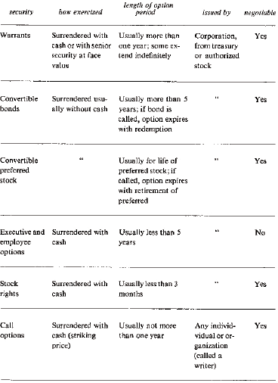

### Convertible Bonds

When a corporation sells a bond, it borrows money. The buyer receives for his cash a con- tract called a bond. The contract stipulates that the corporation will pay the holder a certain (interest) sum annually, usually in two installments. This sum is called the amount of the coupon. Most bonds actually have detachable coupons which are presented to the corpora- tion semiannually for payment. The contract also specifies a date of maturity, or due date, when the corporation will redeem the bond for its face value, usually $1,000.

For example, the Collins Radio Company sold 12,000 bonds in 1960. The bonds have a face value of $1,000 each. The holder of the bond receives $47.50 in interest each year (the coupon) and the bond is redeemable in 1980, when the company agrees to pay the bondhold- er $1,000. Because $47.50 is 4fl% of the face value and because they are due in 1980, these bonds are known as the Collins Radio Company 4fl of 1980 bonds.

The current market *price* of a bond may vary considerably from its face value. If there is doubt about the corporations’ ability to continue interest payments or to redeem the bond for face value at maturity, this will be reflected in a lower current *price* for the bond.

Changing interest rates also cause bond prices to change. When issued, the Collins Radio 4fl of 1980 yielded 4fl% interest. Five years later, in June 1965, interest on bonds of similar quality was 53/8%. If the Collins bond could be sold at $1,000, the proceeds could be invested in bonds yielding 53/8%. The availability of these alternatives thus made the Collins bond unattrac-

tive at $1,000. The price of the bond declined to about $880,* at which price it was as attrac- tive as the investments yielding 53/8%.

For instance, if the bond was purchased at $880, the $47.50 coupon was 5.40% of the principal. In addition, if an investor purchased the bond for $880 in June 1965 and sold it in March 1980 for $1,000, he would realize a capital gain of $120. This capital gain is account- ed for in the calculation of **yield to maturity**, the effective yield of the bond if purchased and held to maturity.

For us the current yield is more relevant. It is calculated by dividing the bond price into the annual interest payment. It is the yield if the price of the bond does not change.

If a corporation wishes to borrow money via the sale of bonds, it may find that investors demand a “high” annual interest payment. A lower interest payment may be accepted if the bond has attached warrants. Or the bond may be convertible into a fixed number of shares of common stock at the option of the bond holder. Such advantages, called “sweeteners,” are common.

The October 1966 issue of Standard & Poor’s *Bond Guide* lists 336 actively traded con- vertible bonds, 164 of which were listed on the New York or American stock exchanges. The total face value of these convertibles was $5 billion. We shall now see that this vast market is a happy hunting ground for users of the basic system and reverse hedging.

### Anatomy of a Convertible Bond

A convertible bond allows the owner to exchange the bond for a fixed number of common shares. A convertible bond can be con-

* We see later that the bond was convertible, sold at $882.50, and the conversion privilege was esti- mated to be worth $2.50.

sidered an ordinary bond plus some number of “warrants.” whence our warrant strategies apply.

Consider the Collins Radio 4fl of ‘80 bond. The holder could surrender this bond to the corporation at any time and receive in exchange 16.25 shares of Collins Radio common stock. In June 1965 the bond sold at $882.50. Suppose now that this bond did not have a con- version privilege. At what price would it have sold? Standard & Poor’s, in its monthly Statistical Analysis Section of the *Bond Outlook*, and Moody’s, in its monthly supplement to *Bond Investments*, estimate what a convertible bond would sell for if the conversion feature were absent. This estimate, the **investment worth** of the bond, is based on the price of sim- ilar quality bonds that are not convertible.

Standard & Poor’s estimated that the Collins 4fl of ‘80 would have sold for $880 if it were not convertible. Therefore, they estimated the conversion feature was worth $2.50. Consider the conversion privilege as equivalent to 16.25 **latent warrants** whose total worth is $2.50. That is, each latent warrant was selling at about fifteen cents.

The exercise price of these warrants is the amount needed to convert them into com- mon. Since the conversion consumes a bond worth $880, the exercise price per warrant is 880 ÷ 16.25, or 54.15. The common stock sold at 255/8, or less than half of the exercise price. At fifteen cents, the latent warrant sold for less than 1% of the exercise price.

Simultaneously, another Collins Radio convertible bond was trading, the 4fl% of ‘83. It sold at $1,125 and was convertible into 36.36 common shares. Standard & Poor’s estimat- ed the worth of the underlying ordinary bond as $870, so that the 36.36 latent warrants were selling at $255, or $7.01 each. The amount surren-

dered upon exercise of these 36.36 warrants would be $870, so the exercise price per war- rant was 23.93.

The position of the two Collins Radio latent warrants in June

|  |  |  |
| --- | --- | --- |
| *6/65 common at 255/8* |  | |
|  | *wt #2* | *wt #1* |
| *Bond price* | *882.50* | *1125.00* |
| *Investment worth* | *880.00* | *870.00* |
| *Price of warrants* | *2.50* | *255.00* |
| *Number of shares per bond* | *16.25* | *36.36* |
| *Exercise price* | *54.15* | *23.93* |

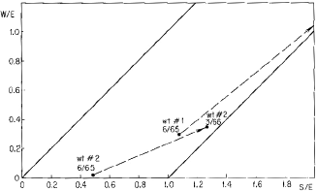

*Figure 10.1. Reverse hedging with Collins Radio latent warrants.*

1965 is plotted in Figure 10.1, the warrant-common diagram. Warrant 2 is clearly a bar- gain at fifteen cents. Investors owning similar quality nonconvertible bonds should have switched to the Collins Radio 4fl of ‘80. These opportunities frequently arise when the com- mon stock is less than half the exercise price.

### Reverse Hedging with Collins Radio “Warrants”

Recall from the Realty Equities example that a warrant is ideal for reverse hedging when it is near the “corner” in the common-warrant diagram. Then if a major upward move takes place with the common, the warrant must move up sharply. If instead the stock sags badly, the warrant will resist decline. The same holds for latent warrants. Furthermore, permitted financing arrangements can make reverse hedging with convertible bonds more profitable than with pure warrants.

Consider this investment in June 1965:

Buy 3 Collins Radio 4fl of ‘83 at 112fi *

through broker, 70% margin $2,362.50 Buy 3 Collins Radio 4fl of ‘83 at 112fi;

bank *lends* 70% of price $1,012.50 Commissions on the 6 bonds $ 15.00 Sell short 100 Collins Radio common at 255/8 0.00 Total cash investment $3,390.00

Three of the 6 bonds were purchased at 70% margin in the account where the 100 shares of common were sold short. Since the 3 bonds are convertible into 109 shares it was not necessary to post margin for the short sale, by Section 220 of Regulation T. Three more bonds were financed through a bank loan. Banks are not restricted by any federal or Exchange regulation in the amount they may lend clients for the purchase of bonds. Banks commonly lend as much as 85 or 90% of the market value of bonds that

* Bond prices are quoted as a percentage of the face value, which is generally $1,000. Thus 112fi is 112fi% of $1,000, or $1,125. The accumulated interest is figured daily and included but not quoted in the purchase price of the bond.

credit-worthy clients wish to purchase. We assumed that the 3 bonds financed through a bank loan required 30% margin.

Now let’s calculate the cost of holding this position. Approximately $3,400 is borrowed at (say) 6%, for an annual cost of $204. The 6 bonds yield $262.50 in coupon payments, for a net interest return of about $55. The common stock was paying $50 per annum in dividends which had to be paid to the lender of the 100 shares of common that we shorted. This near- ly cancels the $55, for practically no gain or loss. The only cost of the investment is the hid- den one of tying up $3,400 in cash.

The 6 bonds represent 218 latent warrants, so this reverse hedge was in the ratio of 2.18 to 1. If the common fell to 11, the investor might expect the bond to sell for $875. (Note the position of warrant 2 in Figure 10.1.) This loss of $1,500 on the 6 bonds is almost offset by the gain from shorting the common. The fall from 255/8 to 11 yields more than $1,400 in prof- its.

In fact, the common moved up by March 1966 to 65fl and the bonds rose to $2,450. This was a profit of about $8,000 on the bonds and a loss of about $4,100 on the short sale of the stock for a net profit of $3,900, a gain of 115% in 9 months.

Warrant 2 then came into a favorable position for reverse hedging (see Figure 10.1). A two-to-one mix would lead to this investment in March 1966:

Buy 6 Collins Radio 4fl of ‘80 at 115 through

broker, 70% margin $4,830

Buy 6 Collins Radio 4fl of ‘80 at 115; bank

*lends* 70% of price $2,070

Commission on the 12 bonds $ 30 Sell short 100 Collins Radio common at 65fl 0 Total cash investment $6,930

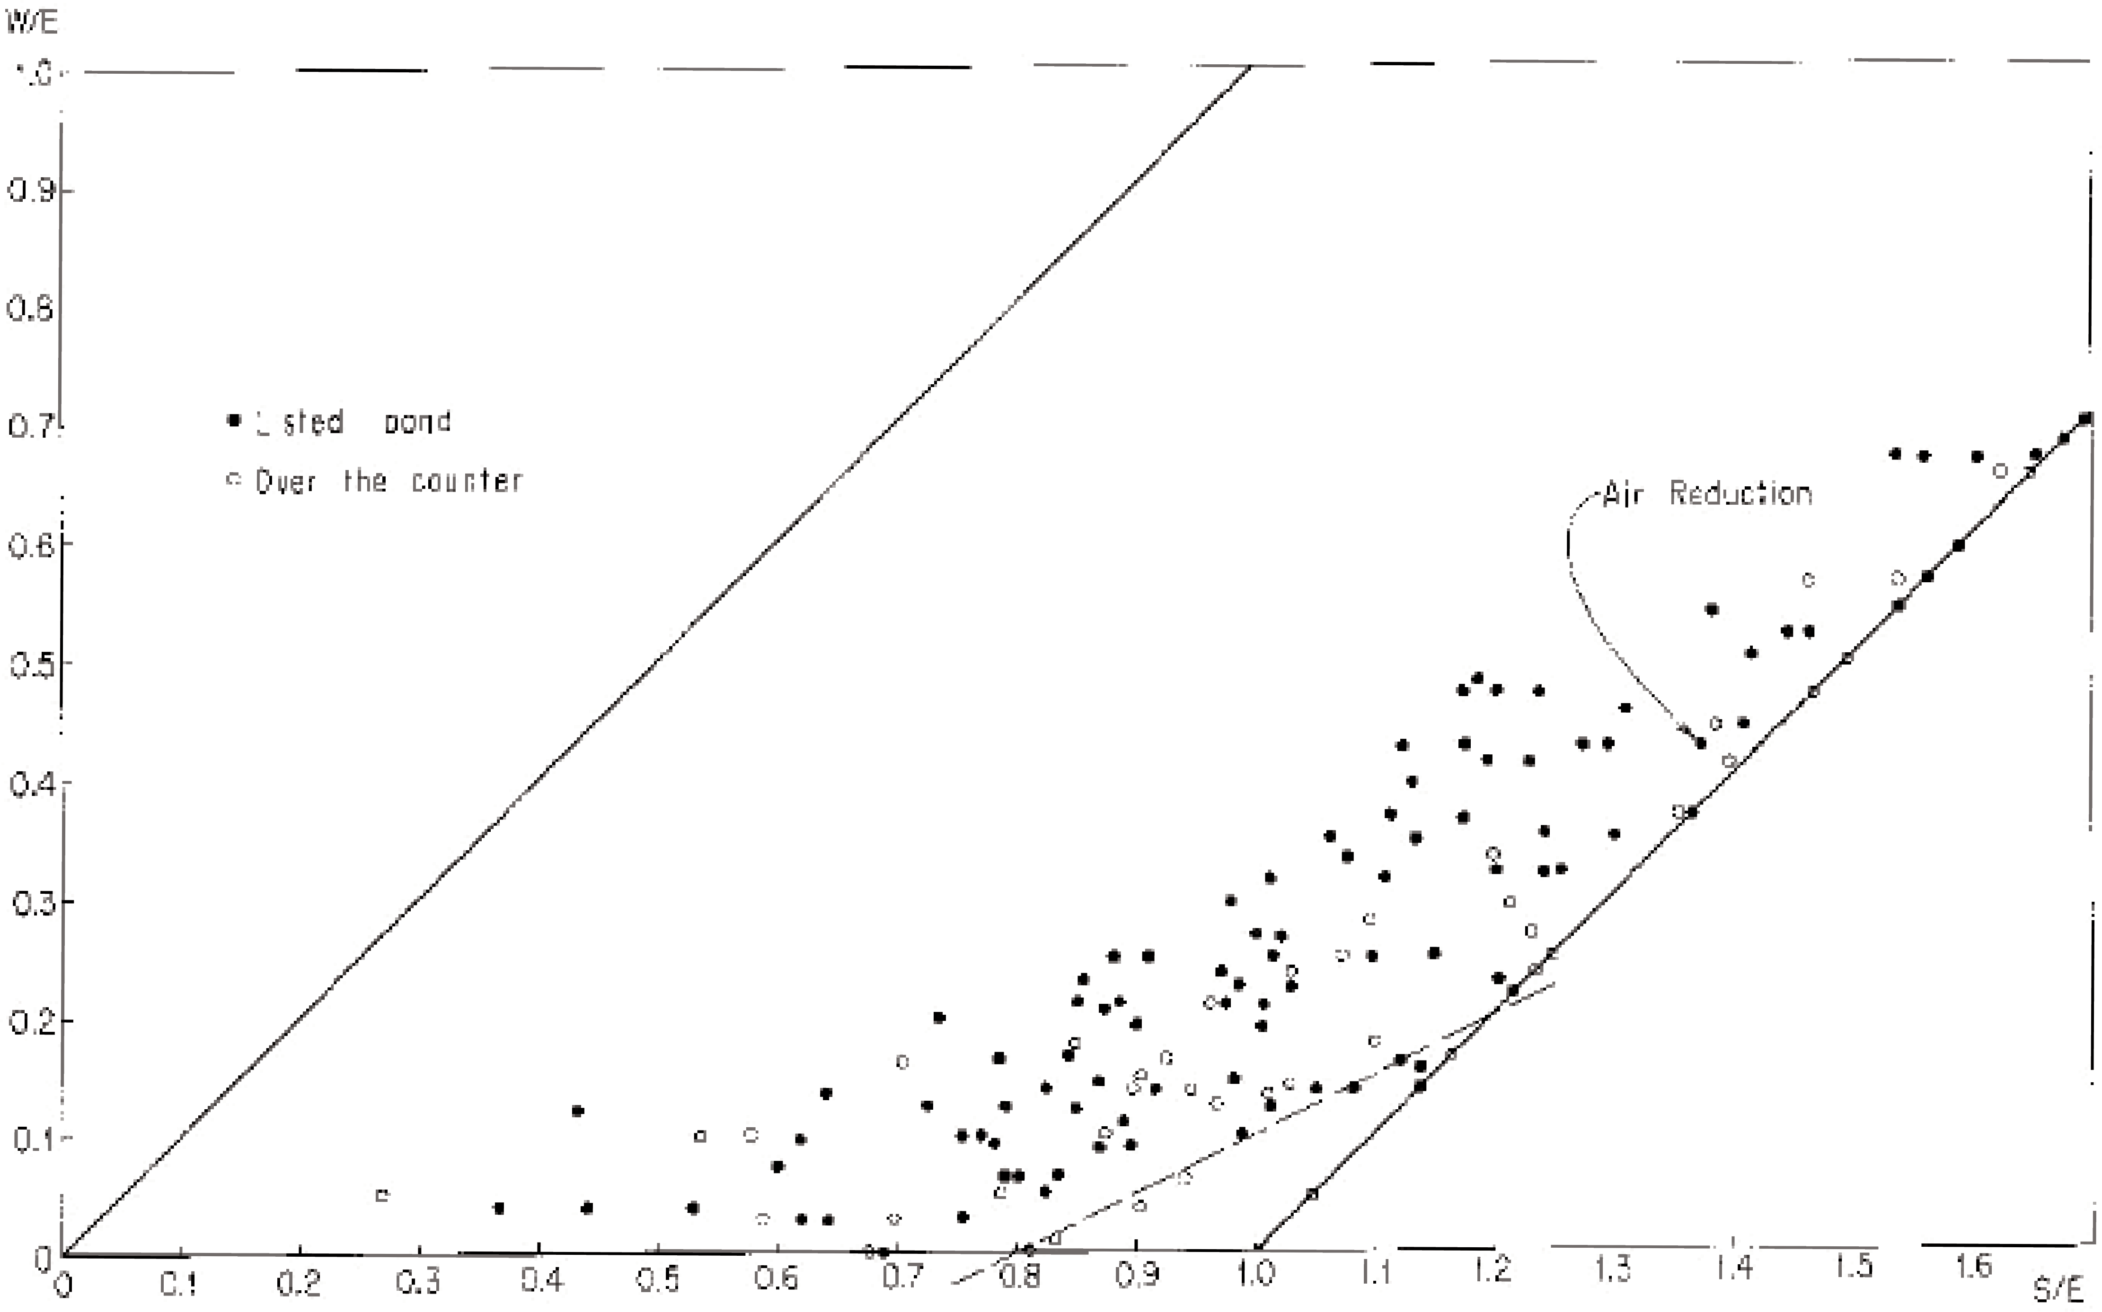

*Figure 10.2. Latent warrants of some convertible bonds, January 9, 1967.*

If the common stock advanced, experience with warrant 1 suggests this reverse hedge would have been profitable. But the common stock fell in 8 months to 44, with the bonds at

$1,010. This represented a loss of about $1,400 on the 12 bonds and a gain of about $2,000 on the short sale of the common shares, for a net gain of approximately $600. On his $6,900 investment this was a gain of 9% in 8 months, low by our standards.

The profit with warrant 1 when the common advanced and the profit with warrant 2 when the common declined show the safety and profit potential from reverse hedging via convertible bonds.

### Picking Convertible Bond Situations

To find the most promising latent warrants we first plot their positions on the warrant-com- mon diagram. This requires identifying S/E and W/E, the standardized prices, just as we did for warrants in Chapter 6. The exercise price E is simply the *investment worth* of the bond dividend by the number of shares obtainable on conversion. The price of the latent warrant W is the difference between the current price of the bond and its investment value, divided by the number of shares obtainable on conversion.

The January 9, 1967, weekly issue of the *Convertible Fact Finder*, published by Kalb, Voorhis & Co. was used to draw Figure 10.2. This issue described 178 listed convertible bonds, all of which were basic-system possibilities. Since the common was usually listed too, most of the bonds were also possible reverse hedges. Of the 147 over-the-counter convert- ible bonds also de-

scribed, more than half were convertible into listed stocks and thus were possible reverse- hedge situations.

We now illustrate how information such as that presented by the *Convertible Fact Finder* was used to plot the positions of the latent warrants in Figure 10.2. The Air Reduction 37/8 of 1987 was convertible into 16 common shares and was selling at 108. The investment worth of the bond (called “Investment Value” by this service) was estimated at 76. The bond therefore sold for $320 above investment worth, making the 16 latent warrants $20 each. The exercise price of a latent warrant was 760 divided by 16, or 47.50. Therefore W/E was 20/47.50, or 0.42. The common stock was at 65, so S/E was 65/47.50, or 1.37. With these values for S/E and W/E, we plot the point labeled Air Reduction in Figure 10.2. All of the bonds are plotted in this way in Figure 10.2.

### Best Candidates for Reverse Hedging

The best reverse-hedge situations are those warrants near the “corner”; that is, warrants for which S/E is greater than 0.8 but less than 1.2, and very low in the diagram. The dashed line which forms a triangle in the lower portion of Figure 10.2 identifies 9 convertible bonds that might be considered foremost for reverse hedging. This dashed line has a slope of 1/2 and represents a zero profit line for a two-to-one mix. If a reverse-hedge position of two to one is taken with any of the 9 situations below it, a profit will result if the warrant position moves *above* the line. Note that a substantial move in the common *in either direction* will necessar- ily move the warrant position above this dashed line.

Figure 10.3 shows the 9 situations on January 9, 1967, with the names of the compa- nies. Holly Sugar seemed the best candidate for reverse hedging unless an investor believed one of the

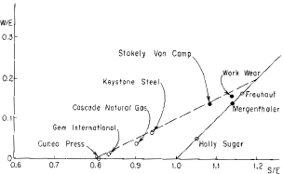

*Figure 10.3. Candidates for reverse hedging on January 9, 1967*

other common stocks was more likely to make a substantial move in either direction. The latent warrants in the upper portion of Figure 10.3 would show a profit in a two-to-one reverse hedge if their common stocks advanced and would probably show no loss if the stocks fell; the latent warrants in the lower portion would yield reverse-hedge profits if the common stocks fell and would probably show no loss if the stocks advanced. Holly Sugar is so low in the diagram, it would probably yield a profit if the stock declined, advanced, or stood still.

This is how an investor might have evaluated Holly Sugar on January 9, 1967. First, he would note that the conversion privilege extended to 1983. (If the privilege expired in less than three

years he would have rejected Holly as a candidate.) Second, the current yield on the bond was about equal to the yield on the common stock. This indicated that he would earn more in interest payments than he would have to pay in dividends on his short position. Third, he would note that the bond was callable by the corporation at 1035/8, well above the present price of 87. This indicates that no loss would occur if the corporation wished to redeem the bond before its due date. In fact, this would result in a profit.

Having thus noted that the conversion privilege extended more than three years, that the yield on the bond was about equal to the yield on the stock, and that there was no danger of a loss if the bond was called, an investor would then draw a profit profile for a reverse hedge. For a two-to-one reverse hedge he would buy 2 latent warrants for every share of common sold short. Each bond is convertible into 48.78 shares so a two-to-one position can be approximated by buying 4 bonds with 195.12 latent warrants and selling short 100 com- mon shares. This would represent a 1.95-to-1 reverse-hedge position.

The best way to enter this situation is to buy only enough bonds through a broker to cover the number of shares sold short, and to finance the balance of the bonds through a bank. This would minimize the cash outlay and increase percentage returns. In this example, this would involve buying 2 bonds through a broker while selling short 100 common shares, and buying 2 bonds through a bank. Ordinarily, financing less than 10 bonds through a bank is difficult. Therefore we assume that 4 Holly Sugar bonds are bought for cash at 87 through the broker who sells short 100 shares of Holly common. (The Holly bonds are traded over- the-counter and cannot be purchased on margin

through a broker.) As explained previously, no money is required to sell short the stock. The total investment is therefore about 4 times $870, or $3,480. We shall ignore commission costs. This is not serious since the interest earned on the bonds exceeds the dividends that must be paid on the short position. This excess then tends to offset commission costs. Let’s estimate the profit of this hedge in 6 months for various price of the common.

If the common is still at 18, it is unlikely that the bond will be less than its present price of 87. If in fact it behaves like the other convertibles pictured in Figure 10.2, the bond will be higher than 87. To be conservative, assume that if the stock is unchanged at 18 in 6 months, the bond will remain unchanged at 87. This indicates a zero profit return on the investment.

We might conversatively assume that if the common moved to its high of 21, represent- ed by S/E of 1.24 in Figure 10.3, the bond would return to is high of 110, slightly above the minimum value line. This would result in a profit of $920 on the bonds and a loss of $300 on the stock, for a net profit of $620, or 17.8% on the investment of $3,480.*

If the common falls to 13fi, represented by S/E of 0.8, we may conservatively assume the bond will fall to is investment worth of 83. This would result in a loss of $160 on the bonds and a profit of about $450 on the stock for a net profit of $290, or 8.3% on the invest- ment.

Plotting these estimated percentage profits against the price of the common yields Figure 10.4. Different mixes would be represented by different profit profiles, but almost all have this prop-

* Note added in press: May 4, 1967, 4 months after this was written, the common was at 34fl and the bond was at 172, for a net profit of $1,725, or about 50% in 4 months.

erty: a profit results whether the common rises or falls. An investor who believed the stock was more likely to rise than fall would choose a mix of more than two to one; an investor who was

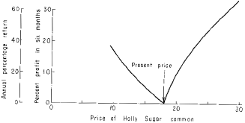

*Figure 10.4. Profit profile for Holly Sugar 2 to 1 reverse hedge.*

pessimistic would choose a smaller mix, perhaps as small as one to one.

### Basic System with Latent Warrants

Unlike pure warrants, latent warrants seldom take on large premiums. There are many rea- sons for this:

1. To purchase a latent warrant an investor must also purchase the bond, and this may be inconvenient.
2. The expiration date of a latent warrant is uncertain because the latent warrant expires if the corporation “calls” the bond. A call provision is part of most bond contracts. When a convertible bond is called, the holder has the option of either converting it into common stock or redeem-

ing it for the call price (usually a few points above face value). * If the bond was purchased below the call price, no loss will result; if the bond was purchased above the call price, the bond will fall to the higher of the call price or the value of the shares that may be obtained on conversion. (This latter value is the conversion value of the bond. It equals the price of the common times the number of shares that the bond may be exchanged for.)

1. The exercise price for latent warrant fluctuates with the investment worth of the convertible bond. This worth in turn varies with the interest rate structure of alternative investments. This uncertainly does not exist for the holder of pure warrants.

Despite these reasons for lower premiums on latent warrants, some are suitable for the basic system. To use the basic system with latent warrants one must sell short the convertible bond and go long the common stock.

Consider the Xerox 4% of ‘84. This bond is convertible into 10 shares of common stock. In December 1964 its investment worth was estimated by Standard & Poor’s at $910; the bond sold at $1,310; the common sold at 94. The exercise price for the latent warrant was 91 and the latent warrant was at 40. ($1,310 less $910 indicated that the 10 warrants were selling at a total price of $400.) The common stock, at 94, was 3% above exercise price and the warrant was at 44% of exercise price. This position is plotted on Figure 10.5. this was an usually high premium

*In rare cases true warrants may be called by the corporation at a specific price before expiration. For example, the United States Finance Corporation warrants were callable in 1962 at $5, although their ostensible expiration date was December 15, 1975.

for a latent warrant; it reflected investors’ optitism for Xerox Corporation—they could pur- chase the bonds on thin margin so they were willing to pay a large premium.

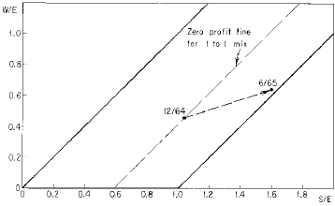

*Figure 10.5. The basic system with Xerox latent warrants.*

Figure 10.5 shows the zero profit line for a one-to-one mix taken in December 1964. Recall that if the common-warrant position moves below this line, a profit results. An investor familiar with latent-warrant premiums would have realized that it would be unusu- al for the common-warrant position to move above this constant profit line; if the common advanced, the probability was high that the position would fall substantially below this line, and if the common fell, the position would probably fall slightly below, or remain on, the constant profit line. (If this position is plotted in Figure 10.2 it can easily be seen that the latent warrant was extremely overpriced.) Assume then that in December 1964 the following investment was made:

|  |  |
| --- | --- |
| Buy 100 Xerox common at 94 | $ 9,400 |
| Sell short 10 Xerox 4% ‘84 at 131 | 13,100 |
|  | $22,500 |
| Margin 70%—total cash invested | $15,750 |

Margin on the short position must be posted because the common stock is not convert- ible into the bonds. (We neglect commissions in this example.) If the common stock fell, the position of the Collins Radio warrants in Figure 10.1 suggests that the common-warrant posi- tion would remain below the constant profit line, for a fall of 40% or less in the common.

The up-side potential is a matter of fact. By June 1965, about 6 months later, the stock was at 143 and the bond at 155. This is a gain of $4,900 on the common stock and a loss of

$1,400 on the 10 bonds, for a net gain (ignoring commissions) of $3,500, or 22% on the cash investment in 6 months.

### The Basic System with Dresser Industries “Warrants”

A strict application of the basic system requires that relatively short-term warrants be sold short. In the preceding Xerox example, the latent warrant had a potential life of twenty years, but the unusually high premium appeared temporary and suggested a basic-system hedge. We turn now to an expiring latent warrant that satisfied the basic-system conditions of Chapter 6.

In November 1965 the Dresser Industries 41/8% ‘77 bonds were at $1,190 and the com- mon stock was at 27fl. The bond was convertible into 36.36 shares until March 1, 1967; the investment worth was $940. The exercise price of the latent warrant, 250 divided by 36.36, was 6.88. The common stock was thus 7%

above exercise price and the warrant was 27% of exercise price (Figure 10.6). This latent warrant meets all the criteria of Chapter 6.

|  |  |  |
| --- | --- | --- |
|  | *11/65* | *11/66* |
| *Bond* | *119* | *100* |
| *Stock* | *27fl* | *28* |
| *Invest, Worth* | *94* | *86fi* |
| *Exer. Price* | *25.85* | *23.79* |

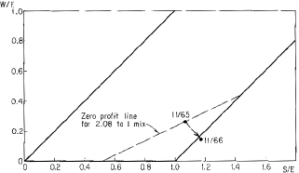

|  |  |  |
| --- | --- | --- |
| *Figure 10.6. The basic system using Dresser Industries “warrants.”* |  |  |
| Consider the following basic-system position: Buy 100 common shares at 27fl | $2,810 |
| Sell short 6 Dresser 41/8 ‘77 at 119 | 7,125 |  |
|  | $9,935 |  |
| Margin 70%—cash investment | $6,955 |  |
| We have included approximate commissions because they | are considerable | in this |

example. The 6 bonds were convertible into approximately 208 shares, so this position was short 2.08 warrants

159

to every common long. The constant profit line for this mix is shown in Figure 10.6. It sug- gests that a gross profit will result if the common does not fall to less than 14 or rise beyond 37.

One year later, with the common at 28 and the bond at $1,000, these warrants slipped slightly below the minimum value line. With no premium left in the warrants, the position should be liquidated. The result: a loss of about $25 on the stock, a gain of about $1,110 on the short sale of the bonds, interest payments of about $250 on the bonds sold short (the bond short seller must pay the bond’s interest to the lender), and $112 received in dividends on the common stock. This is a net profit after costs and commissions of about $950 on the invest- ment of $6,955, or about 14% in one year.

### Finding the Best Basic-System Hedges with Convertible Bonds

To find basic-system candidates among convertible bonds proceed as in Chapter 6 with one important difference. The normal price curves shown in Figure 6.3 do not apply to latent war- rants. In general, latent warrants sell at smaller premiums. Therefore, after the latent warrant basic-system candidates have been plotted in a chart similar to Figure 10.2, their positions should be compared to the positions of all other latent warrants. In the example above, the Dresser Industries warrant was at a point representing S/E of 1.07 and W/E of 0.27. This point in the warrant-stock diagram is about average for all the latent warrants shown in Figure 10.2. Therefore, since the Dresser warrant expired in a short time, it was worth exam- ining as a basic-system candidate.

There is one other difference involved in entering a basic-system position with latent warrants. All calculations must include the

interest cost of holding the position. With pure warrants, no interest is paid while an investor is short. With latent warrants, an investor can be short only by being short with convertible bonds. This means that while the basic-system position in latent warrants is held, interest is paid to the lender of the bonds.

### Convertible Preferred Stocks

A convertible preferred stock, like a convertible bond, is equivalent to an ordinary preferred stock plus latent warrants. The price of an ordinary preferred stock, like a bond, is determined by yield and safety. But a preferred stock has no face value and is not redeemable at a fixed date. It behaves like a “perpetual” bond. Most convertible preferred stocks are callable by the issuing corporation, so in practice they have a finite life span due to changes in interest rates. Once an estimate is made of the investment worth of the underlying ordinary preferred,

the value of the latent warrants can be calculated just as with convertible bonds. The impor- tant differences for hedging are the increase in commission charges (preferred stock commis- sions are the same as common stock commissions) and the impossibility of financing pre- ferreds through a bank on thin margin.

### Call Options

The primary options are puts and calls; combinations of these are called straddles, spreads, strips, and straps. The marvelous maneuvers possible with them led Fred Schwed, Jr. in the hilarious *Where Are The Customer’s Yachts?*, to observe that put-and-call houses are con- stantly

pointing out to possible buyers of options that they are a splendid thing to buy, and pointing out to possible sellers that they are a splendid thing to sell. I have even heard them, when they are excited (and excitement is the normal state of mind of an option broker even when he is home eating his supper) present both viewpoints in the same session . . . . One wonders why the problem of unemployment cannot be solved by having the unemployed buy and sell each other options, instead of mooning around on those park benches.

A **call** is a short-term warrant; it seldom has a life of more than one year. It differs from a warrant in that it is “issued” by an **option writer**, or seller of options, rather than by the corporation into whose stock it may be converted. Calls are not traded on any stock exchange. This introduces some differences when they are used in the basic system or in reverse hedging. To buy a call, margin cannot be used. The full cash price must be advanced. To sell or write a call, an investor must maintain in his brokerage account the common stock into which the call is convertible, *or* he must post margin of 30% of the market value of such shares, less the premium received.

For example, on October 14, 1966, an advertisement in the *Wall Street Journal* offered a call on 100 shares of Sperry Rand common for $625. The exercise price (for calls this is termed the **striking price**) was 24. The common stock closed that day at 237/8. The call expired in one year. A purchaser would have advanced the full $625 and he would have owned a one-year Sperry Rand warrant exercisable at 24. If an investor sold this call, he would have had to advance 30% of $2,400 less $625, or $95, as margin.

Buying a call is equivalent to buying a warrant; selling a call is

virtually the same as shorting a warrant. Thus calls may be substituted for warrants in the basic system or for reverse hedging.

Calls also give rise to other opportunities. When the call on Sperry Rand, excercisable at 24 and expiring in one year, was advertised at $625, the Sperry Rand warrant sold at an adjusted price of $6.83 on the American Stock Exchange. It expired in 11 months and was exercisable at $25.93. Thus the traded warrant had a higher price, a higher exercise price, and a closer expiration date. It was in every way inferior to the call as a purchase. This discrep- ancy could be arbitraged.

If an investor bought the call for $625 and simultaneously sold short 100 traded war- rants for $683, he would have had to make a gross profit in 11 months of at least $58. If the common stock was above $25.93 when the call expired, he would make a gross profit of at least $250.

The market for calls is mainly in the most actively traded common stocks. Therefore opportunities such as the above are rare. If option trading spreads, those who understand war- rants will have further profit opportunities.

### Puts, Calls, and the Basic System

A **put**, like a call, is a negotiable contract; the owner of a put has the privilege of selling com- mon stock at a specified price (the striking price) before a specified time (the expiration date of the option), to the writer of the contract. For example, consider a put on 100 shares of ABC common stock with a striking price of $40 and good for one year. The holder of this put, any time within one year of the date of the contract, may sell 100 shares of ABC to the writer for

$40 per share. For this privilege, he may have paid the

write $500. (In practice, the buyer of the contract does not deal directly with the writer; an option broker acts as middleman and receives the considerable fee of 10% or so for his serv- ices. The buyer may have paid $500 for the put, but the writer may have only received $450. We shall ignore the broker’s fee in the following example.)

The owner of the put profits if at any time during the year ABC common falls below 35 and he exercises his option; he can purchase the stock in the market at less than 35 and sell it to the writer for 40. This results in a profit since he paid $500 for the contract. Buying a put is similar to selling the stock short—profits are made when the stock declines.

The *writer* of the put will benefit if the stock never sells below 35 during the year of the contract. If the stock never sells below 40, the put will not be exercised and the $00 pre- mium received for writing the contact will be clear profit. If the option is exercised when the stock is between 35 and 40, the writer of the put will have a gross profit of the difference between 40 and the price of the stock.

For instance, if the option is exercised when the stock is 38, the writer must pay $4,000 for stock that is worth only $3,800. This $200 loss, when offset by the $500 premium received for writing the contract, results in a profit of $300. Writing a put is therefore some- what similar to buying the common stock—profits are made in both cases when the common stock rises. The writer of a put can pictorialize his prospects as in Figure 10.7a.

Similarly, the writer of a call can pictorialize his prospects as in Figure 10.7b. If the stock never rises above 40 during the contract period, the call will not be exercised and he will profit by the premium of $500. For every point above 40 he will earn $100 less; his break-even point on the up-side is 45.

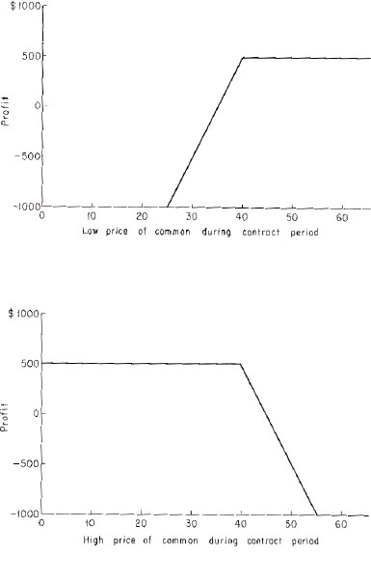*Figure 10.7a. Potential profit for writer of put who received $500 premium. Put is exercisable at 40.*

*Figure 10.7b. Potential profit for writer of call who received $500 premium. Call is exercisable at 40.*

Now consider the investor who simultaneously writes a put and call on a common stock with equal striking prices of 40. An option which consists of a put and a call with identical striking prices is called a **straddle**. The writer of the straddle received a $1,000 premium. If the buyer of the straddle exercises his privilege only at the end of the option period, the strad- dle writer can view his prospects as in Figure 10.8. He loses only if the common falls below 30 or rises above 50. Note the similarity of Figure 10.8 with Figure 4.1, the profit potential for the basic system. Selling straddles is very similar to the basic system.

As an example of straddle writing consider an advertisement in the *Wall Street Journal* of July 12, 1966. An option broker was bidding $400 for a 65-day straddle on United Artists, with the striking price at the market (the price at which United Artists was selling). United Artists closed at 435/8 on that date. Assume an investor had sold a straddle and received a

$400 premium. He would have had to post margin for the straddle, consisting of 30% of 435/8 less the amount of premium he received; 30% of the market price of 100 shares of United Artists is $1,309; this amount less the $400 premium is the amount the seller of the straddle had to post as margin. How would he have fared with this $909 investment?

During the 65-day option period, United Artists common fluctuated in a narrow range and it is unlikely that either the put or call would have been exercised. On the last day of the period, the stock closed at 43⁄. The difference between 43⁄ and 435/8 is not sufficient for the put to be exercised. The holder of the put would have to pay 43⁄ plus commissions for the stock he might sell to the writer of the straddle. His total cost would be more than the 435/8 he would receive. Thus the writer of the straddle would prob-

ably have gained the entire premium of $400. This is a 44% return on his investment in 65 days.

Selling straddles differs from taking a basic-system position in

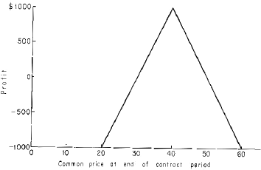

*Figure 10.8. Potential profit for writer of straddle at 40 who received $1,000 premium. We assume that the option buyer exercises his privilege only at the end of contract period.*

that the straddle seller has no control over when the investment will terminate. The holder of the options may exercise them any time within the contract period. Both the put and the call might be exercised profitably if the common stock seesaws sufficiently. The seller of a strad- dle could therefore suffer losses greater than Figure 10.8 indicates.

*Chapter 11*

# DECIPHERING YOUR MONTHLY STATEMENT

You can more fully use your funds in the basic system or in reverse hedging if you can deci- pher your monthly statement. Thus a basic accounting knowledge of your statement can make the investments we describe still more powerful.

### Your Brokerage Account

Your security transactions during the month and the final position of your account are detailed in the monthly statement mailed to you by your broker. We illustrate with a typical format and terminology, as this varies with the brokerage firm. Since all statements contain the same information, it should nonetheless be easy to use our discussion with your own monthly statement.

### The Cash Account

Your general account may consist of many subaccounts, three of which are important to us. They are the cash account, the margin account, and the short account. Transactions in the **cash account** are always paid for or received in full. There are not short sales and no margin transactions.

If $1,000 worth of a security is purchased in the cash account then $1,000 must be deposited. If securities worth $1,000 are sold, the cash account is credited with $1,000. The cash-account portion of a statement might look like this:

YOUR CASH ACCOUNT

*Debit Credit*

Jan. 2 Check re-

ceived 5,000

Jan. 3 Bought 100

ABC 4,000

Balance Jan. 31

100 ABC 1,000

This account was opened January 2 with a check for $5,000. On January 3, 100 shares of ABC were bought for $4,000. The balance in the account on January 31 consisted of 100 shares of ABC and $1,000. Note that when cash flows into your account, the account is **cred- ited**; when cash flows out, the account is **debited**. The uses of the cash account will be clear when we discuss buying power.

### The Margin Account

The margin account (sometimes called the long account) is another subdivision of the gener- al account. Transactions are recorded here when securities purchased are not paid for in full. The margin-account portion of a statement might look like this:

YOUR MARGIN ACCOUNT

*Debit Credit*

Jan. 10 Bought 100

XYZ 5,000

Jan. 14 Check re-

ceived 3,500

Balance Jan. 31

100 XYZ 1,500

This account reveals that 100 XYZ were bought on January 10 for $5,000. Payment for these shares was not made in full; on January 14, the client paid $3,500 toward the purchase. The balance at month’s end indicates that the client holds 100 XYZ and has a debit balance of $1,500; he owes his broker $1,500. This is a typical margin purchase. The client advanced 70% of the cost of the purchased securities and borrowed the balance from his broker. The debit balance in the margin account is the amount owed to the broker. He charges interest on this, at least 1/2% more than the prime rate, depending on the size of the account. If you have a large account with a debit balance, insist on the minimum interest charge.

The Securities Exchange Act of 1934 empowered the Board of Governors of the Federal Reserve System to prescribe the **minimum initial margin** for the purchase of a list- ed security. (With the exception of government and municipal securities, brokerage houses cannot lend clients money to buy over-the-counter securities.) Since 1934 this margin has ranged from 40% to 100%. With a minimum amount of 100%, margin transactions become cash transactions.

In this chapter we take the minimum initial margin prescribed by the Federal Reserve as 70%. In the margin account above, the client advanced exactly this minimum of 70% toward the purchase of $5,000 worth of securities. His **equity** (approximately, his net worth) in this account is the market value of the securities less the debit balance (owed to the bro- ker). Equity is the amount before commissions that the investor will receive in cash if he liq- uidates the account. Therefore, the equity of the account fluctuates with the market value of the securities in the account. For instance, if the market value of the 100 XYZ becomes

$6,000, the equity is about $6,000 less $1,500, or $4,500. Note that the debit balance in the margin account does *not* fluctuate with the market value of the securities—at the start this client owed his broker $1,500 and this does not change with the price of the securities.

The Federal Reserve prescribes the amount of margin required to purchase listed secu- rities; the New York Stock Exchange (and other exchanges) prescribe the margin to be main- tained at all times in the account, the **maintenance margin**. This is the equity of the account divided by the market value of the account. It is (approximately) that portion of the market value of the account that the investor would have if the account were liquidated.

For instance, if the value of the 100 XYZ fell to $4,000, the equity in the account would be $4,000 less $1,500, or $2,500. This $2,500 equity is 62fi% of the market value of the account, so the maintenance margin would be 62fi%. As XYZ falls, the maintenance margin falls. Suppose New York Stock Exchange regulations required that the maintenance margin be at least 25%. If the value of XYZ fell to $2,000 (a drop of 60%), the equity in the account would be $500. This is 25% of the market value and the client would get a maintenance mar- gin call to send more cash, failing which, some of his securities would be sold by the broker.

The Federal Reserve and Stock Exchange requirements are minimums. Many broker- age houses raise the maintenance margin requirement to 30%. Some houses have a higher initial margin than prescribed by the Federal Reserve, particularly for low-priced or specula- tive issues.

If the equity of an account is greater than the *initial* margin requirement, the difference is **excess equity**. For example, when the 100 XYZ became worth $6,000, we calculated the equity in the account above at $4,500. The initial margin required for an account with mar- ket value of $6,000 is $4,200 (70% of $6,000). Therefore, at this point, the account would have an excess equity of $300. Excess equity is loose cash. It may be withdrawn or it may be invested. With 70% margin, the $300 excess equity may be used to purchase $300/70% or $430 in securities, and the account is said to have $430 **buying power**. (Federal Reserve Regulation T, Section 220.4(c)(7) states that if a transaction results in a margin requirement of less than $100, the broker may, at his option, not require his client to post additional funds. The broker then can allow $399 to be invested, giving about $570 in buying power.)

If the equity in the account falls below the initial margin requirement (but remains above the minimum maintenance requirement), the account is **restricted**; that is, it has no excess equity or buying power. We shall see that this is usual with basic-system or reverse- hedge investments.

In a restricted account, new transactions are made by posting initial margin on those transactions. The deficit in equity need not be made up. For instance, the equity in the account above was $2,500, or 62fi% of the market value, when XYZ fell to $4,000. The equi- ty was $300 less than the initial margin requirement on securities valued at $4,000. But to purchase additional securities

worth $1,000, only $700 is required; the deficit of $300 may be ignored.

A restricted account may also engage in **same day substitutions**. For instance, if a sale of $1,000 of securities still leaves the account restricted, the purchase (or short sale) of anoth- er $1,000 in securities is nevertheless permissible provided it is done the same day. Frequently, a position is liquidated in a restricted account, and to preserve the buying power of the account, the proceeds of the liquidation are used to buy short-term bonds that do not tend to fluctuate in price. Then when conditions permit, these bonds may be sold and basic- system or reverse-hedge positions may be substituted (Chapter 12).

To withdraw cash from a restricted account, some securities must be sold. Then 30% of the proceeds of the sale, plus any excess equity that may develop, may be withdrawn. The 30% figure may be changed from time to time by the New York Stock Exchange.

The total cash balance in the cash account may be withdrawn at any time regardless of the condition of the margin account. Similarly, the proceeds from the sale of any securities in the cash account may be withdrawn at any time. Dividends on stocks and interest pay- ments on bonds held in the margin account are deposited in the cash account and so may be withdrawn completely even though the margin account is restricted. Thus in a restricted account the cash account is a haven for funds that would otherwise lose buying power by being absorbed.

### The Short Account

The third major subdivision of the general account is the **short account**. It reflects all short sales and short covering during the month. It might look like this:

YOUR SHOR T ACCOUNT

*Debit Credit*

Jan. 2 Sold short

100 WWW 5,000

Jan. 5 Check re-

ceived 3,500

Jan. 5 Transferred to margin

acct. 3,500

Balance Jan. 31 Short 100

WWW 5,000

In this account, the client instructed his broker to sell short 100 WWW on January 2. The proceeds of $5,000 were credited to his short account. The client posted $3,500 within four trading days, in accordance with initial margin requirements set by Regulation T, and this was credited to his account. Note that it was then transferred to the margin account, leav- ing only the proceeds of the short sale as a credit balance in the short account. The margin is opted only as collateral; this collateral can be held in the margin account and will help offset interest charges that develop there.

The credit balance in the short account is limited to the net proceeds of the short sale. These proceeds cannot be diverted to the margin account because they were given to the lender of the certificates as collateral. If the broker did not have to borrow the certificates from outside and was able to use the certificates of one of his other clients, the proceeds than remain “inside” the house.

Nevertheless, they cannot be used to offset interest charges in the margin account. In effect, the broker has the use of these funds interest-free while the account is short. The statement of the short account indicates that if 100 WWW are delivered to the account, the credit bal- ance of $5,000 can be transferred to the margin account.

The equity in the short account is calculated as the credit balance less the market value of the short securities. If, for instance, the credit balance is $5,000 and the value of the secu- rities sold short is $5,000, the equity in the account is zero. Roughly, this indicates that if the short account is liquidated (the short position covered), the client will recover zero dollars. *This should be the status of the short account at all times*. The credit balance in the short account should always equal the market value of the securities short. This is accomplished by marking the account to the market, which is now explained.

In contrast to the margin account, where the debit balance does not fluctuate with the market value of the securities in the account, the credit balance in the short account does change with changing security prices. For example, suppose after selling short 100 WWW and receiving proceeds of $5,000, the value of the 100 WWW falls to $4,000. Then the client (through his broker) can demand the return of $1,000 from the $5,000 left with the lender of the securities as collateral; only 100% of the market value need be left with the lender of the certificate. This $1,000 is then transferred to the *margin* account, where it may offset inter- est charges against the debit balance. Therefore, only $4,000 will remain with the lender of the certificates and that is the amount shown as the credit balance in the short account.

If instead the market value of the 100 WWW had risen to

$6,000, the lender of the certificates would have demanded from the short seller an addition- al $1,000 as collateral. This would be transferred out of the margin account and given to the lender of the certificates. Since the lender now has $6,000 in collateral, the balance in the short account is $6,000.

These adjustments of the credit balance in the short account, as prices of the short secu- rities change, are called **marking to the market**. Accounts are not always marked to the mar- ket, indicating that the broker, perhaps, did not have to go outside to borrow the securities. In cases where a mark to the market would transfer funds to the margin account, offsetting a debit balance, the broker should be instructed to do so. This cuts interest charges in the mar- gin account.

Consider again the short account above. It suggests that the value of 100 WWW on January 31 was still $5,000. The initial maintenance required to enter this position was trans- ferred to the margin account. What about the required maintenance margin? The New York Stock Exchange requires a minimum of 30% maintenance margin on a short position, as opposed to 25% for a long position. Assume, for example, that the short sale above is the only transaction in his entire account—no purchases were made in the margin account. Then his margin account would have a *credit* balance of $3,500, the margin that was posted, and the short account would have a credit balance of $5,000, the proceeds from the short sale. His equity in the short account is zero and his equity in the margin account is $3,500. If the value of the 100 WWW rises to $6,500, the short account is marked to the market and $1,500 is transferred from the margin account to the lender of the certificates. The credit balance in the margin account becomes $2,000 and the credit balance in the short account becomes

$6,500. The equity in the short account is still zero and the equity in the margin account is now $2,000. The equity has fallen to about 30% of the market value of the securities sold short. At this point the investor might receive a maintenance margin call.

### Calculations in a Mixed Account

The important figure to calculate, for our purposes, is the account’s current buying power. We want to capture and use this whenever it appears, thereby stretching (leveraging) our funds to a maximum.

The cash account is but a temporary stopping place for funds so it usually has a zero cash balance. The cash account also may contain over-the-counter and other nonmarginable securities. The cash account, and hence these securities, may be ignored when we calculate the current buying power in the account.

Suppose an investor is both long and short and that the short account is marked to the market. Then the equity in his short account is zero and the equity in his margin account is the equity of the entire account. (If your statement is not marked to the market, you can com- pute the transfer and then calculate the total equity in the account.)

From the total equity of the account, determine the buying power, if any, as follows. If all securities at current prices qualify for 70% initial margin, calculate the market value of all securities, both long and short. If the total equity exceeds 70% of the market value of the securities, the difference is the excess equity in the account. It may be withdrawn as cash or it may be invested in new securities on the same basis as cash.

For example, suppose the total equity in the account is $5,000

and the market value of the long and short securities is $6,000. Then $5,000 less 70% of

$6,000 is $800. This is the excess equity in the entire account. Without posting additional cash, this excess equity represents 10/7 x $800 = $1,143 buying power toward 70% margin- able securities.

The initial margin required for the securities may vary from one percentage figure. In 1966 the margin for securities under $2.50 was $2.50 per share, between $2.50 and $5 it was share value, and above $5 it was the greater of $5 per share and 70%. When the margin varies on the securities held, the calculation of excess equity is as follows. Using current market value, compute the initial margin required for all securities held long or short. If the total equity exceeds this, the difference is the excess equity.

To check the maintenance margin, calculate 25% of the market value of the long secu- rities plus 30% of the market value of the short securities. If this is less than or equal to the total equity, a maintenance margin call is due.

### Applicability to the Basic System

The market value of a basic-system position can change drastically with very little change in total equity, as described in Chapter 9 under Volatile Price Movements. For instance, if the securities in the account both fall in price, the resulting loss on the common long will prob- ably be offset by the gain on the shorted warrants. The equity will be close to the starting equity. But the market value of the securities is much less; this generates buying power, which the investor can exploit.

If instead both securities rise in price, any rise in equity will probably be much less than the rise in market value. Now the

account will be restricted. This too may be profitable. If the position should be closed out, a new position can be taken in another basic-system position by substituting the market value of the liquidated position for the new one. If this cannot be done the same day, the liquidat- ed market value can be saved by temporarily buying short-term bonds. This preserves the increased buying power until it is needed.

This leads to investments on small margin. That is ordinarily very risky, but when used with the basic system, where moves in either direction rarely lose, small margin is a virtue.

*Chapter 12*

# PORTFOLIO MANAGEMENT

Your portfolio is your total security holding. In managing it you have to decide how to appor- tion your funds between competing attractive situations. You also have to choose whether to use margin, and if so, how much. What should you do if there is a violent rise or fall in the price of one of your securities? These are typical questions of portfolio management. Though the answers are often complex, there are general principles which serve as guides. We illus- trate some of these principles with situations from the basic system.

### Exploiting a Rise in the Price of the Common

Figure 8.1 shows that in January of 1966, Ed Thorp was about 200 adjusted Sperry warrants short for each 100 shares of common long. He had paid on average about 16 for the common and had sold the warrants at an average price of about 6. Six months later when the common was about 27 and the warrants were about 10, Thorp liquidated at a profit as explained in Chapter 8.

Besides the profit., Thorp secured an advantage that generally occurs when a basic-sys- tem position is liquidated after a large rise

in the price of the common. Suppose for simplicity that just 100 shares of Sperry common were purchased at 16 and that 200 warrants were shorted at 6. With initial margin at 70%,

$1,120 was required to buy the common, and $1,000 was needed to short the warrants, for a total initial margin of $2,120.

When the common later rises to 27, the equity in the common is the $1,120 initial mar- gin plus the 11 point or $1,100 profit, or $2,220. But the equity in the warrants is the $1,000 initial margin minus the loss of 4 points per share, or $800, leaving an equity of $200. Total equity is now $2,220 plus $200, or $2,420, including a profit of $300.

The market value of the securities short and long is $2,000 plus $2,700, or $4,700. The equity behind them is $2,420/$4,700, or 51% of their value, so the account is restricted. Note too that the equity ($2,420) is less than the value of the common ($2,700) by $280, so the broker is charging the account interest on this difference.

If we liquidated our Sperry position our $2,420 in released equity enables us to buy on 70% initial margin just $2,420/.7, or about $3,450 worth of new securities. But there is a spe- cial regulation known as the same day substitution rule, * which will let us keep our buying power equal to the $4,700 value of the liquidated securities. We can continue to operate on 51% margin!

The regulation permits an investor to buy or sell new securities equal in value to any he may sell or cover in his account without putting up additional margin even though the account is restricted. However, this must be done on same day.

It may not be either possible or desirable to reinvest on the same day. In the actual sit- uation with Sperry, Thorp wanted to put

* Regulation T of the Federal Reserve System, Section 220.3(g).

part of his released funds into a basic-system position in Pacific Petroleums and wished to hold the rest to await developments. Even if he wanted all his released funds in Pacific Petroleums, it might not have been possible in one day. Remember that a short sale can be made only on an up-tick. If there was no up-tick in the warrant price that day, no warrants could be sold short. Even if there was an up-tick, there might be so few buyers or so many sellers that the desired number of warrants could not be sold short.

A simple solution is to preserve buying power by purchasing short-term listed bonds. In the actual situation, Thorp sold 200 Sperry common at 271/8 and covered 100 warrants at 10 and 300 at 10fi. After commissions, his account was credited with $5,349.77 proceeds of the common and was debited $4,219.50 for covering the warrants. This gave him $9,569.27 buying power to preserve under the same-day substitution rule. He could invest up to

$9,569.27 in new securities without putting up additional margin.

Thorp on the same day then bought 200 Pacific Petroleums at 11fi for a net debit of

$2,337 and sold short 200 Pacific Petroleums warrants at 53/8 for a net credit of $1,050.21. This used up $3,387.21 of the one-day buying power. To save most of the rest, Thorp bought 6 Pennsylvania Railroad bonds at 991/8 for a net debit including commissions and interest of

$5,988.33. He saved all but $193.73 of the one-day buying power. The bonds were paying 5% interest and were due for redemption on December 1, 1968. The bond commission each way was a mere $1.25 per $1,000 bond, or about .25% round trip. (Ordinarily the commis- sion would be $2.50, but for short-term bonds the commission is reduced.) This is about two and a half weeks interest, so after that length of time the bonds would be returning a profit, provided the price stayed at 991/8.

### Exploiting a Decline in the Price of the Common

If a rise in the price of the common leads to advantages for a basic-system investor, a decline might be expected to produce disadvantages. Strangely enough, a decline may also be advan- tageous! To see how this works, suppose in the Sperry example that after our purchase of 100 common at 16 and shorting 200 warrants at 6, the common declined to 10 in 6 months. The warrant, with about 14 months to go, would probably sell at about 2fi. We invested $2,120 as before, lost $600 on the decline of the common, and gained $700 from the fall in the war- rants. Our profit of $100, or about 5%, is discouragingly small and would barely cover com- missions.

But we can benefit from the decline. Much of our equity is now released and may be reinvested. With 70% margin the common requires $700 and the 200 warrants at 2fi require

$500, for a total of $1,200. Our initial equity plus $100 in profit exceeds the margin require- ment by $1,020. This can now be reinvested, nearly doubling our position in Sperry. But most important, the warrant and common are now much more favorably positioned in Figure 6.1 than they were, and our future expected rate of return is much higher.

### Diversification?

Suppose you have two equally attractive investments. Should you put all your money in one of them or should you somehow divide it between them? Different people answer this in dif- ferent ways. We prefer to divide our funds equally. To see why, suppose that we have avail- able to us two investments, each offering us a 50-50

chance of no profit or of doubling our money. If we have $1,000 and we put it all in one of them, we end up with either $1,000 or $2,000. The “average” payoff is $1,500.

But if we put $500 in each of them, we end up with $1,000 if both shown profit, with

$2,000 if both show a profit, and with $1,500 if one shows a profit and one doesn’t. Again the “average” profit is $1,500, but now we are more likely to get a profit. Only if both invest- ments fizzle do we come away with no profit.

Now consider a long series of such investments, as in the historical analysis of the basic system in Chapter 7. Let two individuals compete, one putting all his money into just one alternative each time, and the other diversifying equally between the two. It can be shown mathematically [14] that the profits of an individual who diversifies will tend to far surpass those of the individual who does not!

This is illustrated in Figure 7.2, where we compare the results of only buying common, of only shorting warrants, and of dividing our funds (hedging) between the two. This last strategy outperforms the other two. Notice that hedging is just an unusually efficient way to reduce risk by diversifying.

In the case of equally attractive investments, remember the old adage “Don’t put all your eggs in one basket.” In fact you should divide your eggs equally among your baskets.

If there are two attractive investments but one is much better than the other, this no longer holds. Put nearly all your funds in the better investment.

### Having Several Accounts

Suppose you have a basic-system position in two companies. It may happen that one com- mon stock rises and the other one falls.

If the two positions are held in one account, the advantages which accompany a rise in price (operating on lower margin) and a fall in price (releasing funds for favorable reinvestment) will tend to cancel each other. The funds released from one position are automatically applied against the other to bring the margin up to the initially required amount. We can preserve these advantages by opening an account with a new brokerage house each time we take another position.

A separate advantage of having accounts with several houses is that it is easier to locate securities to short. Also one can compare the regulations of the houses (interest rates on loans to you, whether they will short the securities you want them to) and the brokers (efficiency in handling orders, particularly over-the-counter and Canadian). Multiple accounts, howev- er, also mean more paperwork and phone calls for you and make it harder to keep track of your portfolio.

### Long-Term Gains

Profits on short sales are always taxed as ordinary income. But if you buy common stock, hold it more than 6 months, and then sell it, any profit is a long-term capital gain. This is taxed at a preferential rate, currently the smaller of 25% or one-half of what would be due if the gains were ordinary income. Thus there is a possible tax advantage in holding a basic- system position for more than 6 months.

Basic-system positions were the warrants have less than 6 months until expiration are therefore less attractive than they might otherwise seem. Of course, if the common shows a profit when the warrant is covered, the common could be held the full 6

months before being sold. Similarly, suppose a position has been held for almost 6 months and a decision has been made to close it out. If part of the profit is from a rise in the com- mon, the probable tax saving might dictate holding either the common or the whole position for the full 6 months. These decisions will vary with the individuals’ portfolio and tax situa- tion.

*Chapter 13*

# WHY WE ARE SHARING THE SECRET

Suppose you had discovered our system. How would you exploit it? You could begin by investing as much of your own money as possible. We did this ourselves. Your next step could be to invest the money of others and perhaps get payment of some kind. Suppose you charged one-fifth of the net realized profits, payable annually. If you made 25% per annum on the principal you would receive one-fifth of this, or 5% per annum, and the investor would receive 20%. Both should be satisfied.

But if a person is so compensated by fifteen or more people, he must register as an investment advisor with the Securities and Exchange Commission, or S. E. C. The S. E. C. prohibits profit sharing by such registered investment advisors, because of possible abuse. For instance, one could invest each client’s money in a different volatile stock, without believing that these stocks were good investments. Since the stocks are volatile, they may change greatly in price. For those stocks that fall the advisor gets no commission, but for those that rise he shares the possibly large profit.

Investment advisors frequently charge their clients one-half of 1% of the principal. This amounts to $5,000 per year on each $1

million invested. On a $1,000 account, the advisor gets $5 per year. Why bother? Advisors therefore generally set a minimum limit on the size of their accounts.

Charging a percentage of the principal meets the S. E. C. objection to profit sharing.

But the client might now object that he pays whether or not the advisor is competent.

Investment advice is also given by services to paid subscribers. The annual fees range from a few dollars to $500 or more. The subscribers generally receive a regular information bulletin, and some services offer assistance in managing portfolios.

A booming, successful stock market service can be a lucrative business. But it impos- es on its creators the obligation of a business. They must devote most of their efforts to it for the years needed to make it work.

Suppose you had discovered our system and wanted to profit from it beyond your own investments, you you did not want to spend the best years of your life as a businessman. You could hope to secure the accounts of fewer than fifteen millionaires and share the profits. Ten

$1 million accounts earning 25% per year and paying one-fifth of this, or 5% of the princi- pal, yields $500,000 per year. With 90,000 millionaires (people with $1 million in assets) in the United States, it should be easy to sign up ten.

### They Wouldn’t Believe Us

We found that millionaires are surprisingly hard to come by. The S. E. C. prohibits you from soliciting accounts unless you are a registered investment advisor, and if you become one it prohibits profit sharing. We couldn’t advertise for millionaires but we knew several and described to them the results of our research.

We expected them to be sympathetic and willing to accept the

possibility that there was a scientific system for stock market profits. One of us had recently published a winning system for blackjack [19], the first time a casino game had ever been effectively broken. Surely we should be taken seriously if we claimed we could make con- sistent profits in the market.

But millionaires are a skeptical bunch. How could these whippersnappers succeed where they had been baffled for a lifetime? How could these academics foretell a price move- ment more accurately than they, who are business experts or financial advisors with a life- time of experience in evaluating companies, their personnel, and their prospects?

A typical reaction was, “Maybe you can calculate the odds in blackjack but the stock market is psychology and you can’t figure that.” The card game of poker depends on bluff and psychology. Can we figure that? In simplified forms of poker with two players, mathe- matical strategies have been discovered which tell you how to bluff best! By routinely fol- lowing these mathematical prescriptions, you will in the long run play as well as or better than any opponent who does not—no matter how sophisticated, or tricky, or crafty he may be. This mathematical mastery of bluff and psychology is being used today in economic the- ory [20].

We are misguided when we exalt ourselves by insisting that the psychology of the mar- ketplace and of man are unknowable. The sciences of man are now emerging from the dark ages. Economics and psychology stand today at Koestler’s watershed * just as astronomy did in time of Tycho Brahe. Our superstition, blind belief, and ignorance are being swept away forever by the scientific accumulation and analysis of data. There will be science and pre- dictability in the affairs of men.

* Arthur Koestler, The Sleepwalkers. Macmillan, New York, 1959.

### I Want to Do It Myself

One oil baron with an income of more than $1 million a year (there were 35,000 people with such magnificent incomes in 1964) * was not excited when he learned that we were making 25% a year in the market. Suspecting the reason, one of us questioned him closely and learned that he expected to earn 50% on his assets in the coming year. All his funds were committed to his oil business and he was hungrily seeking more cash. It was more profitable for him to invest his money himself.

One of our millionaire friends saw his equity in the market shrink from $1 million to

$400,000 during the 1966 crash. He then invested $20,000 with us. After he got a glimmer of the method from the trade slips, he commented that it was a “sure thing.” He accepted our estimate that it would most probably take about four or five years to expand his $400,000 to

$1 million again.

This was too slow for him. In his heart he believed that this market which had so quick- ly sliced his $1 million to $400,000 would just as quickly give it back again. He was not the owner now of a mere $400,000, but rather of $1 million that was whimsically imprisoned and that must soon be returned to him. To get his $1 million back he would have to invest his money himself, presumably by the same amazing methods that had recently been so costly.

We knew that he wondered how our abstract “system” could produce better profits than his investments. The investments which dealt him such rapid, enormous losses were recom- mended by close

* Philip M. Stern, *The Great Treasury Raid*. Random House, New York, 1964.

friends on the inside of companies. These tipsters assured him that they too had lost tem- porarily. But they were investing even more now that prices had fallen to such bargain lev- els. When prices rebounded soon, all losses would be wiped out, the originally expected prof- its would be realized, and the extra investments made at bargain prices would yield a fortune. Yes, he would rather do it himself.

### The Threat of Rediscovery

We have seen a few of the problems of investing the money of others for profit. But why bother with this? We saw in Chapter 7 that seventeen years of investment in the basic system would have turned $10,000 into $222,890 (i.e., 10 times last entry of Table 7.1). Why not invest $10,000 or so now, forget it, and retire in seventeen years?

One reason is that seventeen years is a long time to wait. But our crucial reason is that we don’t think we have seventeen years. We believe that the basic system and our other meth- ods will be rediscovered more and more frequently. Many of these ideas were explained in Kassouf’s *Evaluation of Convertible Securities*. The several thousand copies which have cir- culated since 1962 are continually causing people to examine the basic system. We shall see in Chapter 14 that when enough money is finally invested in the basic system it will be ruined.

Three years after Kassouf’s book, Fried’s warrant service included a few basic-system hedges among its many recommendations. Some of Fried’s thousands of subscribers will eventually realize, either from trial and error or by reasoning, that the hedges consistently give them large profits.

The most serious threat comes from the halls of academe. The scientific analysis of securities prices has been pursued in Ameri-

can universities with increasing intensity during recent years. Some of the important papers appear in *The Random Character of Stock Prices*, published by the M. I. T. Press. The last part of the book discusses work in options, including warrants. One of the nation’s leading mathematical economists, Paul Samuelson of M. I. T., has studied warrants for eleven years [15]. This group, undoubtedly aware of the technique of hedging, must eventually recognize the enormous profit potential of the basic system and related methods.

We learned just how widespread the concept of hedging was when Ed Thorp addressed the Air Force Eleventh Annual Summer Scientific Conference. In his discussion of recent developments in probability and game theory, he said there was now a stock market system which produced 25% per year with high safety, and that large fluctuations in market price had a comparatively small effect on the profits. With this clue, a member of the audience, Colonel Beckham, immediately suggested hedging warrants. Hours before Thorp’s talk, Dr. Tom Bean had mentioned to him in passing that one of his recent investments had been a hedge in Sperry Rand warrants. We have had two other instances where we briefly described the system and had our listener guess the warrant hedge.

In each case where someone guessed the hedge, or even had tried it, we found that they did not grasp the profit potential. They either rejected it as not very profitable, not safe enough, or they tried an imperfect version, had indifferent results, and gave up.

Even though we knew of no other basic-system players outside our own circles, it was “in the air.” We believed that within a few years enough people would be well enough on to it so that it would become common knowledge. Someone would write this book with its attendant benefits. We felt it should be us.

*Chapter 14*

# WHAT THE FUTURE HOLDS

When investors apply our methods on a large scale, this may unfavorably affect the prices of the securities. What would happen, for instance, if many people were to try to buy Sperry Rand common at 20 and short Sperry warrants at 10? The increased supply of warrants for sale might lower the price below 10. If the common rose to 22 and the warrants fell to 9, late- comers could find a less attractive basic-system investment. If the common rose enough or if the warrants fell enough, the Sperry situation could no longer be profitable. Figure 14.1 illustrates this.

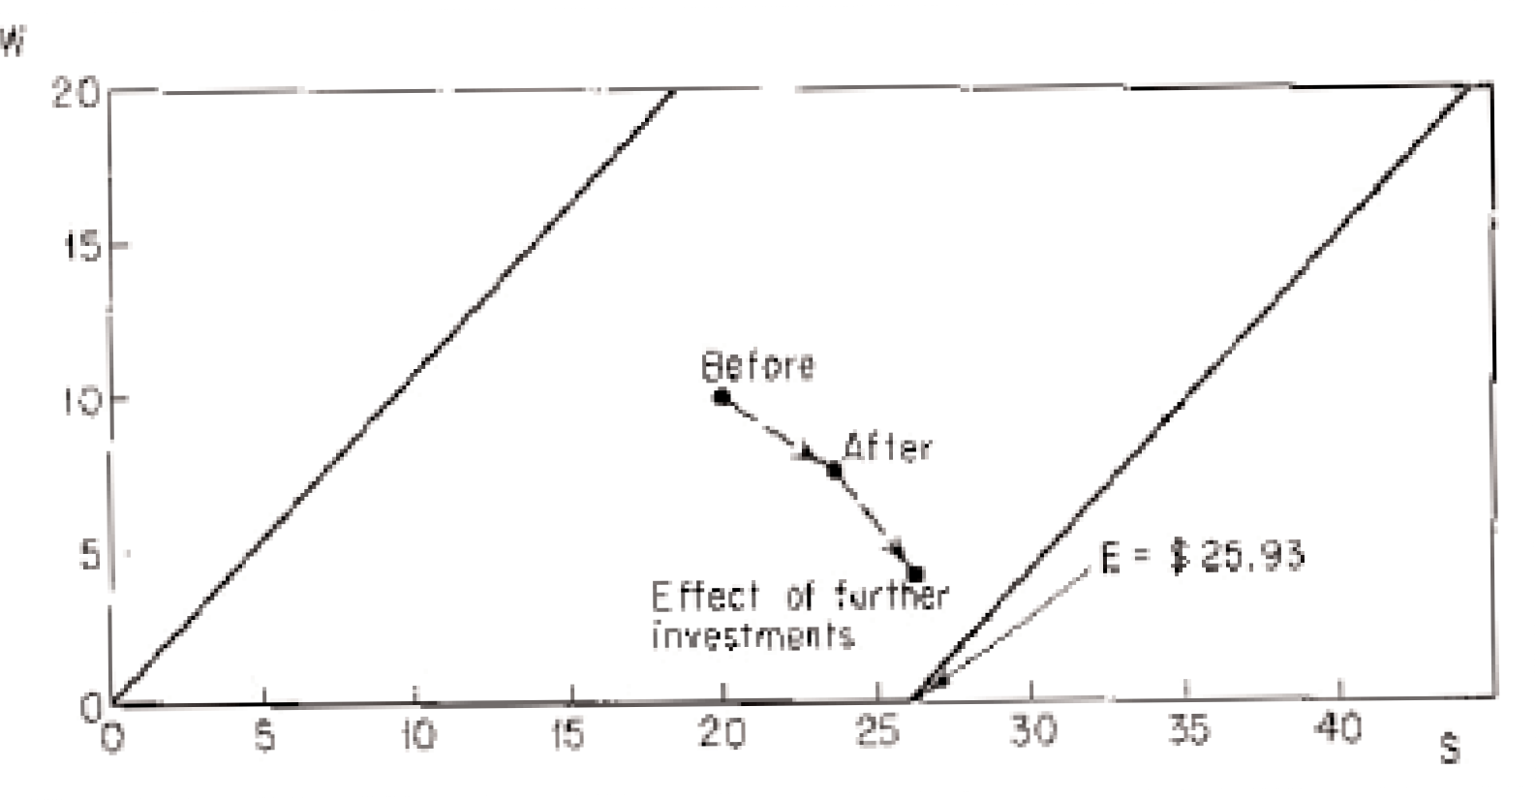

*Figure 14.1. Illustrating the effect of basic-system investments in a hypothetical Sperry Rand situation.*

### How Much Can Be Invested in the Basic System?

The basic system will be the first of our methods to be ruined by widespread use, because it is the easiest to use and is explained here in the most detail. How large an investment will it take to do this? How will this ruin happen?

We don’t know how much it takes to unfavorably change the prices as in Figure 14.1. But we can get some idea as follows. On October 14, 1966, the best basic-system situations were Pacific Petroleums, Sperry Rand, and Universal American. Table 14.1 shows us the short interest in those warrants, as reported on October 14, 1966, by the American Stock Exchange. If the entire short interest had been part of basic-system positions with a mix of three to one, the table shows that $4,600,000 could have been invested in all. Since these were all excellent situations on October

*Table 14.1. The possible basic-system investment in three prime situations as they were October 14, 1966.*

*Margin was 70%.*

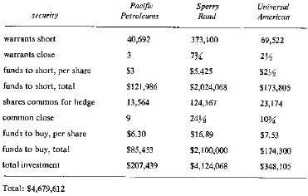

14, 1966, we see that the basic system alone could have supported at least $4,600,000 with- out being ruined.

The full potential of just the basic system was much greater, but limited. To see this limit, note that even if large basic-system investments do not spoil the prices, they will cause a large short interest. When this happens, the American Stock Exchange will probably ban further short sales in the security, thus preventing further basic-system investments. Suppose that the Exchange bans short sales when the short interest is half the total issue of warrants. If this happened for Pacific Petroleums, Sperry Rand, and Universal American, with their prices as of October 14, 1966, Table 14.2 shows that $15 million could have been invested in these three situations before the ban.

*Table 14.2. A conceivable upper limit to basic-system investments in three prime situations on October 14, 1966. We assume prices are as they were then, but that the short interest has reached half the outstand- ing number of warrants.*

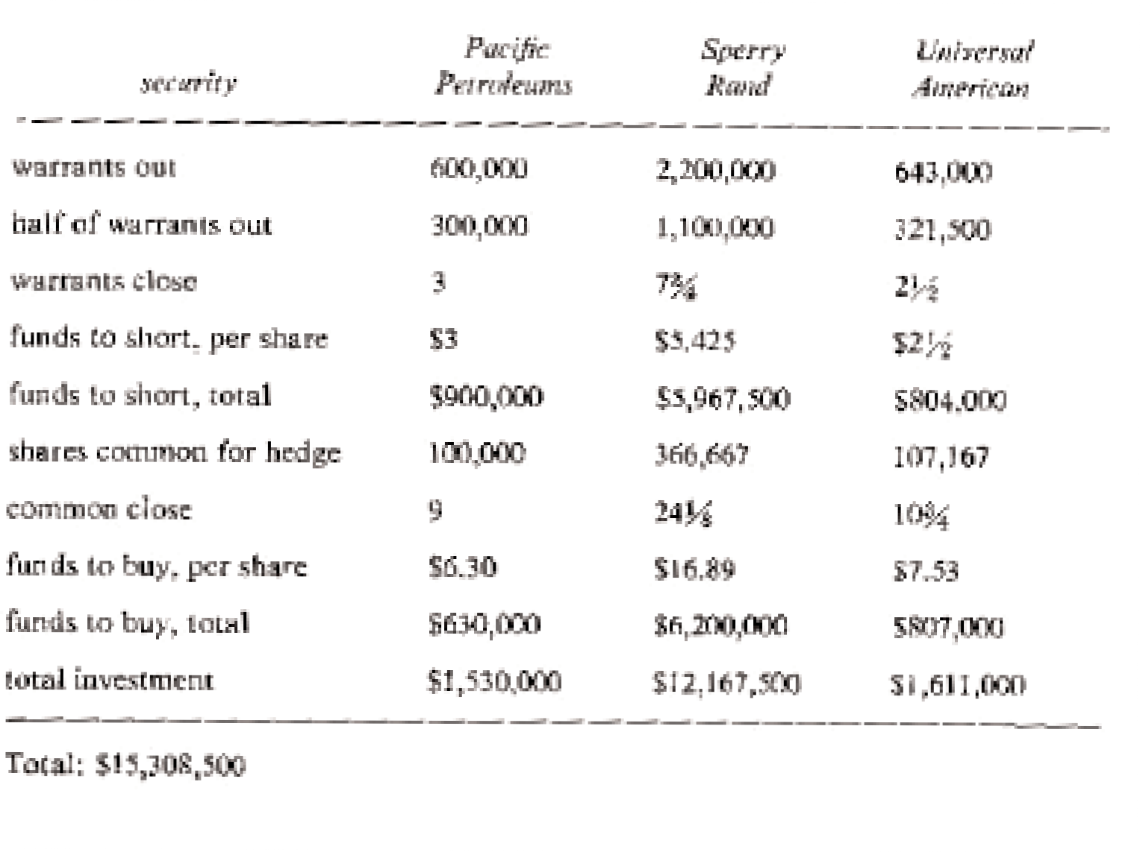

How long will it be before the basic system is ruined by massive investing? The only comparable situation we know of is Thorp’s winning blackjack system. Several years after it was published players were still successfully using it. It is true that the $15 million which could perhaps be invested in our three illustrative basic-system situations is a tiny sum in the multibillion-dollar stock market. A single fund could invest this much. We note though that only a few funds are allowed to sell short. We might therefore hope for several years’ life in the basic system.

### How Much Can Be Invested by the Entire System?

If the basic system is lost, we can turn to convertible bonds, convertible preferreds, puts and calls, over-the-counter and Canadian warrants, and foreign options. Convertible bonds and convertible preferreds cover a large area of investment. The face value of actively traded con- vertible bonds is $5 billion. It will be many years before all the opportunities in these secu- rities are identified and negated by massive investments.

### A General Solution for the Stock Market

The grand dream of stock market researchers is a method which predicts the price movement of the major common stocks, such as the 30 Dow-Jones industrials. Naturally we are not referring to perfect prediction; we mean enough prediction to give the investor an edge of perhaps 20% or more a year.

Now that computers are widely available, many groups are attempting this (and perhaps succeeding?). We are convinced that we can now eventually find a prediction method for the major common stocks.

**A.PP DIX**

, ner I i.l t c.: t t

stand ur 11 h d •.

p

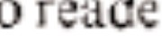r:'i. <H• d r

ur' o rea , di c I t a d f I ss

 to e d .1i to u • d o d r-

*1at1t 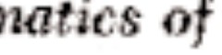* *th*

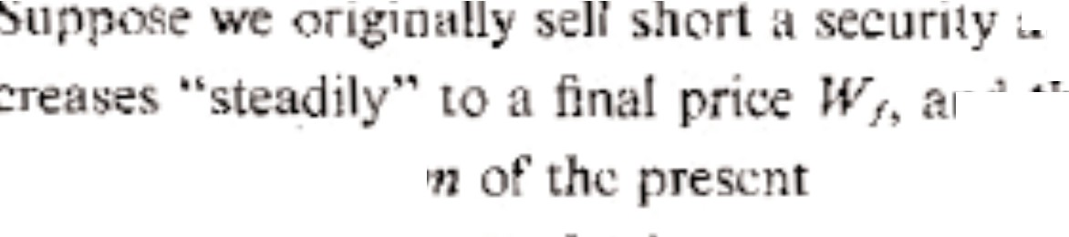

* t pri

n t h

ri • . 0 • • •

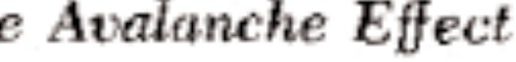

*W* th t th p t<.: d -

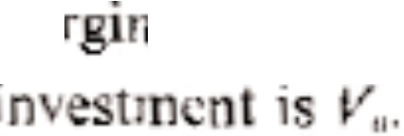rn rquin..di·"

th • f, U we ·ornp1 ·e ur ., dditionL1 b i p r o rt

h re . F r, impJidt, w • ne1lcct transa ·t'• n c t . f we· limitin pr ·es,es f' niili r i th ale tlu , we find o 1 pr fit *J>* i to

g d a pr, im'l•t *n) *

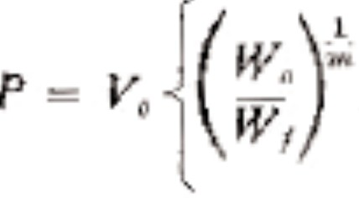

- h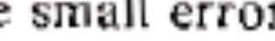r in th ormula om • om th fa t t *t*

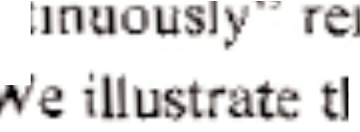in *: t* • he ri dr ps.

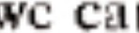 nn t

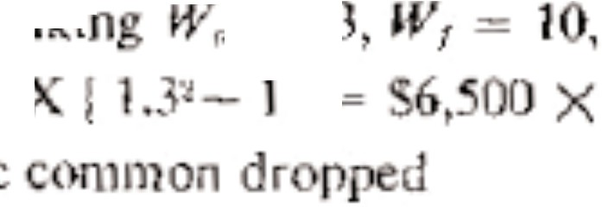b it 'lb] ' .. T,· •

nz-1 V=.65 =. 00

. 9 -= H· *d* e • d h

r> = 1

*½* tl

n1pu ofit in th woul :e ; e • t thi •. tn

t e bl . led nfy a t ·r the *p*, fe.ll a. ull r oint

l

pro t \'­

= 3,

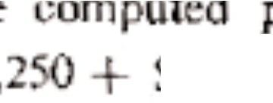

l.5'.

the om w • t ·n,aJlcr am unt $1

1.

n gt

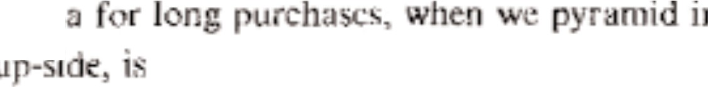

lll

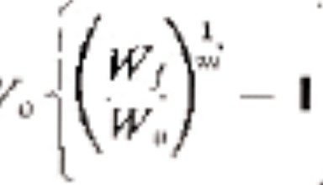the " , mann r n th

*P=*

01 ·r • . c , • , nt m· *r* u 

a har

equir4;<J

*p* ,,

yi • tiappr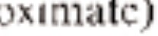

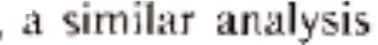p1(WII- f - I.

f mul

mu. r te ag in wi 3

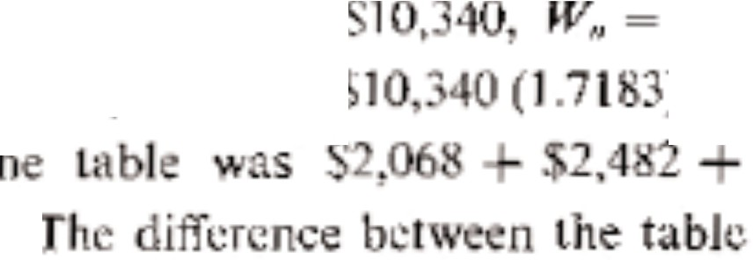

.J

***V,.*** =-

l *==*

10

.

*1 * = *5.* l

m

. ,07 4 + ,7

a11<l th ula ha t la ti n prcvi nsl *1•*

Th M iUu. t ti n at the nd

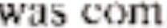 p l ·u fr 1 1 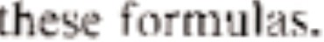

Chapter.

1. *OtJ !'t'•th ou11l r and Canadiat1 Warr nts*
   * r-lh • unter, d , 1 adian war-

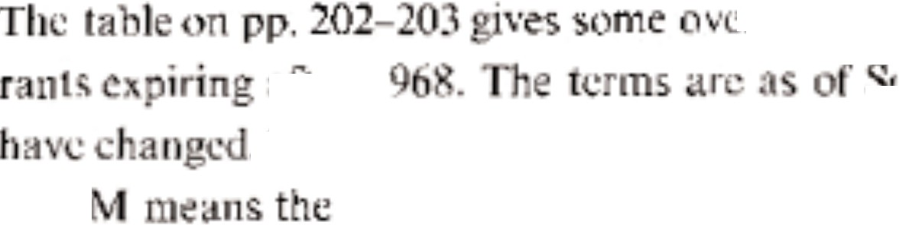

a r I

. Tb·n

that ntr .. I

, ·pte 1b ·r l d ,

, T· e .I, it t 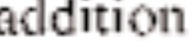

1. 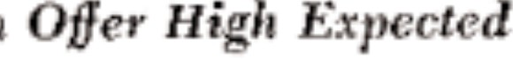*i .nl'i*• *Pr of T at* ff *d* 'ng *Cm*

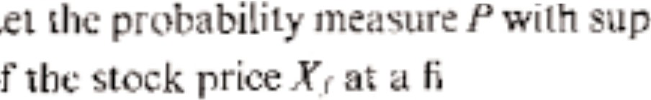p

time, ...• n • r•

***R t11Yn***

d dis ·ibuti<. ir ti d· t : i.h n

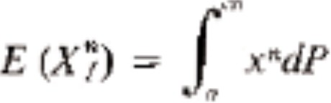

h pr • t p• •• n I ·t

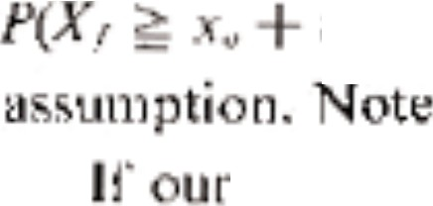*I* = ***P(.*** *J* = ·., -

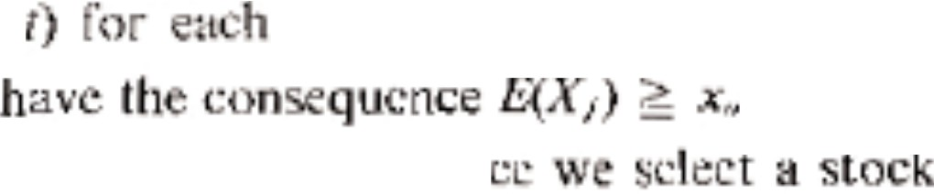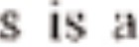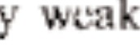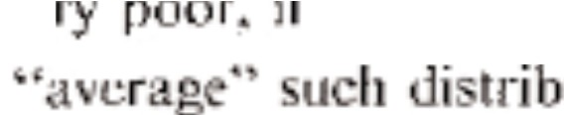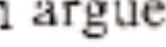

that it <l Jes

1*nf*ornu-tti n •·t *i* c

lh  f)fl C,

*0.* Thi

* f r ,nstan

S Um"' **l l**

ea

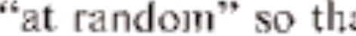 *fl* i Ult

ha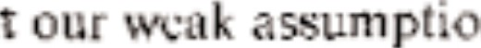n i • ti . TJ i i

utio 1. we ca1

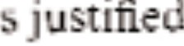t h' h p

tion by *th* n arch h *win* that real t pri e h nge ate ppr xi-

|  |  |  |  |
| --- | --- | --- | --- |
| y rtn I y o | I n rn, l y i t rr b 1t • l-1. |  | |
| 1  rant ar h rL d | sh· t f' , mor1 art pur h· sed • . an  t . £. Th final gain *G* ' ti 1 | IOO | ar- |

*G1* = *X1* - .. *E* if *E*

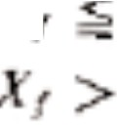

*X*

-*1* = .. *E* if

|  |  |  |  |  |  |
| --- | --- | --- | --- | --- | --- |
| Th' lead to  U ingl | - | tr, th | per | um *nt* i a ! rd  entprofitisE(G1).J.7£ | m urc,th ti .  28'. With I |
| margln |  |  | nd | 70 '; rn· rgin | n ll i t I t |
| > |  |  |  |  | .4 *(.·* |
| n Frida  th... r |  | m |  | Pa ·Hie tr< I ·llm  n lp-ti t | 1-:1with  tr |
| t |  | 1 |  | 1.1 hur | t e JU d |



Tho  o 1t t o y ar log re • h1 h a .2

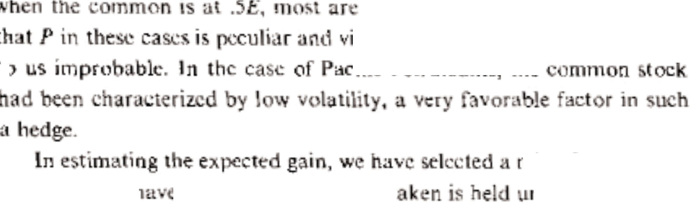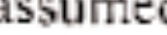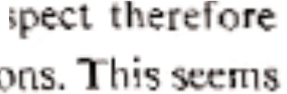

.

no.

u

.

t

,

e

H1

mix , f • rr· nts t

ntil atior . lf

w How • *r* ,rrary rni • or inter • tc to

,r th mi .

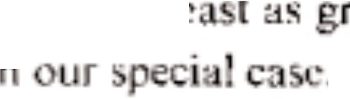hq• th m im m gaH wj l *i*

|  |  |  |  |  |  |  |  |
| --- | --- | --- | --- | --- | --- | --- | --- |
| warrant wa  . 3 h | | |  | 19£, • od  ir i I | the at  m . ·h | .-{/17.27. or  31 19 . | |
| he • m • **b**  **t** *5* .'.·ft *(G 1)* > .1 | | | *E.* | o, £G('1  liu,. ·1t tb pr | . t6 .. 1f t HJ• •  v ilin m· ·gin 1ate | re d  r 70 */* on th, | |
| t: mm n | .J7 | . l | *E* | :v Lid | h | n •t | d |
| r 1it wo | ld |  | l | *(* "1.7'5{ | r | , . |  |

id t 1 1 th .. g jn •

rca and *i* r a ly o

***e.*** *rgt fjJi>Sted odjsut*

*I* .*J*.,.

*SI*

Uffe"' *Xr! .-J,q*.*,*

*Jf{l* ' ll r1t1Jl *P piu• tt1 I' u-e*

T T Albtrte G Trunk L111c

0 ALI Pepsi-Cota

-69 j

Ul 7. *2*

,.,

0 Pork l(} l{H. *t*

|  |  |  |  |  |  |  |  |  |
| --- | --- | --- | --- | --- | --- | --- | --- | --- |
| A | | | l 7 | | | | t | |
|  | 0 | R |  |  | 2- | |  | 7.SU |
| 0 |  |  |  |  | 1- I | |  | 13.06 |
| T |  | Brnrnal |  |  | -7 | |  | 10 |
|  | 0 | Brili h | mi | rica11 C<1n. | 69 | | l | 17.50 |
| **T** | T |  |  |  | -? | | l | t |
| *T* | **T** | *C* |  | d | *-i* | |  | 0 |
| A | 0 |  | f | |  | lY | ) | .1 t |
| 0 | 0 | * 1o,dal |  | | p. | 6 4 |  | 10 |

**4**

|  |  |  |  |  |
| --- | --- | --- | --- | --- |
| T | T | Consol. Bu1 ClinS | 1969 | t |
|  |  | oi.uo. Lmri | f97l |  |
|  |  | oneol. Oil &Gas 974 | 1'114 | **l** |

t-

t-

**'00.,Ct'** Tire

|  |  |  |  |  |  |  |
| --- | --- | --- | --- | --- | --- | --- |
| nd R | be:r | 7 |  | 2 | 15 |  |
|  |  | J | ? | I.OJ | l | t |

0 () 1Ridg

oro1u,,io11 I ] l9 1 7.301

**A** .. J 9,.x)

1-72 1 IO

|  |  |  |  |
| --- | --- | --- | --- |
| ' | 0 | Domim  ., y Corp. r 1 |  |
| **T** | T  0 | Exqumt • nu  Far West Fin. | ltll. |

] l 1

,._ 11.Stlt

6-78 Ll l .Bl

|  |  |  |  |  |
| --- | --- | --- | --- | --- |
| **A** | 0 | Fin. Gen. |  | Olp. |
|  | 0 | Pood F ir |  | pertl |
| 0 | 0 | f |  | :rcmont) |

1 3.SO

l9'74 t

*-16* l 21.

0 4 9 l, **7**

Hate -f!IJ l

A 0 10-73 \

T T Hu· H () ] 7 10.

* + *;,;,dwJ18(:*

*fr te,J.*

*&lk* 1•·1

0 l(a.lv,1:ff Ci;;i-rp,

0 Ky Hhre

1 91

11-70 t t

T T L:llk I ind a1. Ci·1!5



s 0 M ck Trui:;k!'. *i95-')*

*s* 0 Mack Truek.s. 1961.

**M**i.il-Ammca I ' 111111Co.

0 0 

s at. G . , :rp,.

**1 ·1**

*-1* l

196'.9' J .1

4-71 L0.5

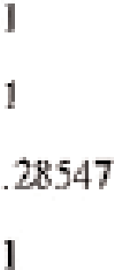4-7.2

*-"13*

I 7

4-

1:2. o·

s..1st

**4**- .81

pi

1!3.9i}t

.A,

A

7r

0

**A** 0 A T

T

*s*

T

0 Okiahomil. Cern1mt

(). I .rt ific **A:iibc** *C* •-·•. f I

0 lr\Jrit n F.0shic Si

T , uml!t:. h1!F3ll , !,j, 1 • n

O .R ·n- nition Equi mimt

Rio Algoti.!

**0 Hmli:in-dRR**

**0** I:!: b • **.Ai,i:·u1*::,,-1..***



o Tandy Corp_



l :'11

12-72

_g1 1

I *].*

7- I

4--71

:•9)5 ]

'l' f1, **l**

**l.•-70**

l2--69

l **l-,.**

**14**

7.lC

**·1**

*2*

25

22..25



1

s 0 • I. E Wtilbl.b Cor, .

1i \ ·, 11,ern Deic211-a

:i 15

6-70 1

·

t Co.mplc:t wuran1.u:nn.s.

:t: C _bdore e;-,:.pir..riiot1.

1. *Tke Prollicti* . *of* l-\1dtlarief Pnet:s

v,r h er'I.· d. it1 • ,haptc:r S tnat• he n .Kasso tf found TC-1 ti ns.:hip be­ tween ob rved Wi:iUant :pric nd-11 tfli 1 ta • om. be reci nia:Utt-

malica· •]a •• nshi p1 gir en by Ka·, . • ,t,o,r di . rl.a •o,n [] O]t i :

=(;i, - 1)1h• - 1 w ere

*z* 1. 07 + 5.355/T - 14.257 *.R* + 0.298D 1.015·1og(X/X)+ 0.40- *x*

pr,-• "red price , a *[* 1ed · · -, t/adjus.tod ex·rcise T ce

*X* pri • of c:ornmon oc.k

. - *.:tI*aJdjust exercuse p.ioe

*X* me n of pr viou.s .-lcven I ont:h' h _sh low **a** er .ge

*T* m •h:s. 1erlilainm.mg :c..fo *e* :tp'r *ti*

*.R* = 31nnu.al s·oc_ dijvidendl/X

*D* ... (n.um er ,· nC\\· . ret<i tf al[ option a«: e. erci ed) + (nL.tmbcr of

ou.t andin- com - o-,n

1. = natu al 1t.lgarithm

re.)

-or e .. mp or1 N01-·rntber l *5* 966j SpC:J ry Raa • co[I nnon d os.ed

at- ; the warrant dos.,:d at 8 .. Tbe w11. rant was. con *f* ib!eii ioto 1.08

s-hrail"C£ up n pa·ment f -•• 8. TJi!J r Jo11 · hr a !j-u :d-xi:,- . TG w 1

28/ [ ,08 = 25.9.Jo.



= 2 .49

= J(U;O *R* = 0,00 *lJ* = O.l2

*z* = 2.44

J ·:;:: 1,1.

Therefare this mod J w-o-.:ild predi t . pric ' o.r t traded Sp ny warra:nt of



*E,* ***B'a.,i*** *..gsfem* lh,dg *P,'1rjonn* ,m:;:g· *JtJ4lJ 1968*

We h ve ;s,_tid th a; e ct r tin expir (on da.te; th morettr, ti\1 •

lhe h LC- s;terr ii. \'CStllrl ·nt, ·w how *t* is. now from th put perform-

ance of all listed warrants which qualified between 1946 and 1966. We calculated the monthly percent- age change in the price of the warrant and its associated common stock.

The percentage change was calculated for 24 months before expiration, i.e., the percentage change in price from 24 to 23 months before expiration, and for every month thereafter to expiration. If the warrant or common did not trade within three days of an exact number of months *T* remaining before expiration, it was discarded from the sample for that *T* value. In Figure E.1, showing the average monthly percentage change for our sample, we see that listed warrants tend to fall faster as expiration approaches. Figures E.2, E.3, and E.4 show the average monthly percentage change for various hedged positions.

205

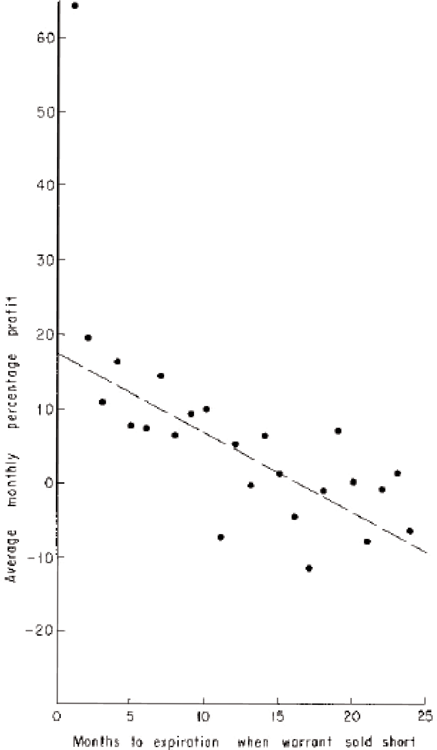

*Figure E.1. Percentage gain from shorting warrant and covering in one month assuming 100% margin and no transaction costs.*

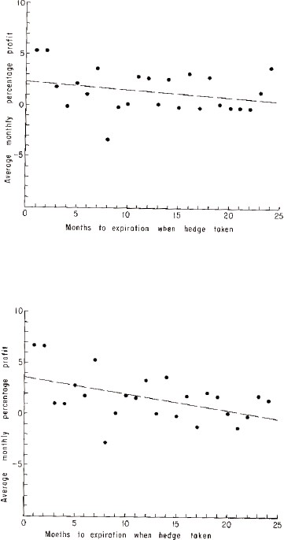

*Figure E.2. Percentage gain for a 1 to 1 hedge held for one month, assuming 100% margin and no transaction costs.*

*Figure E.3. Percentage gain for 2 to 1 hedge held for one month, assuming 100% margin and no transaction costs.*

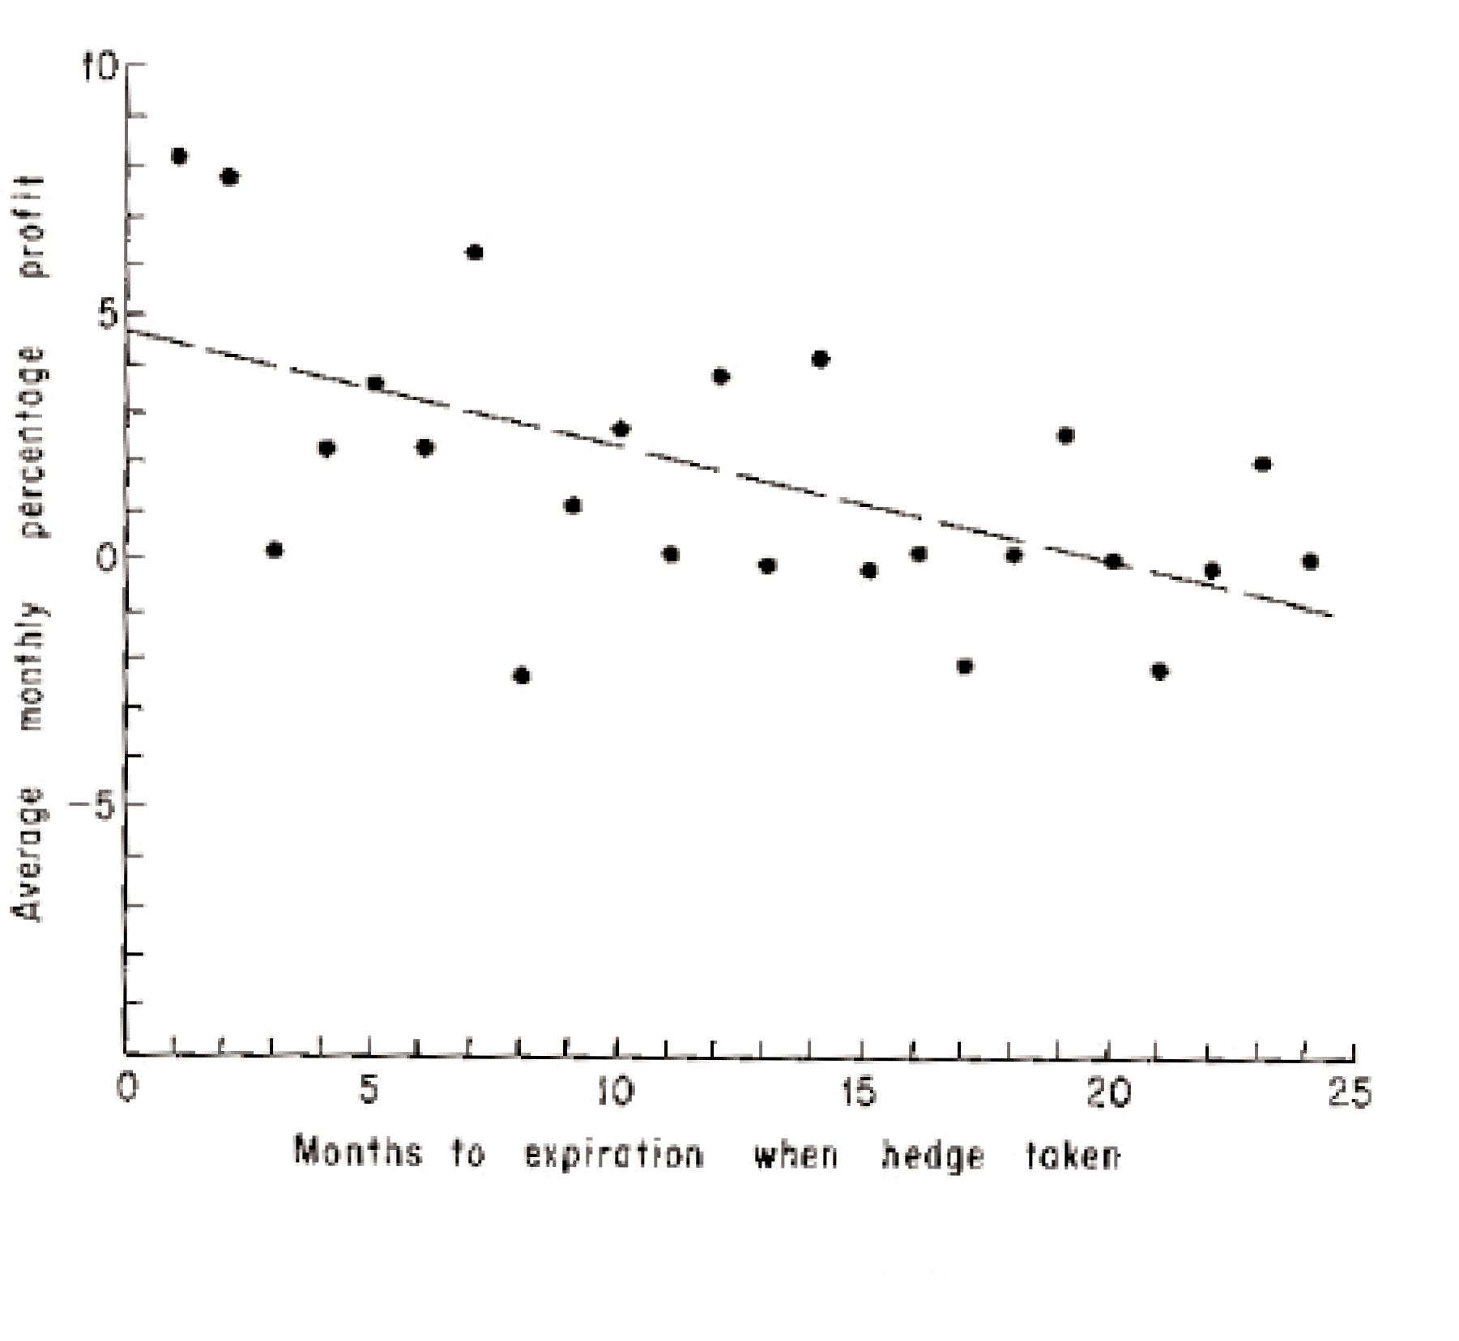

*Figure E.4. Percentage gain from 3 to 1 hedge held for one month, assuming 100% margin and no transaction costs.*

**REFERENCES**

1. Bladen, Ashby, *Techniques for Investing in Convertible Bonds*.

Salomon Bros. and Hutzler, New York, 1966. A leading practitioner’s view of convertible bond premiums.

1. Cootner, Paul, editor, *The Random Character of Stock Market Prices*.

The M.I.T. Press, Cambridge, 1964. Technical articles revealing the views of academe toward stock prices.

1. Crane, Burton, *The Sophisticated Investor*. Revised. Simon and

Schuster, New York, 1964. A popular book that attempts to touch on all practical aspects of buying and selling stocks. Most techniques and strategies presented are not convincing.

Indicates the many rules of thumb and superstitions that guide many investors.

1. Edwards, Robert D. and McGee, John, *Technical Analysis of Stock Trends*.

Fourth Edition. John Magee, Springfield, Mass., 1957. A forbidding “text” on chart reading. The “evidence” presented is not scientific or convincing.

1. Fisher, L. and Lorie, J. H., “Rates of Return on Investments in Common Stocks.”

*The Journal of Business*, XXXVII, no. 1, Jan., 1964, 1-12, 15-17. Calculation of hypothetical investor experience in New York Stock Exchange stocks from 1926 to 1960.

1. Fried, Sidney H., *The Speculative Merits of Common Stock Warrants*.

R.H.M. Associates, New York, 1961. A poplar survey of warrants. Contains interesting historical anecdotes, some elementary hedging, and some doubtful evaluative techniques.

1. Galbraith, John Kenneth, *The Great Crash*. Houghton-Mifflin, Boston, 1954. An account of the 1929 stock crash. An unusual combination of scholarship and entertainment.
2. Graham, Benjamin, David L. Dodd, and Sidney Cottle, with Charles Tatham, *Security Analysis*. Fourth Edition. McGraw-Hill, New York, 1962. The “bible”. A thorough survey of the field of investments. Primarily a book on fundamental analysis.
3. Investment Statistics Laboratory Daily Stock Price Index American Stock Exchange, 1962—present (quarterly). New York Stock Exchange, 1961 annual, 1962—present (quarterly). 467 Hamilton Ave., Palo Also, Calif.
4. Kassouf, Sheen T., *A Theory and an Econometric Model for Common Stock Purchase Warrants*. Analytical Publishers Co., 602 Vanderbilt Street, Brooklyn, New York 11218, 1965. A mathematical theory of warrant evaluation with a statistical estimation of normal price curves.
5. Kassouf, Sheen T., *Evaluation of Convertible Securities*. Analytical Publishers Co., 602 Vanderbilt Street, Brooklyn, New York 11218, 1962. A brief summary of hedging with warrants and convertible bonds.
6. Leffler, George L. and Farwell, Loring C., *The Stock Market*. Third Edition. The Ronald Press Co., New York, 1963. A standard text on the mechanics of investing.
7. Levy, Robert A., *An evaluation of selected applications of stock market timing techniques, trading tactics and trend analysis*. Ph.D. Thesis, The American University, Washington, D.C., pre-print, April 1966. An apparently successful attempt to substantiate the theory of “relative strength” in some listed stocks from 1960

through 1965.

1. Markowitz, Harry, *Portfolio Selection*. John Wiley & Sons, Inc., New York, 1959. An economist’s view of how a rational investor *should* choose portfolios.
2. Samuelson, Paul A., “Rational Theory of Warrant Pricing.” *Industrial Management Review*, VI, (Spring, 1965), 13-32. An economist’s view of how a rational investor *might* price warrants. Highly mathematical.
3. Securities and Exchange Commission, Report of Special Study of Securities Markets, Part 2. 88th Congress, 1st Session, House Document No. 95, Pt. 2.
4. Shultz, Birl E., *The Securities Market and How It Works*. Revised. Ed. by Albert

P. Squier. Harper and Row, New York, 1963. A standard text on the mechanics of investing.

1. Skelly, William S., Convertible Bonds: *A Study of Their Suitability for Commerical Bank Bond Portfolios*. Salomon Bros. and Hutzler, New York, 1959. The role convertible bonds can play in a bank’s portfolio.
2. Thorp, Edward O., *Beat the Dealer*. Revised. Random House, New York, 1966. The best seller which presents a winning strategy for the casino game of blackjack, or twenty-one. Includes anecdotes and experiences of the author and an account of unsuccessful attempts by casinos to change their rules.
3. Von Neumann, John and Morgenstern, Oskar, *Theory of Games and Economic Behavior*. Wiley (Science Editions), 1964. The seminal work on game theory by a mathematician and an economist. Highly mathematical.
4. Weinsteain, Meyer H., *Arbitrage in Securities*. Harper Bros., New York, 1931. An interesting description of the warrant and convertible bond market in the late 1920s and early 1930s. Some early forms of hedging are detailed with some crude evaluation techniques.

**INDEX**

ACF Brill, 37, 93 Armour, 37

ARA, Inc., 109, 202 Asked price, 19fn, 104

Accounts (*see* Brokerage account) Atlas Credit Corp., 202

Adjusted exercise price, 24 Atlas Corp., 16, 29

defined, 26 Automobile Banking, 202

Adjusted warrants, 24 Avalanche effect, 36, 37fn, 39,

defined, 25 41-42, 199-201

Adler Electronics, 10 used in Bunker-Ramo warrants, Aeronautical Industries, 101 64

Air Force Eleventh Annual Summer Axes, 21 Scientific Conference, 194

Air Reduction 37/8 of 1987, 149,

151 Banning of short sales, 73, 74, 138

Alberta Gas Trunk Line, 202 139

Algoma Central Railway, 106 in Moly warrants, 61

Alleghany Corp., 16, 29, 109 Bar graph, 20

Allright Auto Parks, 202 choosing candidates, 77-79,

American Commonwealth Power, 160-161

99, 101 compared with only buying

American Foreign Power, 101 common, 96-97

American Power & Light, 99 compared with only shorting

American Stock Exchange, warrants, 96-97 handbook, 71-72, definition, 43-49

bans short sales in Moly performance, 93-94, 99-102

warrants, 61 204-209

American Tobacco, 33, 34 possible size of investment,

Arbitrage, 23fn 196-198

simplified mechanical strategy, Canad. Delhi, 105-106

91-97 Canadian warrants, 108-109

with latent warrants, 155-161 Capital, how to divide, 87

with options, 163-167 Cascade Natural Gas, 106 Bean, Dr. Tom, 194 Cash, withdrawl of, 174

Bear market, 33 Cash account (*see* Brokerage Beckham, Colonel, 194 account)

Bid and asked prices, 104 Center for Research in Security Blough, Roger, 55 Prices, 9

Blue chip, 33-34 Central States Electric, 101

Blue Monday, 56 Chartist, 8

Bonds, bank financing, 147-148 Chemcell, 202 choosing bond situations, “Circus,” 9

150-161 Clairtone Sound, 202

commissions, 183 Coastal States Gas, 106

convertible, 141-161 Coburn Credit, 202

prices, how quoted, 147fn Collins Radio 4fl of ‘80 bond, Book value, 66 143-146

Brahe, Tycho, 191 4fl of ‘83 bond, 143-146

Bramalea Consolidated, 202 “warrants,” 147-150

British American Con., 202 Colonial Acceptance Corp., 202

Brokerage account, 169-179 Colorado Fuel and Iron, 37, 93

cash account, 169-170 Columbia Broadcasting, 12, 13

margin account, 170-174 Columbia University, 14, 133

mixed account, 64, 178-179 *Commercial and Financial*

restricted account, 173 *Chronicle*, 99

short account, 174-178 Commissions, bonds, 183

Bruce, E. L., 60 Commonwealth & Southern, 101

Bull market, 33 Consol. Building, 202

Bunker-Ramo, 62, 65, 93, 132 Consolidated Cigar, 101

Burns, Arthur F., 14 Consol. Leasing, 202

Buy-in, 58, 105 Consolidated Oil and Gas, 105, 106,

Buying on margin, 39 118-119, 202

Buying power, 40, 135, 178 Control-certificate system, 128

definition, 173 Conversion value, bond, 156

Convertible bonds, 141-161

*Convertible Fact Finder*, 150-151

Cage room, 57 Convertible preferred stocks, 141,

Calls, 141-142, 161 142, 161

definition, 162 Convertibles, definition, 49

with basic system, 163-167 description, 141-142

Canad. Brit. Alum., 106 Cooper Tire and Rubber, 109, 202

Coral Ridge, 202 Executive House, 106

Cornering the market, 127 Exercise price, definition, 16 definition, 60 standardized, 73-74

Corner of warrant-stock diagram, adjusted, 26

151 for convertible bond, 151

Coronation Credit, 106, 202 Expected value, 115

Coupon, amount of, 143 Expiration date, 16

Crane, Burton, 54 Exquisite Form Bra Can., 202

Credit brokerage account, 170 Extension of warrant privileges, 137 Cuban crisis, profits continued

during, 14

Current yield, 144

Curtiss-Wright, 101 Face value, bond, 143 Far West Fin., 202

Federal Reserve System (*see* Regulation T)

Debit, brokerage account, 170 Fin. Gen. Corp., 202

Debit balance, 171 First National Realty, 29

Decline in common, exploiting, 184 Fitch, Francis Emory Inc., 71

Desert isle strategies, 134 Food Fair Properties, 202

Diversification, 184-185 Fried’s warrant service, 193

Dividend, effect on warrant, Fundamental analysis, 11-13 110-111 Future stream of earnings and

Dow-Jones industrial average, dividends, 11 plummets in 1962, 34

Dominion Lime, 202

Dow Theory, performance of, 9 Gabriel (Maremont), 202

Dresser Industries “warrants,” with Gains, long term, 186

basic system, 158-160 on short sales, taxed as ordinary Durant, Richard, 9 income, 186

General Acceptance, 29, 37, 72, 73,

76, 79, 202

Electric Power & Light, 101 General Builders, 202

Emerson Radio, 7, 8, 12 General Cable, 101

Engineers Public Service, 101 General Dynamics, 12, 14

Equity, definition, 172 General Electric, 101

excess, 173 General Motors, 11

Equivalent securities, 23fn Gen T & R, 106

Eureka Corp., 93, 137 Gilbert, Eddie, corners market in Evaluation of Convertible E. L. Bruce, 60

Securities, 193 Great Lakes Power, 106 Excess equity, definition, 173 Great Northern Cap, 106

*Great Treasury Raid*, 192fn Kalb, Voorhis, 150

Gridiron method, 51 Kalvar Corp., 203

Guerdon, 93 Kennecott Copper Corp., 59, 128

Guide point, 80-81 Kennedy, President J. F., 55

Gyrodyne, 105, 106, 119 Kerr McGee Oil, 107

Keyes Fibre, 203 Koestler, Arthur, 191fn

Harder, Lewis, 59-60

Hartfield Stores, 202

Hedging, definition, 43 profit estimate, rough, 45

scientific proof of high expected Lake Ontario Cement, 105, 107

return, 200-201 Lakeland Nat. Gas. 203

Hilton Hotels, 29 Latent warrants, with basic system Hirsch, Marx, 54-55 145, 150

Hoerner-Waldorf, 202 Laurentide Financial, 107

Holly Sugar, reverse hedging with, Leverage, created, 178 151-155 definition, 17

Husky Oil Canada, 202 example, 17

Hydrocarbon, 10, 11 Levy, Robert A., 51

Listed warrants, identifying, 71-72 mathematical and computer

IBM, 42, 200 analysis of, 109ff

Indian Head, 29, 109 Life Investors, 203

Inherent value, 11 Loan clerk, 58

Initial margin, definition, 38 Loews Inc., 101 low-priced stocks, 40-42, 179 Long, definition, 34

minimum, 171 Long account, 170

Intermediate decisions, 67, 134 Long term gains, 186

Inland National Gas, 106 Lybrand, Ross Bros. & Montgomery International Minerals and *Newsletter*, 98

Chemicals, 37

International Mining, 59, 128

International Utilities, 101

Intrinsic value, 11

Inventory, broker’s, 58 Mack Trucks, 29, 72, 93, 97, 130,

Investment, minimum for system, 4 203

Investment worth, bond, 145 Mack Truck warrants, *New York* Italian Super Power, 101 *Times* misunderstands, 130 short sales banned in, 72-73

Maintenance margin, amount, 38

Jade Oil and Gas, 105, 107, 119 call, 172, 178

Jefferson Lake Petrochemical, 29 defined, 38, 172

Manati Sugar, 37, 93 Moody’s *Bond Investments*, 145

Margin, 37-39, 171ff *Moody’s Manuals*, 72

buying on, 38

initial, 38, 40-42

maintenance, 38, 172 National Daily Quotation Service, not required, 121 104

who prescribed by, 171 National General Corp., 29, 203 Margin account, 36-39, 170ff National Tea, 69

minimum deposit for, 38 New issues, year of, 10

opening, 88 New York *Herald Tribune*, 12

Marking to the market, defined, 35, *New York Times*, 12, 54, 60, 130

177 Newconex Holdings, 107

Martin, William M., 133 Newspaper price scales,

Martin Marietta, 72-73 construction of, 75, 77 warrant, calculation of adjusted Niagara Hudson Power, 101

exercise price, 73 Nickerson, A. L. 53 Mathematical expectation, 115 Norfolk and So RR, 107

Maturity date, bond, 143 Normal price curves, 31, 77, 79,

Maximum value line, defintion, 31 110

McCrory, 29, 137 defined, 31

McLean Industries, 107 individual, 82

Mid-America Pipeline Co, 203 intermediate, 79

Midwestern Gas Trans., 203 mathematics of, 201, 204 Millionaires, our experiences with, North Central Airlines, 107

190-193

Minimum value line, 31

Mix, choosing, 80-83 *Oil and Gas Journal*, 54 defined, 46 Oklahoma Cement, 203

illustrated, 46 Option writer, 164

optimal varies, 85 definition, 162

Mixed account, 178-179 Over-the-counter warrants, 71,

definition, 64 103ff

Mohawk & Hudson Power, 101 disadvantages, 105, 108

Molybdenum Corp., 12-14, 37-39 refusal to short, 105, 108

52-62, 65, 69, 93, 128 table of, 202-203

stockholder’s meeting, 54, 55

Molybdenum warrants, 13-14

International Mining, trades in, Pacific Asbestos Corp., 203

59-60 Pacific Petroleums, 29, 69, 72, 73,

investments in, 52ff 76, 79, 88, 119, 183, 197, 201

short sales banned in, 61 hedge, 80-87

terms of, 52 potential investment in, 196

short sales banned in warrant, Released margin, 40

139fn Restricted account, 173

Pan American Airways, 10, 37 Reverse hedging, 119-125

Penn-Ohio Ed., 101 spotting candidates for, 123-125,

Pennsylvania Dixie Cement, 37, 93 151-155

Pennsylvania RR bonds, 183 with Collins Radio “warrants,”

Perpetual warrants, 16 147-150

Phillips Petroleum, 99 with Realty Equities warrant,

Pink sheets, 104 120-123

Portfolio management, 181-187 with Holly Sugar, 151-155 Potential dilution, 110, 111 Richfield Oil, 37, 93

Premium, 28 Rights, 141-142

Price relationship, stock and Rio Algom, 29, 72, 73, 76-77, 79,

warrant, 18ff 203

Profit profile, construction, 84-85 Rules relating warrant and stock Protection, how much, 83-87 prices, 22-24

Puritan Fashions, 203 Ruthland RR, 203

Puritan Sportswear, 10

Puts, 163-167

definition, 141, 163

writer of, 164 Safeway Stores, 101

pyramid, 40 Same day substitution, 174, 182

Samuelson, Paul A., 194 Schine empire, 122

Quebec Natural Gas, 203 Schwed, Fred Jr., 161

Quotron, 103 Seab. W. Airlines, 203

Securities and Exchange Commission, 128, 138, 189

R. H. M. Associates, 103, 107, 109 190

Radford, Admiral A. W., 54-55 Securities Exchange Act, 171

Radio-Keith-Orpheum, 37 Security Prices, University of Random buying and selling, 9 Chicago Center for Research

*Random Character of Stock Prices*, in, 9

194 semi-log grid, 95

Realty Equities, 29, 69, 119-124, Shell Investments, 203

147 Sheraton East Hotel, 54

reverse hedging with warrant, Short account, 175-178 120-123 defined, 174

Recognition Equipment, 203 marking to the market, 177 Rediscovery of system, threat of, Short interest, 196

193-194 Short-sale candidates, how to pick,

Regulation T, 121, 147, 173, 187fn 220-73

Short-sale profits, taxed as ordinary Standardized common stock price, income, 186 74

Short sales banned, 73-74, 138-139 Standardized exercise price, 73

Short selling, 34-42 Standardized warrant price, 74 avalanche effect, 39-42 State Loan & Finance, 107

banning, 138-139 Stern, Philip M., 192fn

broker’s incentive for, 57 Stock axis, 21

creates new shares, 129 Stock market, general solution for, effect on price, 129-130 198

explained, 57-59 Stock options, 141-142

warrants, 36-39 Stock rights, 141-142

Short squeeze, defined, 59 Stocks, 1929-1932 price drop in, 33 risk of, 127-133 Straddle, 161

Short term gains, 186-187 basic system with, 167

Slater Steel, 203 definition, 166

*Sleepwalkers*, 191fn Straps, 161

Socony Mobil, 53 Street name, 57

Southeast Power & Light, 101 Striking price, 162

Sperry Rand, 15-16, 22-29, 72-73, Strips, 161

76, 79, 86-88, 110-111, 119, Sweetener, 98, 144

130, 162-163, 181-184, 194- Symington Wayne, 107

195, 197, 204 Syntex, 26

Sperry Rand common, 19, 26-27

Univac division, 66, 68 Tandy Corp., 203

Sperry Rand warrant, 18, 24 Tax, capital gains, 186 investment in, 65-69 Tax advantages of warrants to potential hedge investment in, corporations, 97

196 Technician, 8

predicted price, 201, 204 Teleregister, 62, 64-65, 69 relation to common price, 18 *see* Bunker-Ramo terms of, 23-24, 66 Textron Inc., 29-30

Spread, 104, 161 warrants, 12-13

Square root law, 42 Toronto Exchange, 88, 108

Standard and Poor’s, *Bond Guide*, Traders Finance, 203

144 Trans-World Airlines, 29

*Bond Outlook*, 145 Trend, 117

fact sheets, 72 effect, 111, 113

*Stock Guides*, 111 Tri-Continental Corp., 16-17, 29 Standard and Poor’s 500, Two basic rules relating warrant to

performance of, 33 stock prices, 22-24

plummets in 1962, 34 check of, 28-30

valid for adjusted warrants and sources of, 107fn

adjusted exercise price, 26 Warrant terms, sources for, 107fn Warrants, 15

adjusted, 24-26

United Airline, 107 attached to bond, 98

United Artists straddle, 166-167 best, 77, 79

United Elec. Service of Italy, 101 Canadian, 103, 106, 107,

United Industrial, 29, 72-73 200-203

United States Finance Corp., 156 choosing warrant situations,

Univac, 65-66, 68 88-89

Universal American, 29, 69, 72-73 definition, 15

76, 79, 86-88, 105, 119, 132, effect of dilution, 110-111

196 effect of dividend, 110-111

Universal American 1962 warrant, effect of past price history, 111 actual profits in, 93fn exercise price, 16

potential hedge investment in, expiration date, 16

197 extension of conversion privilege,

short sales never banned, 139fn 137-138

Universal Pictures warrants, 18 gain from short sales, 37

University of California, Irvine, 49 latent, 145

University of Chicago, Center for not traded on NYSE, 71 Research in Security Prices, 9 over-the-counter, 103, 106-107,

Up-tick, 92 201

defined, 36 perpetual, 16

Uris Building, 29 premium, 28

profits from shorting, 37

Volatile price movements, 134-137 regional, 103

Volatility, 42, 118 short selling, 36-39

compared, 119 tables of, 29, 202-203

defined, 117 tax advantage in issuing, 98

estimated, 118-119 terms of, 72

why issued, 16

Warrant-stock diagram, applied,

Walgreen Co., 101 73-77

*Wall Street Journal*, 26, 53, 71, 104, construction of, 18-22

109, 128, 162, 166 “corner,” 151

Warrant axis, 21 explained, 18ff

Warrant hedge, 43fn zero-profit lines in, 47-49 Warrant prices, effect of common Western Decalta, 203

on, 18-22 Weston (George) Ltd., 107

effect of short position on, 129 *Where Are the Customers’ Yachts?*, prediction of, 201, 204 161

White Oil Company, 99 Yield, current, 144 Writer, option, 164 to maturity, 144

definition, 162

Xerox 4s of ‘84, 156-158 Zero-profit line, 80

explained, 47

how to draw, 48, 81

Yearly range, 119 with reverse hedge, 124

**ABOUT THE AUTHORS**

**EDWARD O. THORP**

*is the author of the best-seller* Beat the Dealer: A Winning Strategy for the Game of Twenty- One, *published by Random House in 1962 and in revised form in 1966. It presented the first sci- entific winning system ever devised for a major casino gambling game. He has also written* Elementary Probability *(1966) and numerous mathematical papers on probability, game theory, and functional analysis.*

*He completed undergraduate and graduate work at U.C.L.A., receiving the B.A. and M.A. in physics, and the Ph.D. in mathematics in 1958. He has taught at U.C.L.A., M.I.T., New Mexico State University, and is now Professor of Mathematics at the University of California at Irvine. He acts as investment counselor for selected clients.*

**S. T. KASSOUF,**

*Assistant Professor of Economics at the University of California at Irvine, completed his under- graduate work in mathematics and graduate work in economics at Columbia University and received the Ph.D. in 1965. His dissertion involved an econometric model for common stock pur- chase warrants and was under the sponsorship of Arthur F. Burns. He is the author of Evaluation of Convertible Securities, published by Analytic Investors, Inc., an investment advisory firm. He served as editor and investment counselor for this organization, from its inception in 1962 until 1965. He acts as investment counselor for selected clients.*